

CE3708 Geotechnical Engineering Lab Manual

Prepared by
Dr. Da Hu
Dr. Jayhyun Kwon
Dr. Adam Kaplan

Department of Civil and Environmental Engineering
Kennesaw State University
Marietta, GA, USA

Version 1.0 — May 2025

© 2025 by Da Hu, Jayhyun Kwon, and Adam Kaplan.
This work is licensed under a Creative Commons Attribution-NonCommercial 4.0 International License.
https://creativecommons.org/licenses/by-nc/4.0/
Disclaimer
This laboratory manual is part of an ongoing effort to support high-quality, open-access engineering education. It is actively maintained and periodically updated to improve clarity, accuracy, and instructional value. While the content has been carefully reviewed, minor errors or omissions may remain.
Feedback from users is welcome and encouraged to support future improvements.
Table of Contents
Lab 1 Water Content 1
Lab 2 Specific Gravity 4
Lab 3 Mechanical Sieve Analysis 8
Lab 4 Hydrometer Analysis 12
Lab 5 Atterberg Limit 19
Lab 6 Relative Density 24
Lab 7 Sand Cone 28
Lab 8 Proctor Compaction 32
Lab 9 Constant Head Permeability 36
Lab 10 Direct Shear 40
Lab 11 Unconfined Compressive Strength 46
Lab 12 Consolidation 50
Acknowledgment of Sources 57

Lab 1 Water Content

Overview
The water content or moisture content of the soil is an indicator of the amount of water present in the soil. The natural water content of the soil is essential knowledge for all studies of soil mechanics. It provides an idea of the state of the soil in the field. In geotechnical engineering, knowing the water content of the soil is vital for designing foundations, ensuring slope stability, and constructing earth structures like dams. High moisture levels can weaken soil, affecting foundation strength and increasing landslide risks. Proper soil compaction and understanding expansive soil behavior depend on accurate water content testing to prevent infrastructure damage. Water content in soil can be defined as
$$w=\frac{Weight of water present in a given soil mass}{Weight of dry soil }$$
The water content $w$ is typically expressed in percent. For better results, the minimum size of the most soil specimens should be approximately as given in Table 1-1. These values are consistent with ASTM Test Designation D2216-19.
Table 1-1. Minimum Size of Moist Soil Samples to Determine Water Content (ASTM Test Designation D2216-19)
Maximum Particle Size in Soil (mm) | U.S Sieve  No. | Minimum Mass of Soil Sample (g)
0.425 | 40 | 20
2.0 | 10 | 50
4.75 | 4 | 100
9.5 | 3/8 in. | 500
19.0 | ¾ in | 2500

Learning Objective
To determine the water content of soils.

Tools and Materials
- Container for soil sample
- Oven with temperature control. For drying the oven is generally kept between 105 ºC to 110 ºC
- Balance. The balance should have a readability of 0.01 g for specimens having a mass of 200 g or less
- Container handling apparatus.

Reference Standard
ASTM D 2216-19 - Standard Test Methods for Laboratory Determination of Water (Moisture) Content of Soil and Rock by Mass

Step-by-Step Guide
The test procedure follows the steps of ASTM D2216-19 Test Method. The procedure for determining the water content is as follows:
- Determine the mass (g) of the empty moisture can (M₁) and record the number.
- Place a sample of representative moist soil in the can and determine the combined mass (g) of the closed can and moist soil (M₂).
- Put the can in the oven to dry the soil to a constant weight. In most cases, 24 hours of drying is enough. Temperature should be maintained at a temperature between 105º C to 110º C.
- Determine the combined mass (g) of the dry soil sample plus the can (M₃).

Sample Data and Calculation
Table 1-2. Sample data for moisture content
Sample No. | 1 | 2 | 3
Can No. | 12 | 23 | 36
Weight of the can, M₁ (g) | 19.8 | 23.51 | 16.32
Weight of the can + wet soil, M₂ (g) | 159.7 | 165.21 | 158.23
Weight of the can + dry soil, M₃ (g) | 138.58 | 145.65 | 137.55

Sample calculation
For example,
Weight of the can, M₁ = 19.8 g
Weight of the can + wet soil, M₂ = 159.7 g
Weight of the can + dry soil, M₃ = 138.58 g
Water Content, $w=\frac{M_{2}-M_{3}}{M_{3}-M_{1}}×100=17.78 \%$

Important Numbers
Most natural soils, which are sandy and gravelly in nature, may have water contents up to about 15 to 20%. In natural fine-grained (silty or clayey) soils, water contents up to about 50 to 80% can be found. However, peat and highly organic soils with water contents up to about 500% are not uncommon.
Typical values of water content for various types of natural soils in a saturated state are shown in Table 1-3.
Table 1-3. Natural water content for various types of soil
Soil | Natural Water Content in a Saturated State (%)
Loose uniform sand | 25-30
Dense uniform sand | 12-16
Loose angular-grained silty sand | 25
Dense angular-grained silty sand | 15
Stiff clay | 20
Soft clay | 30-50
Soft organic clay | 80-130
Glacial till | 10

Report Guidelines
In the lab report, the following contents should be included:
- Objective of the test
- ASTM standard
- Analysis of test results – complete the provided table for moisture content and include one sample calculation, discuss the meaning of the results, and include what type of soil sample was tested based on the test results.
- Report source of error
- Summary and conclusion - 1) what experiment was performed, 2) how it was performed, and 3) what the results were.

Lab 2 Specific Gravity

Overview
The specific gravity of a given material is defined as the ratio of the weight of a given volume of the material to the weight of an equal volume of distilled water. In soil mechanics, the specific gravity of soil solids (which is often referred to as the specific gravity of soil) is an important parameter for the calculation of the weight-volume relationship. This parameter is critical in geotechnical engineering for determining the soil's density and compaction, which are essential for foundation design and stability analysis. Accurate knowledge of specific gravity is also vital for the classification and identification of soil types, aiding in the selection of appropriate construction materials and methods. Thus, specific gravity, G_{s} is defined as
$$G_{s}=\frac{Unit weight (or density) of soil solids only}{Unit weight (or density) or water }$$
The general range of values of G_{s} for various soils is provided in Table 2-1.
Table 2-1. General ranges of Gs for various soils
Soil Type | Ranges of G_{s}
Sand | 2.63-2.67
Silts | 2.65-2.7
Clay and silty clay | 2.67-2.9
Organic Soil | Less than 2

Learning Objective
To determine the specific gravity of soils.

Tools and Materials
- Oven Dried soil sample
- Scale capable of measuring to the nearest 0.01g
- 500-ml etched flask
- Distilled or demineralized water
- Squeeze bottle
- Thermometer capable of reading to nearest 0.5o C
- Funnel
- Stopper and tubing for connecting flask to a vacuum supply
- Vacuum supply

Reference Standard
ASTM D854-23 - Standard Test Methods for Specific Gravity of Soil Solids by the Water Displacement Method

Step-by-Step Guide
The test procedure follows the steps of ASTM D854 -23 Test Method, where an oven dried specimen of soil is used. The specific gravity calculation is based on three measurements:
- Mass of the flask filled with distilled water to etch mark, M_{a}
- Mass of the flask filled with water and soil to etch mark, M_{b} and
- Mass of the dry soil, M_{o}
Specific gravity of the soil solids, G_{s}, is calculated based on these three parameters:
$$G_{s}=\frac{M_{o}}{M_{o}+{(M}_{a}-M_{b })}$$
Since the density of water is temperature-dependent, a temperature correction factor, K (Table 2), may be applied to report G_{s} at a standard temperature of 20º C. The temperature-corrected factor G_{s}, G_{s20} is expressed as:
$$G_{s20}=G_{s}K$$
Table 2-2. Temperature correction factor, K, for reporting G_{s20}
Temperature (ºC) | Correction Factor K
17 | 1.0006
18 | 1.0004
19 | 1.0002
20 | 1.0000
21 | 0.9998
22 | 0.9996
23 | 0.9993
24 | 0.9991

The procedure for performing the specific gravity measurement is as follows:
- Fill the flask with water up to 500-ml mark.
- De-air the water.
- Determine the mass of the flask and the water.
- Put about 100-grams of sand into the flask and add de-aired water to make it about 2/3 full.
- Remove the entrapped air from soil-water mixture by applying vacuum.
- Add de-aired water to the flask up to 500-ml mark and determine the mass.
- Pour the soil and water into an evaporating dish and oven dry.
- Determine the mass of dry soil

Sample Data and Calculation
Table 2-3. Sample data for specific gravity
Sample No. | 1 | 2 | 3
Mass of the flask + water filled to etched mark, M₁ (g) | 683 | 659.7 | 675
Mass of the flask + soil+ water filled to etched mark, M₂ (g) | 745.1 | 722 | 737
Mass of dry soil, M_{s} (g) | 100 | 100 | 100
Water temperature T (°C) | 23 | 24 | 23.5
Temperature correction factor, K | 0.9993 | 0.9991 | 0.9992
Specific Gravity | 2.64 | 2.65 | 2.63

Sample calculation
Mass of the flask + water filled to etched mark, M₁ = 683 g
Mass of the flask + soil + water filled to etched mark, M₂ = 745.1 g
Mass of dry soil, M_{s} = 100 g
Water temperature T = 23 °C
Temperature Correction Factor, K (from Table 2-2) = 0.9993
Specific Gravity, $G_{s}=\frac{M_{s}}{M_{s}+{(M}_{1}-M_{2 })}×K=2.64$

Important Numbers
Specific gravity of soil solids is controlled by soil mineralogy. In coarse-grained soils such as sands and gravels, where the mineralogy is dominated by quartz and feldspar, G_{s}, is typically around 2.65. In fine-grained soils, G_{s} is more variable due to the presence of clay minerals and may range from 2.70-2.85.
In the absence of laboratory testing, G_{s} is often assumed based on the predominant mineralogy of the soil. However, certain types of soils, including organic soils, gypsum, and fly ash, possess values of G_{s}, that are significantly less than the range of 2.65-2.85 often assumed by practicing engineers. Therefore, it is particularly important when dealing with such soils to measure G_{s,} rather than assuming a value.
Finally, ASTM D854 includes criteria for assessing the acceptability of test results using this method. Assuming that all the tests are performed by the same laboratory technician, G_{s}, for two separate tests of the same material should be within 0.06 of each other to be considered acceptable.

Report Guideline
In the lab report, the following contents should be included:
- Objective of the test
- ASTM standard
- Analysis of test results – complete the provided table for specific gravity and include one sample calculation, discuss the meaning of the results, and interpret the data by including the soil type of the sample based on the results.
- Report source of error
- Summary of the experiment - 1) what experiment was performed, 2) how it was performed, and 3) what the results were.

Lab 3 Mechanical Sieve Analysis

Overview
To classify soil for engineering applications, it is essential to understand the distribution of particle sizes within a soil sample. Particle size or grain size analysis is crucial in geotechnical engineering as it helps determine soil properties such as permeability, shear strength, and compaction characteristics. Grain size refers to the size of an opening in a square mesh through which a grain will pass. This test method can classify the soil and anticipate its behavior, enabling more accurate predictions and informed decisions in various geotechnical applications. Particle size analysis is crucial for determining soil suitability for construction projects like roads, embankments, and dams. Additionally, it can predict soil-water movement in the absence of permeability test data.
Sieve analysis is a common technique used to determine this grain size distribution for dry granular soil. This method employs sieves constructed from woven wire with square openings. It is important to note that as the sieve number increases, the size of the openings decreases. Table 1 provides a list of U.S. standard sieve numbers along with their respective opening sizes. For practical purposes, the No. 200 sieve has the smallest openings suitable for this test.
Table 3-1. U.S. standard sieve size
Sieve No. | Opening (mm) | Sieve No. | Opening (mm)
4 | 4.75 | 35 | 0.5
5 | 4 | 40 | 0.425
6 | 3.35 | 45 | 0.355
7 | 2.8 | 50 | 0.3
8 | 2.36 | 60 | 0.25
10 | 2 | 80 | 0.212
12 | 1.7 | 100 | 0.18
14 | 1.4 | 120 | 0.15
16 | 1.18 | 140 | 0.125
18 | 1 | 170 | 0.106
20 | 0.85 | 200 | 0.075
25 | 0.71 | 270 | 0.053
30 | 0.6 | 400 | 0.038

Learning Objective
To obtain the grain size distribution curve for a given soil sample.

Tools and Materials
- Oven-dried soil
- Mortar and pestle or a mechanical soil crusher pulverizer
- Sieve stack
- Scale capable of measuring to the nearest 0.01g
- Mechanical Shaker(optional)
- Timing device

Reference Standard
ASTM D6913-04(2009)e1- Standard Test Methods for Particle-Size Distribution (Gradation) of Soils Using Sieve Analysis

Step-by-Step Guide
The test procedure follows the steps of ASTM D6913-04 Test Method. The procedure for sieve analysis is as follows:
- Collect oven-dried soil sample, finely pulverize it using a mortar, pestle, or mechanical pulverizer.
- Place the soil on the top of the sieve stack. Stack the sieves with larger openings (lower numbers) on top of those with smaller openings (higher numbers). Place a pan under the last sieve (#200) to catch the soil that passes through. Always include the #4 and #200 sieves in the stack.
- Ensure the sieves are clean, brushing out any stuck soil particles. After weighing the pan and each sieve separately, pour the soil into the sieve stack, cover it, and place the stack in the sieve shaker.
- Secure the clamps, set the timer for 10-15 minutes, and start the shaker. Dust masks and ear protection are recommended for this step.
- When finished, measure the mass of each sieve and retained soil.

Sample Data and Calculation
Table 3-2. Sample data for sieve analysis
Sieve  No. | Opening  (mm) | Sieve Wt.  (g) | Sieve + Soil Wt. (g) | Wt. of soil  retained (g) | Percent  retained | Cumulative  percent  retained | Percent  finer
4 | 4.75 | 521 | 521 | 0 | 0.0 | 0 | 100
8 | 2.36 | 491.8 | 504 | 12.2 | 4.01 | 4.01 | 95.99
16 | 1.18 | 422 | 450.5 | 28.5 | 9.36 | 13.37 | 86.63
30 | 0.6 | 401.8 | 490 | 88.2 | 28.98 | 42.35 | 57.65
50 | 0.297 | 375.5 | 478 | 102.5 | 33.67 | 76.02 | 23.98
100 | 0.149 | 355.3 | 410 | 54.7 | 17.97 | 93.99 | 6.01
200 | 0.075 | 351.1 | 368.2 | 17.1 | 5.62 | 99.61 | 0.39
Pan | - | 364.2 | 365 | 1.2 | - | - | -

For example,
For #16 sieve,
Sieve weight = 422 g
Sieve + soil weight = 450.5 g
Weight of soil retained = (450.5 – 422) = 28.5 g
Percent retained= 28.5/304.4 × 100 = 9.36%
Cumulative percent retained= 0 + 4.01 + 9.36 = 13.37%
Percent finer= 100 – 13.37= 86.63%
The grain-size distribution of the soil sample is determined by plotting the percentage of finer particles against the respective sieve sizes on semi-logarithmic graph paper, as illustrated below:
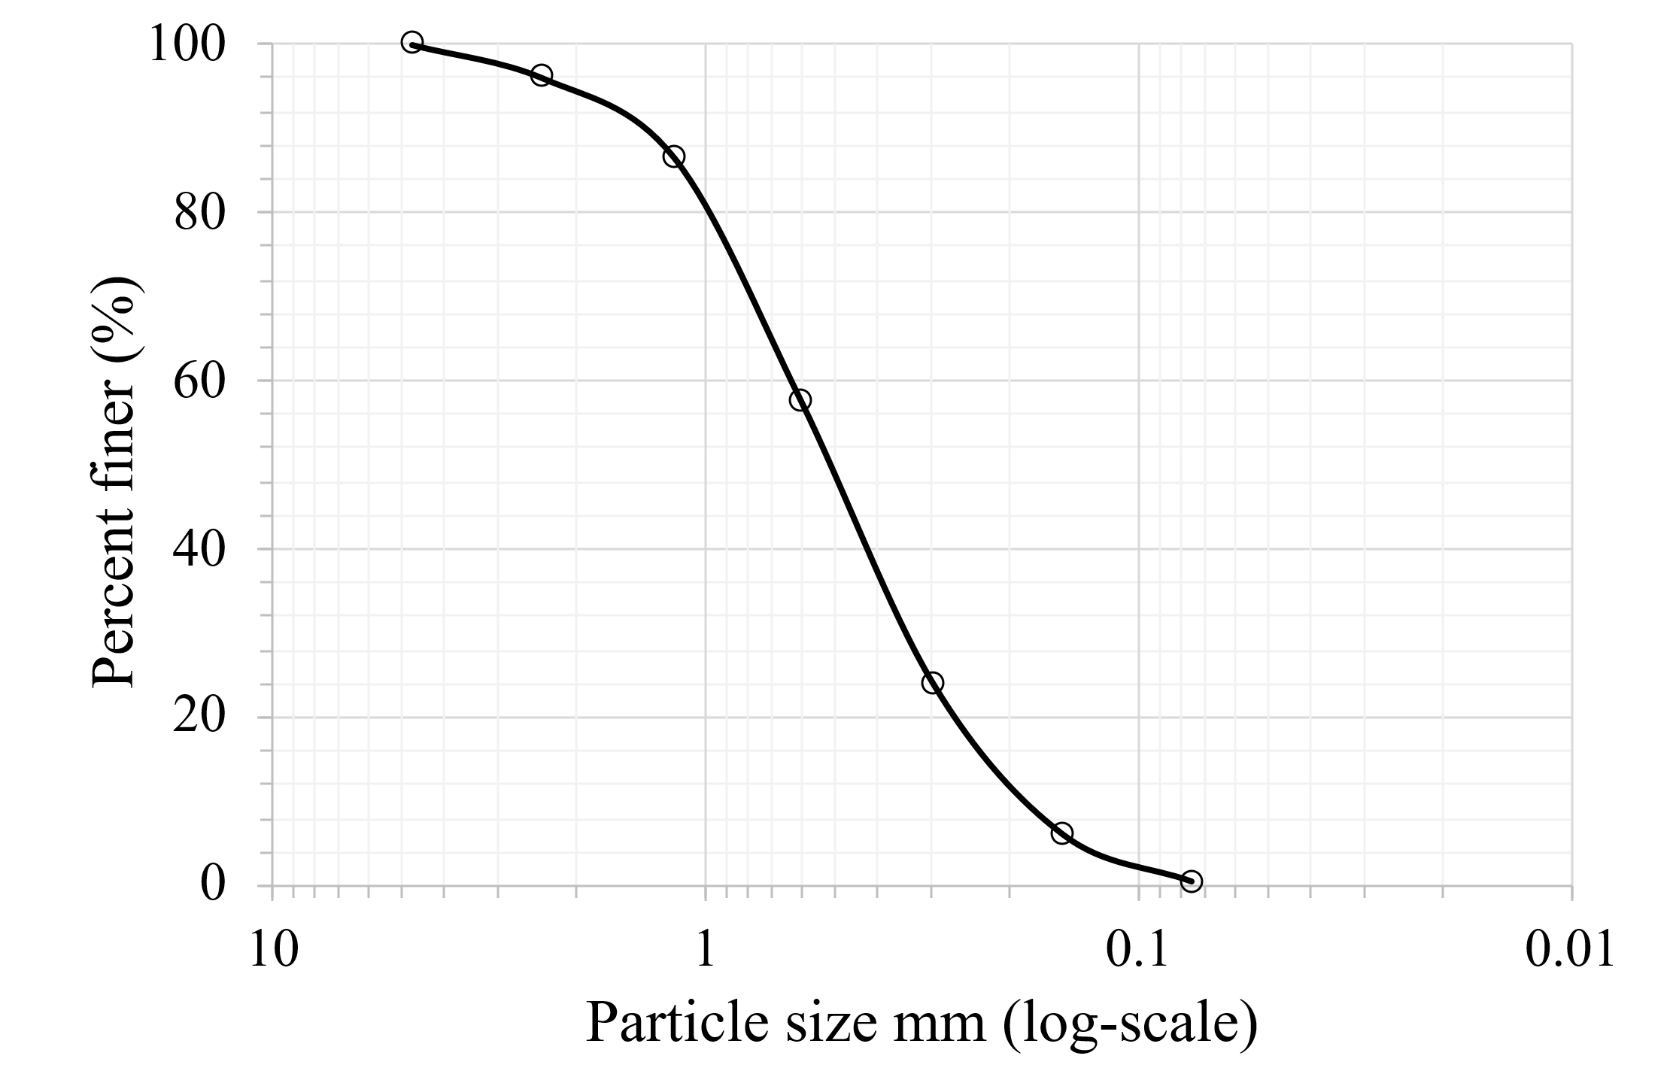
Figure 3-1. Sample particle size distribution curve
The values of D₁₀, D₃₀, and D₆₀, which are the diameters that correspond to the percent finer of 10%, 30%, and 60%, respectively can be determined from the grain-size distribution curve. The values of the uniformity coefficient C_{u} and the coefficient of gradation C_{c} can be calculated using the following equations:
$$C_{u}≡\frac{D_{60}}{D_{10}}$$
$$C_{c}≡\frac{D_{30}^{2}}{D_{60}{×D}_{10}}$$

Important Numbers
- Well-Graded Soil: Soil is considered well-graded when it includes a wide range of particle sizes, and the smaller particles efficiently fill the voids between larger ones. For sand, a well-graded classification is achieved when the coefficient of uniformity (Cu) is greater than 6 and the coefficient of curvature (Cc) falls between 1 and 3.
- Poorly Graded Soil (Uniform Soil): Soil with particles that are nearly the same size is described as poorly graded or uniform. This is typically indicated when the coefficient of uniformity (Cu) is close to 1, suggesting minimal variation in particle size.

Report Guideline
In the lab report, the following contents should be included:
- Objective of the test
- ASTM standard
- Analysis of test results – complete the provided table for sieve analysis and include one sample calculation, plot the particle size distribution curve, discuss the meaning of the results, and interpret the data
- Report source of error
- Summary of the experiment - 1) what experiment was performed, 2) how it was performed, and 3) what the results were.

Lab 4 Hydrometer Analysis

Overview
Soil is a mixture of minerals, organic matter, water, and air of which minerals and organic matter constitute about 50% of the soil by volume. Soil solids are made up of particles of different sizes. Soil texture is defined by relative proportions of sand, silt, and clay. The United States Department of Agriculture (U.S. Salinity Laboratory Staff, 1954) defines sand, silt, and clay as particles with sizes from 2 to 0.05 mm, 0.05 to 0.002 mm, and less than 0.002 mm, respectively. Such small particles cannot be determined using sieve analysis. For this reason, hydrometer analysis for particle size distribution of soil is a widely used method. The hydrometer analysis is a widely used method of obtaining an estimate of the distribution of soil particle sizes from the #200 (0.075 mm) sieve to around 0.001 mm. The data are plotted on a semi-log plot of percent finer versus grain diameters to represent the particle size distribution. Both sieve analysis and hydrometer analysis are required to obtain the complete gradation curve of the coarse and fine fractions of many natural soils.
Soil particle size is determined using Stoke’s law which predicts the velocity of free-falling spherical soil particles in water based on particle size. The larger the particle size, the faster the settling velocity. The viscosity of water affects particle settling velocity and is itself affected by temperature. Therefore, a correction is necessary for temperatures deviating from a standard temperature of 20 ºC.

Learning Objective
To determine the particle size distribution of fine-grained soil (smaller than 0.075 mm diameter grains), using a hydrometer.

Tools and Materials
- Glass cylinders, 1000-ml capacity
- ASTM 152-H hydrometer
- Thermometer
- Dispersing agent [sodium hexametaphosphate (NaPO3) or sodium silicate (NaSiO3)]
- Stop clock
- Balance. The balance should have a readability of 0.01 g for specimens having a mass of 200 g or less.
- Mixer
- Container handling apparatus.

Reference Standard
ASTM D7928-21e1 - Standard Test Method for Particle-Size Distribution (Gradation) of Fine-Grained Soils Using the Sedimentation (Hydrometer) Analysis

Step-by-Step Guide
The test procedure follows the steps of ASTM D7928-21e1 Test Method. The procedure for hydrometer analysis is as follows:
- Start by placing 50 g of fine soil in a beaker and then add 125 mL of the dispersing agent (sodium hexametaphosphate [40 g/L] solution). Stir the mixture until the soil is thoroughly wet. Let the soil soak for at least ten minutes.
- While the soil is soaking, add 125 mL of the dispersing agent in a cylinder and fill it to the mark with distilled water. (The reading at the top of the meniscus formed by the hydrometer stem and the solution is called the zero connection.) Record a reading less than zero as a negative (-) correction and a reading between zero and sixty as a positive (+) correction. The meniscus correction is the difference between the top of the meniscus and the level of the solution in the jar (usually about +1). Shake this cylinder to mix the contents thoroughly. Insert the hydrometer and thermometer into the cylinder and note the zero correction and temperature, respectively.
- Transfer the soil slurry to a mixer by adding more distilled water, if necessary, until the mixing cup is at least half full. Then mix the solution for two minutes.
- Immediately transfer the soil slurry into the empty cylinder and add distilled water up to the mark.
- Cover the open end of the cylinder with a stopper and secure it with the palm of your hand. Alternate turning the cylinder upside down and back upright for one minute, inverting it approximately 30 times.
- Set the cylinder down and record the time. Remove the stopper from the cylinder, and very slowly and carefully insert the hydrometer for the first reading. (Note: It should take about seconds to insert or remove the hydrometer to minimize any disturbance, and the release of the hydrometer should be made as close to the reading depth as possible to avoid excessive bobbing.)
- Take the reading by observing the top of the meniscus that was formed by the suspension and the hydrometer stem. Remove the hydrometer slowly and place it back into the first cylinder. Very gently spin it in the first cylinder to remove any particles that may have adhered to it.
- Take hydrometer readings at 15 sec, 30 sec, 1 min, 2 min, 4 min, 8 min, 15 min, 30 min, 1 hr., 2hrs., 4 hrs., 8 hrs., 16 hrs., 24 hrs., and 48 hrs. These are approximate times that will usually give a satisfactory plot spread. Record the temperature of the soil-water suspension to the nearest 0.5°C for each hydrometer reading.
For calculations, follow the following steps:
- Apply the meniscus correction $F_{m}$ to the actual hydrometer reading R.
- Obtain the effective hydrometer depth (L in cm) for the corrected meniscus reading.
$$R_{cl}=R+F_{m}$$
- Obtain the value of K if the G_{s} of the soil is known. If it is not known, assume that it is 2.7 for this purpose.
- Calculate the equivalent particle diameter by using the following formula:
$$D=K×\sqrt{\frac{L}{t}}$$
Where t is given in minutes, and D is given in mm
- Determine the temperature correction F_{T}.
- Determine correction factor “a” using G_{s}.
- Calculate the corrected hydrometer reading as follows:
$$R_{cp}=R-F_{z}+F_{T}$$

- Calculate the percent finer as follows:
$$P=\frac{R_{cp}×a}{50}×100$$

- Adjust the percent fines as follows:

$$P_{A}=\frac{P×F_{200}}{100}$$

Where F₂₀₀ = % finer of #200 sieve as a percent

- Plot the grain size curve D versus the adjusted percent finer on the semilogarithmic sheet.

Sample Data and Calculations
Hydrometer Number =152H
- Specific Gravity of Soil =2.7
- % Finer of #200 sieve as a percent, F₂₀₀= 43.9%
- Dispersing Agent = Sodium Hexametaphosphate
- Weight of Soil Sample =50.0 g
- Zero Correction = +4
- Meniscus Correction = +1

Table 4-1. Sample data for hydrometer analysis
Time (min) | Hydrometer reading | Temp (ºC)
1 | 30 | 26
2 | 28 | 26
4 | 26 | 26
8 | 24 | 26
15 | 22 | 26
30 | 20 | 26
60 | 18 | 25
120 | 16 | 25
1440 | 13 | 25

Table 4-2. Values of effective depth based on hydrometer and sedimentation cylinder of specific sizes 152H
Corrected Hydrometer Reading | Effective Depth, L (cm) | Corrected Hydrometer Reading | Effective Depth, L (cm)
0 | 16.3 | 31 | 11.2
1 | 16.1 | 32 | 11.1
2 | 16.0 | 33 | 10.9
3 | 15.8 | 34 | 10.7
4 | 15.6 | 35 | 10.6
5 | 15.5 | 36 | 10.4
6 | 15.3 | 37 | 10.2
7 | 15.2 | 38 | 10.1
8 | 15.0 | 39 | 9.9
9 | 14.8 | 40 | 9.7
10 | 14.7 | 41 | 9.6
11 | 14.5 | 42 | 9.4
12 | 14.3 | 43 | 9.2
13 | 14.2 | 44 | 9.1
14 | 14.0 | 45 | 8.9
15 | 13.8 | 46 | 8.8
16 | 13.7 | 47 | 8.6
17 | 13.5 | 48 | 8.4
18 | 13.3 | 49 | 8.3
19 | 13.2 | 50 | 8.1
20 | 13.0 | 51 | 7.9
21 | 12.9 | 52 | 7.8
22 | 12.7 | 53 | 7.6
23 | 12.5 | 54 | 7.4
24 | 12.4 | 55 | 7.3
25 | 12.2 | 56 | 7.1
26 | 12.0 | 57 | 7.0
27 | 11.9 | 58 | 6.8
28 | 11.7 | 59 | 6.6
29 | 11.5 | 60 | 6.5
30 | 11.4

Table 4-3. Values of k for computing diameter of particle in hydrometer analysis
Temperature | Specific Gravity of Soil Particles
 | 2.45 | 2.5 | 2.55 | 2.6 | 2.65 | 2.7 | 2.75 | 2.8 | 2.85
16 | 0.0151 | 0.01505 | 0.01481 | 0.01457 | 0.01435 | 0.01414 | 0.01394 | 0.01374 | 0.01356
17 | 0.01511 | 0.01486 | 0.01462 | 0.01439 | 0.01417 | 0.01396 | 0.01376 | 0.01356 | 0.01338
18 | 0.01492 | 0.01467 | 0.01443 | 0.01421 | 0.01399 | 0.01378 | 0.01359 | 0.01339 | 0.01321
19 | 0.01474 | 0.01449 | 0.01425 | 0.01403 | 0.01382 | 0.01361 | 0.01342 | 0.01323 | 0.01305
20 | 0.01456 | 0.01431 | 0.01408 | 0.01386 | 0.01365 | 0.01344 | 0.01325 | 0.01307 | 0.01289
21 | 0.01438 | 0.01414 | 0.01391 | 0.01369 | 0.01348 | 0.01328 | 0.01309 | 0.01291 | 0.01273
22 | 0.01421 | 0.01397 | 0.01374 | 0.01353 | 0.01332 | 0.01312 | 0.01294 | 0.01276 | 0.01258
23 | 0.01404 | 0.01381 | 0.01358 | 0.01337 | 0.01317 | 0.01297 | 0.01279 | 0.01261 | 0.01243
24 | 0.01388 | 0.01365 | 0.01342 | 0.01321 | 0.01301 | 0.01282 | 0.01264 | 0.01246 | 0.01229
25 | 0.01372 | 0.01349 | 0.01327 | 0.01306 | 0.01286 | 0.01267 | 0.01249 | 0.01232 | 0.01215
26 | 0.01357 | 0.01334 | 0.01312 | 0.01291 | 0.01272 | 0.01253 | 0.01235 | 0.01218 | 0.01201
27 | 0.01342 | 0.01319 | 0.01297 | 0.01277 | 0.01258 | 0.01239 | 0.01221 | 0.01204 | 0.01188
28 | 0.01327 | 0.01304 | 0.01283 | 0.01264 | 0.01244 | 0.01255 | 0.01208 | 0.01191 | 0.01175
29 | 0.01312 | 0.01290 | 0.01269 | 0.01249 | 0.01230 | 0.01212 | 0.01195 | 0.01178 | 0.01162
30 | 0.01298 | 0.01276 | 0.01256 | 0.01236 | 0.01217 | 0.01199 | 0.01182 | 0.01165 | 0.01149

Table 4-4. Temperature correction factors, CT
Temperature (C) | Factor (CT)
15 | 1.10
16 | -0.90
17 | -0.70
18 | -0.50
19 | -0.30
20 | 0.00
21 | 0.20
22 | 0.40
23 | 0.70
24 | 1.00
25 | 1.30
26 | 1.65
27 | 2.00
28 | 2.50
29 | 3.05
30 | 3.80

Table 4-5. Correction factors a for unit weight of solids
Unit Weight of Soil Solids, g/cm³ | Correction Factor, a
2.85 | 0.96
2.8 | 0.97
2.75 | 0.98
2.7 | 0.99
2.65 | 1.00
2.6 | 1.01
2.55 | 1.02
2.5 | 1.04

Sample calculation

Time 2 minutes
R_{cl} = R + F_{m} = 28 + 1 = 29
From Table 4-1, effective length L is 11.5 cm.
K = 0.01253 from Table 4-2
Equivalent particle size
$$D=K×\sqrt{\frac{L}{t}}=0.01253×\sqrt{\frac{11.5}{2}}=0.03mm$$
$$R_{cp}=R-F_{z}+F_{T}=28-4+1.65=25.65$$

$$P=\frac{R_{cp}×a}{50}×100=\frac{25.65×0.99}{50}×100=50.79 \\ P_{A}=\frac{P×F_{200}}{100}=\frac{50.79×0.439}{100}=22.30\%$$

Important Numbers
Hydrometer analysis is used to determine the particle size distribution of fine-grained soils, particularly those smaller than 0.075 mm. From the test results, the percentage of particles finer than 0.002 mm in diameter is often used as an estimate of the clay-size fraction. Although most true clay minerals have particle sizes smaller than 0.001 mm, the 0.002 mm threshold is commonly adopted as the upper boundary for classifying particles as clay-sized in geotechnical engineering. The amount of clay in a soil significantly influences its plasticity, compressibility, and overall behavior, especially under changes in moisture content.

Report Guideline
In the lab report, the following contents should be included:
- Objective of the test
- ASTM standard
- Analysis of test results – complete the provided table for hydrometer analysis and include one sample calculation, discuss the meaning of the results, and interpret the data
- Report source of error
- Summary of the experiment - 1) what experiment was performed, 2) how it was performed, and 3) what the results were.

Lab 5 Atterberg Limit

Overview
The Atterberg limits are a fundamental measure of the critical water content of fine-grained soils, particularly clays and silts. These limits, named after the Swedish chemist Albert Atterberg, are used to categorize soils and predict their behavior under various moisture levels. The three main Atterberg limits are the liquid limit (LL), the plastic limit (PL), and the shrinkage limit (SL). The Atterberg limits are critical for classifying soils and understanding their behavior under different moisture conditions.
The Atterberg limits often refer to the liquid limit and plastic limit of soil. The Plasticity Index is calculated as the difference between the Liquid Limit and the Plastic Limit. It represents the range of water content at which the soil retains plasticity.
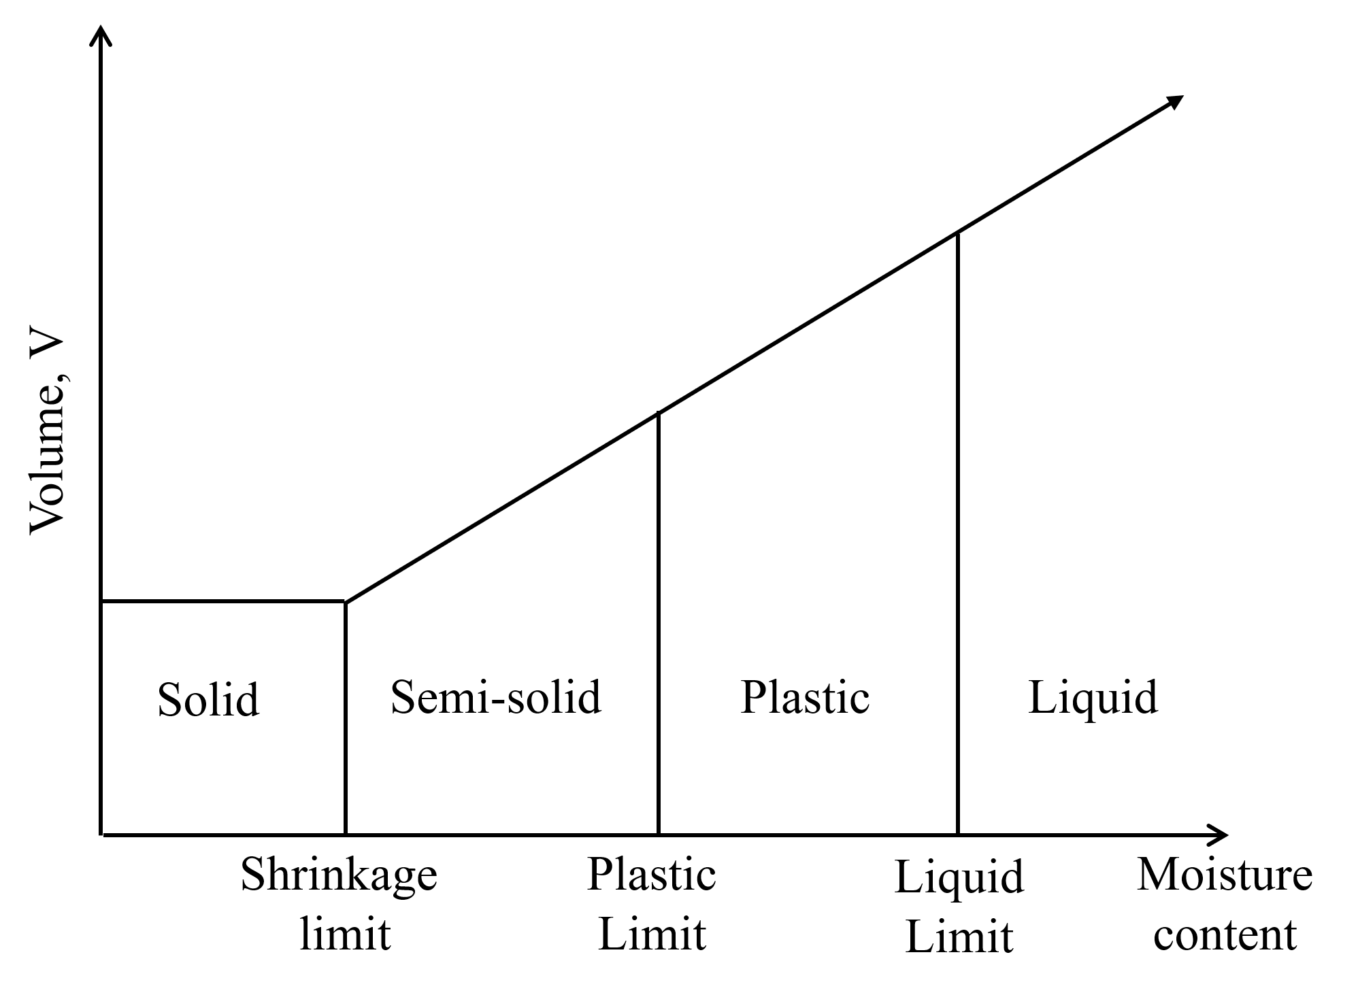
Figure 5-1. Consistency of fine-grained soils at different moisture contents

Learning Objective
To determine the liquid limit (LL), plastic limit (PL), and plasticity index (PI) of the portion of the soil that passes the No. 40 sieve.

Tools and Materials
- Balance (readability of 0.01 g)
- Liquid limit device (see Figure 2)
- Grooving tool
- Mixing and storage container
- Water content container
- Spatula
- Oven
- Ground glass plate

Reference Standards
ASTM D4318 Standard Test Methods for Liquid Limit, Plastic Limit, and Plasticity Index of Soils.

Step-by-Step Guide
Plastic Limit Test
- Put about 30 grams of air-dried soil sample through a US No. 40 sieve into a porcelain evaporating dish, then add water and thoroughly mix.
- Take the soil that is the size of small marbles from the moist soil prepared in step 1 and roll it on a glass plate with the palm of your hand at about 80 strokes per minute.
- Roll the soil until the tread reaches 1/8 in. in diameter. If the soil crumbles when a thread is about 1/8 inch in diameter, collect the crumbled sample and weigh it in a moisture can determine the water content.

Liquid Limit Test
- Place approximately 250 grams of air-dried soil sample in a porcelain evaporating dish, add water, and mix thoroughly.
- Using a spatula, place a portion of the prepared soil in the liquid limit device's brass cup.
- Smooth the soil surface in the cup to a maximum depth of about 8 mm.
- Use the groove tool to cut a groove down the center of the soil.
- Turn the device's crank at a rate of approximately 2 revolutions per second.
- The soil on the groove's two sides will start to flow toward the center. Count the number of revolutions needed for the grove in the soil to close by ½ inch.
- Take a soil sample from the cup to determine the water content.
- A minimum of three trials shall be conducted, each trial producing specific blow counts: one requiring between 25 and 35 blows, another between 20 and 30 blows, and a third between 15 and 25 blows.

Sample Data and Calculations
Table 5-1. Sample data for Atterberg limit test
Test | Plastic Limit (PL) |  |  | Liquid Limit (LL)
Trial Number | 1 | 2 | 3 | 1 | 2 | 3
Container ID | G1 | G2 | G3 | G4 | G5 | G6
Mass of container (M_{c}), gram | 7.1 | 7.3 | 11.1 | 7.0 | 11.3 | 11.1
Mass of moist soil + container (M₁), gram | 23.0 | 22.5 | 23.1 | 31.6 | 28.5 | 30.1
Mass of dry soil + container (M₂), gram | 19.6 | 19.2 | 20.4 | 24.6 | 22.7 | 25.1
Mass of moisture (M_{w}), gram | 3.4 | 3.3 | 2.7 | 7.2 | 5.8 | 5.0
Mass of dry soil (M_{s}), gram | 12.5 | 11.9 | 9.3 | 17.6 | 11.4 | 14
Moisture Content (w), % | 27.20 | 27.73 | 29.03 | 40.91 | 50.88 | 35.71
Number of Cranks |  |  |  | 23 | 17 | 30
Plastic Limit (PL) | 28 %
Liquid Limit (LL) |  |  |  | 40%
Plasticity Index (PI) | 40-28 = 12
Shrinkage Limit (SL) | 23

Sample calculation
- Plastic limit
For Plastic Limit test trial 1.
- Mass of container (Mc): 7.1 gram
- Mass of moist soil + container (M₁): 23.0 gram
- Mass of dry soil + container (M₂): 19.6 gram
$$Water content=\frac{M_{1}-M_{2}}{M_{2}-M_{c}} × 100\%= \frac{23-19.6}{19.6-7.1} × 100\%=27.2\%$$
The plastic limit is the average moisture content of the three trials.
- Liquid limit
The liquid limit of the soil sample can be determined from the flow curve, which is created by plotting the moisture content against the corresponding number of blows on semi-logarithmic graph paper. The liquid limit of the soil is the moisture content corresponding to 25 blows. An example of a flow curve is shown in Figure 3.
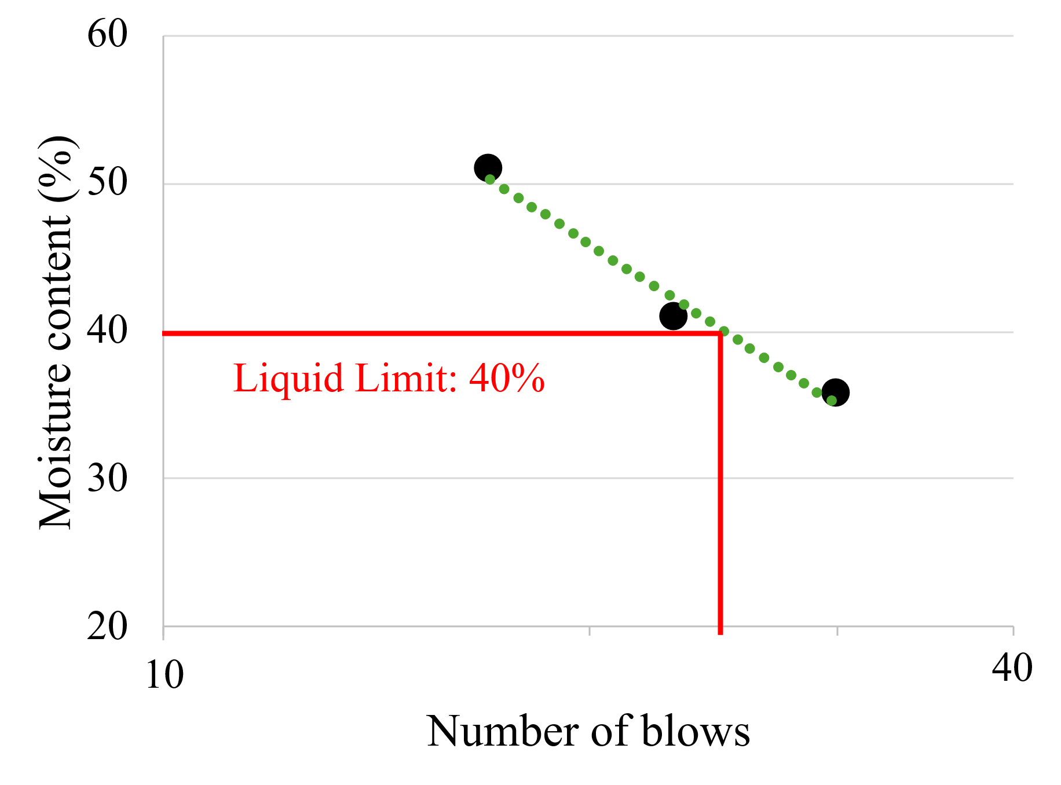
Figure 5-2. Flow curve for Liquid Limit determination

- Shrinkage limit
The shrinkage limit of soil can be approximated using the following equation if the plasticity index and liquid limit are known.
$$SL=46.4\left(\frac{LL+43.5}{PI+46.4}\right)-43.5=46.4\left(\frac{40+43.5}{12+46.4}\right)-43.5= 22.8$$
The plasticity chart shown in Figure 5-3 can also be used to determine the shrinkage limit. First, plot the plasticity index against the liquid limit on the chart. Then, connect points O and A with a straight line. The intersection point C is the shrinkage limit.

Important Numbers
Table 5-2. Typical values of Atterberg limits for some clay minerals
Clay mineral | Liquid Limit | Plastic Limit | Shrinkage Limit
Montmorillonite | 100-900 | 50-100 | 8.5-15
Illite | 60-120 | 35-60 | 15-17
Kaolinite | 35-100 | 20-40 | 25-29

Report Guidelines
Your report should include the following sections:
- Objective of the test
- ASTM standard
- Analysis of test results – complete the provided table for Atterberg limit test and include one sample calculation
- Summary and conclusions – comment on the Atterberg limit values of the given soil sample

Lab 6 Relative Density

Overview
The relative density of cohesionless soil is determined by comparing the solid's void ratio to the void ratios in its densest and loosest states. The relative density of a soil is calculated by dividing the difference between a cohesionless soil's maximum and field void ratios by its maximum and minimum index void ratios. ASTM D4253/4254 provides details on the procedure. Relative density and percentage compaction are commonly used to determine the compactness of a soil mass.
Table 6-1 below shows different state of denseness of cohesionless soil with respect to relative density. The required size (mass) of the test specimen and mold is determined by the maximum particle size in the sample as well as the sample's particle-size distribution. Table 6-2 lists the required mass for the test specimen.
Table 6-1. Consistency of coarse-grained soils at various relative densities
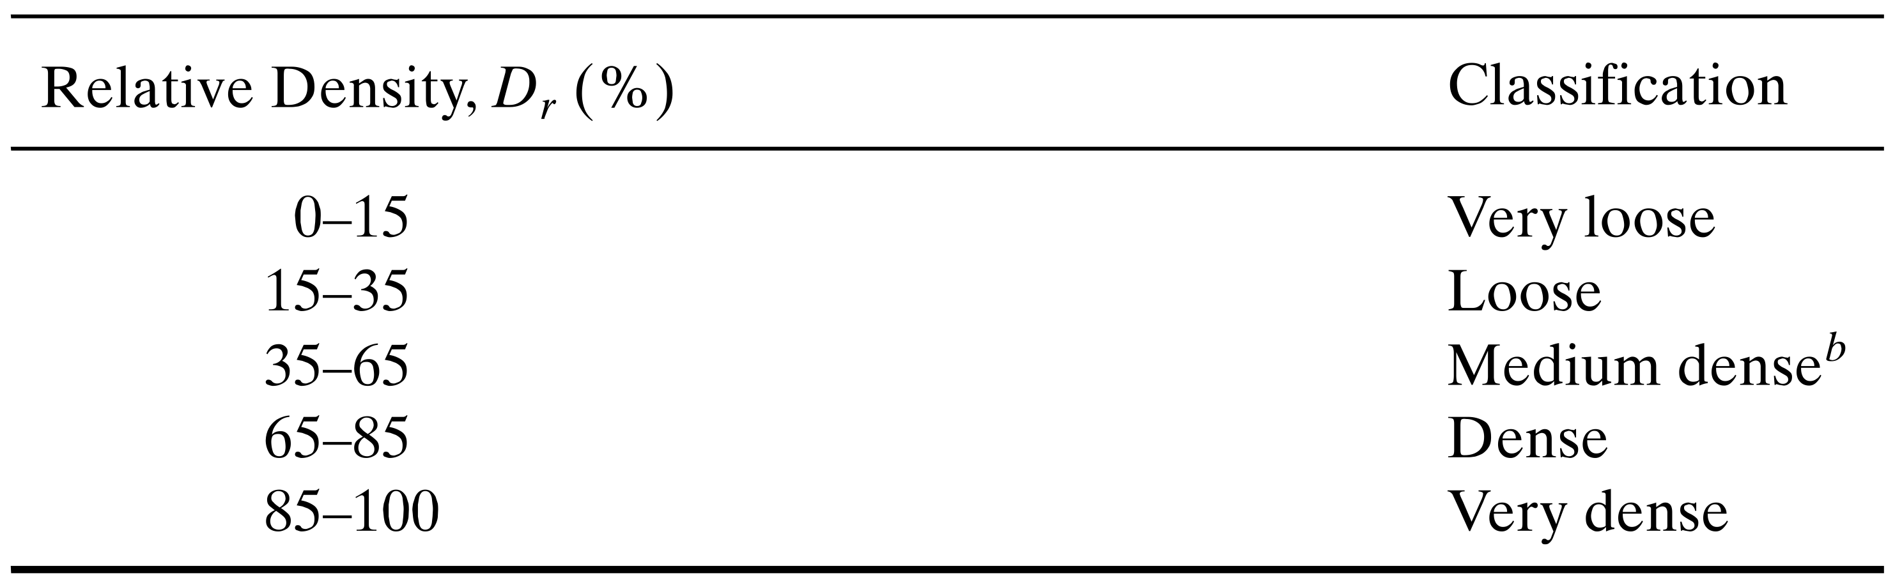
Table 6-2. Required mass of specimen (ASTM D4253)
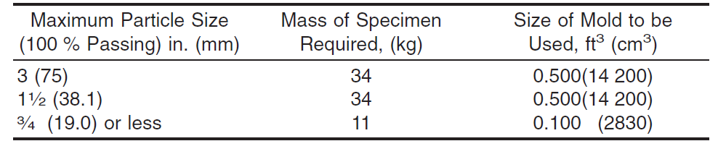

Learning Objective
The purpose of this experiment is to use a vibrating table to determine the relative density of cohesionless, free-draining soil.

Tools and Materials
- Vibrating table
- Mold assembly set consisting of standard mold, guide sleeves, surcharge base-plate, surcharge weights, surcharge base-plate handle, and dial-indicator gage (See Figure 1)
- Balance
- Scoop
- Straightedge

Reference Standards
ASTM D 4254 – Standard Test Methods for Minimum Index Density and Unit Weight of Soils and Calculation of Relative Density.
ASTM D 4253 – Standard Test Methods for Maximum Index Density and Unit Weight of Soils Using a Vibratory Table.

Step-by-Step Guide
- Refer to Table 2 to determine the required size (mass) of the test specimen and mold.
- Mix the oven-dried specimen to ensure an even distribution of particle sizes and as little segregation as possible.
- Fill the mold with soil and use a scoop or funnel to level the surface. To ensure the soil is properly settled, strike the sides of the mold several times using a metal bar, rubber hammer, or a similar tool.
- Place the appropriate surcharge base plate on the soil's surface and twist it a few times to ensure that it is firmly and uniformly in contact with the soil. Remove the handle on the surcharge base plate.
- Secure the mold to the vibrating table.
- Firmly attach the guide sleeve to the mold, then place the appropriate surcharge weight on the surcharge base plate.
- Vibrate the mold assembly and specimen for 8.00 +/- 0.25 minutes at 60 +/- 2 Hz or 10.00 +/- 0.25 minutes at 50 +/- 2 Hz.
- Take the surcharge weight and guide sleeve from the mold.
- Put the indicator gauge holder into each of the guide brackets. Obtain and record dial indicator gauge readings on opposing sides of the surcharge base plate. Brush off any fines that may have accumulated on the surcharge base plate where these readings will be taken.
- Remove the surcharge base plate from the mold, then detach it from the vibratory table. Prevent any fines from accumulating on the surfaces of the surcharge base plate and mold rim.
- Use a balance to measure and record the mass of the mold and soil. To calculate and record the mass of the soil in the mold, subtract the empty mold's mass from the total mass of the mold and soil.
- Determine the maximum index density/unit weight.
- Repeat steps 2-12 until the maximum index density/unit weight is consistent (within 2%).

Sample Data and Calculations
Table 6-3. Sample data for relative density test
Soil type | Silty sand
Specific gravity of soil, Gs | 2.68
Volume of mold, V_{m} | 2830 cm³
Internal diameter of the mold, d | 152.4 mm
Internal height of the mold, H | 155.14 mm
Thickness of surcharge base plate, t_{b} | 3.1 mm
Mass of mold, M_{m} | 9.236 kg
Minimum density
Mass of mold and soil (M₁) | 13.63 kg
Minimum density, ρ_{d-min} = (M₁ - M_{m}) / V_{m} | 1552.65 kg/m³
Maximum void ratio, e_{max} = (Gs x ρ_{w})/ ρ_{d-min} -1 | 0.726
Maximum density
Mass of mold and soil (M₃) | 13.87 kg
Average initial dial reading, r_{i} | 24 mm
Average final dial reading, r_{f} | 11 mm
New volume of soil, V_{soil-new} = New height of soil x internal area of mold  New height of soil = Internal height of mold – settlement  Settlement = (r_{i} – r_{f}) + t_{b} | 2536.29 cm³
Maximum density, ρ_{d-max} = (M₃-M_{mold}) / V_{soil-new} | 1827.08 kg/m³
Minimum void ratio, e_{min} = (Gs x γ_{w})/ ρ_{d-max} -1 | 0.467

Sample calculation
Minimum density and maximum void ratio
Density = Mass of soil / Volume of soil
- Volume of soil = Volume of the mold, V_{m} : 2830 cm³
- Mass of soil = Mass of mold and soil, M₁ - Mass of mold, M_{m} = 13.63 kg - 9.236 kg = 4.394 kg
- Minimum density, ρ_{d-min} = 4.394 kg / 2830 cm³ = 0.00155265 kg/cm³ = 1552.65 kg/m³
- Maximum void ratio, e_{max} = (Gs x ρ_{w})/ ρ_{d-min} -1 = 2.68 x 1000 kg/cm³ / 1552.65 kg/cm³ – 1 = 0.726

Maximum density and minimum void ratio
- New volume of soil, V_{soil-new} = New height of soil x internal area of mold
New height of soil = Internal height of mold – settlement
Settlement = (r_{i} – r_{f}) + t_{b}
New height of soil = 155.14 mm – [ (24 mm – 11 mm) + 3.1 mm] = 139.04 mm = 13.904 cm
$$Internal area of mold = \frac{π}{4} ×{Diameter}^{2}=\frac{π}{4} ×{15.24}^{2} = 182.41 {cm}^{2}$$
New volume of soil, V_{soil-new} = 2536.29 cm³
- Mass of soil = Mass of mold and soil, M₃ - Mass of mold, M_{m} = 13.87kg - 9.236 kg = 4.634 kg
- Maximum density, ρ_{d-max} = 4.634 kg / 2536.29 cm³ = 1827.08 kg/m³
- Minimum void ratio, e_{min} = (Gs x ρ_{w})/ ρ_{d-maz} -1 = 2.68 x 1000 / 1827.08 – 1 = 0.467

Report Guidelines
Your report should include the following sections:
- Objective of the test
- ASTM standard
- Analysis of test results – complete the provided table and include one sample calculation
- Report source of error
- Summary and conclusions – compare maximum and minimum void ratio obtained from this experiment to the void ratio obtained with Miura’s equation.
- Miura et al. (1997) established a relationship between the maximum and minimum void ratios of clean sand below.

$$e_{max}≈1.62 e_{min}$$

Lab 7 Sand Cone

Overview
The field density, or in-situ density test, is an important quality control test for soil compaction. The material's in-situ density is determined using a nuclear density gauge or the sand cone test. The sand cone test is a long-standing method for measuring soil density in-place. The procedure is outlined in ASTM D1556. The sand cone test uses test hole volumes of about 0.1 ft³ to calculate the in-place density of soils with a maximum particle size of up to 2-inches. This test method is typically only used on unsaturated soil. This test method is also not suitable for soils that are soft or easily crumbled.
The advantages and disadvantages of the sand cone test are summarized in Table 7-1.
Table 7-1. Advantages and disadvantages of the sand cone test
Advantages | Disadvantages
- Accurate and reliable; a long history of accepted use  - ASTM standard test method  - Does not require extensive training  - No licensing or permitting required for use  - Equipment and materials are not hazardous | - Tests may take 30 minutes or more to complete  - Heavy equipment in the area may need to pause operation briefly  - Should not be used to test saturated, highly plastic soils  - All excavated material must be carefully recovered

The test hole volume should be determined based on the expected maximum particle size in the soil and the depth of the compacted layer. To minimize errors, ensure that test hole volumes are as large as possible and not smaller than those specified in Table 7-2.
Table 7-2. Minimum test hole volumes (ASTM D1556)
Maximum particle size |  | Minimum test hole volumes
in. | mm | cm³ | ft³
½ | 12.7 | 1415 | 0.05
1 | 25.4 | 2125 | 0.075
1 1/2 | 38 | 2830 | 0.1

Learning Objective
The goal of this experiment is to use the sand cone test to determine soil density in the field.

Tools and Materials
- Sand cone density apparatus including sand container, sand cone, and base plate.
- Excavation tool such as shovel
- Standard proctor mold
- Balance

Reference Standards
ASTM D1556 - Standard Test Method for Density and Unit Weight of Soil in Place by Sand-Cone Method

Step-by-Step Guide
Sand cone apparatus calibration
- Measure the weight of the Proctor mold and base.
- Pour the sand into the compaction mold and level the surface, taking care not to disturb the mold, as this may cause the sand to rearrange and become compact. Measure the weight of the Proctor mold, base, and sand.
- Fill the apparatus with dried and conditioned sand to match the state expected during testing.
- Determine and record the mass of the sand-filled apparatus.
- Place the base plate on a clean, level, and flat surface.
- Invert the container/apparatus and insert the funnel into the flanged center hole on the base plate.
- Open the valve fully until the sand flow stops, ensuring not to vibrate the apparatus, base plate, or surface before closing the valve.
- Close the valve sharply, remove the apparatus, and determine the mass of the apparatus and the remaining sand.
- Calculate the mass of sand used to fill the funnel and base plate by subtracting the final mass from the initial mass.
- Repeat the process at least three times.
Field density test
- Make sure the surface of the test location is level. The base plate can be used as a tool to level the surface and, if necessary, secure it against movement with nails pushed into the soil near the plate's edge.
- Dig the test hole through the center hole of the base plate, being careful not to disturb or deform the soil that will surround the hole. The sides of the hole should slope slightly inward, while the bottom should be reasonably flat or concave.
- Place all excavated soil, as well as any soil that became loosened during the digging process, in a moisture-tight container.
- Clean the flange of the base plate hole, then invert the sand-cone apparatus, open the valve, and let the sand fill the hole, funnel, and base plate.
- When the sand has stopped flowing, close the valve.
- Determine the mass of the apparatus with the remaining sand, record it, and calculate the amount of sand used.
- Determine and record the mass of moist soil removed from the test hole.
- Mix the material thoroughly, then obtain a representative specimen to determine the water content.

Sample Data and Calculations
Table 7-3. Sample data for sand cone test
Unit weight of sand
Weight of proctor mold, W_{l} | 9.35 lb
Weight of proctor mold + sand, W₂ | 12.34 lb
Volume of mold, V_{l} | 0.033 ft³
Unit weight of the sand, γ_{d-sand} = (W₂ - W_{l}) / V₁ | 90.6 lb/ft³
Sand cone apparatus calibration
Weight of sand filled apparatus (before use), W₃ – Step 4 | 10.53 lb
Weight of apparatus (after use), W₄ – Step 8 | 7.35 lb
Weight of sand to fill cone, WC = W₃ – W₄ | 3.18 lb
Results from field test
Weight of sand filled apparatus (before use), W₅ | 10.53 lb
Weight of apparatus (after use), W₆ – Step 16 | 4.81 lb
Volume of hole, V₂ = (W₅ - W₆ - WC)/ γ_{d-sand} | 0.028 ft³
Weight of container, W₇ | 0.5 lb
Weight of container and moist soil, W₈ – Step 13 | 3.30 lb
Moist unit weight of soil in field, γ = (W₈ – W₇) / V₂ | 100 lb/ft³
Weight of moisture can, W₉ | 0.10 lb
Weight of moisture can and wet soil sample, W₁₀ | 0.35 lb
Weight of moisture can and dry soil sample after 24 hours, W₁₁ | 0.33 lb
Moisture content of soil in field, w = (W₁₀ – W₁₁) / (W₁₁ - W₉) | 8.7 %
Dry unit weight of soil in field, γ_{d-soil} = γ / (1+w/100) | 92.00 lb/ft³

Sample calculation
Unit weight of the sand
Unit weight = weight of soil / volume of soil
- Volume of soil = Volume of the proctor mold: 0.033 ft³
- Weight of soil = Weight of proctor mold filled with sand, W₂ - Weight of mold, W₁ = 12.34 – 9.35 = 2.99 lb
- Unit weight of the sand, γ_{d-sand} = 2.99 / 0.033 = 90.6 lb/ft³
Volume of the hole
- Weight of sand filled in the hole
= Weight of sand cone apparatus before use, W₅ – weight of apparatus after use, W₆ - Weight of sand to fill cone, WC = 2.54 lb
- Volume of the hole = Weight of sand filled in the hole / unit weight of sand = 2.54/90.6 = 0.028 ft³
Unit weight of soil in field
- Weight of soil from hole = Weight of container and moist soil, W₈ – Weight of container, W₇ = 3.3 – 0.5 = 2.8 lb
- Moist unit weight of soil in field = Weight of soil from hole / Volume of the hole = 2.8/0.028 = 100 lb/ft³
- Dry unit weight of soil in field = Moist unit weight / (1+water content) = 100/(1+8.7/100) = 92 lb/ft³

Report Guidelines
Your report should include the following sections:
- Objective of the test
- ASTM standard
- Analysis of test results – complete the provided table and include one sample calculation
- Report source of error
- Summary and conclusions – Comment on the in-situ moisture content and in-situ density of soil obtained from the field

Lab 8 Proctor Compaction

Overview
The Standard Proctor Compaction Test is a widely used laboratory procedure in geotechnical engineering to determine the optimal moisture content at which a soil type will achieve its maximum dry density under a specific compactive effort. This relationship between moisture content and dry density is critical for evaluating the suitability of soil for use in foundations, embankments, and other earthworks. In this test, a known weight of soil is compacted into a cylindrical mold in three equal layers. Each layer is subjected to 25 blows from a standard 5.5-pound hammer dropped from a height of 12 inches, delivering a consistent amount of energy to the soil. The process is repeated for different moisture contents to develop a compaction curve, from which the optimum moisture content (OMC) and maximum dry density (MDD) are determined.
The compaction is achieved using the tamping or impact method, originally developed by R. R. Proctor in 1933, which simulates field compaction conditions in a controlled laboratory setting. A 4-inch diameter mold is typically used, with a volume of approximately 944 cm³. The data obtained from this test informs field compaction specifications and helps ensure adequate strength and stability of soil structures. This lab emphasizes proper sample preparation, accurate measurement techniques, and analysis of compaction behavior for a given soil type.

Learning Objective
To identify the optimum moisture content (OMC) and maximum dry density (MDD) from compaction test data.

Tools and Materials
- Automatic soil compactor
- Compaction mold assembly (4-inch diameter)
- Balance/Scale
- Drying oven
- Moisture cans
- Straightedge
- Sample extruder or jack
- Mixing pans
- Plastic squeeze bottles

Reference Standard
ASTM D698: Standard Test Methods for Laboratory Compaction Characteristics of Soil Using Standard Effort

Step-by-Step Guide
The test procedure follows the steps of ASTM D698 test method.
- Obtain approximately 3 kg of air-dried soil.
- Sieve the soil through a No. 4 (4.75 mm) sieve to remove oversized particles.
- Assemble the 4-inch diameter compaction mold with its base plate and extension collar.
- Weigh and record the mass of the empty mold assembly (without soil).
- Add water to the soil to achieve an initial moisture content of approximately 5%. Mix thoroughly to ensure uniform moisture distribution.
- Fill the mold with the moist soil in three equal layers.
- Use the automatic soil compactor to apply 25 evenly distributed blows to each layer with a 5.5 lb (2.5 kg) hammer dropping from a height of 12 inches (305 mm).
- Remove the collar carefully and trim any excess soil flush with the top of the mold using a straightedge.
- Weigh and record the mass of the mold with the compacted soil.
- Extract a representative sample of the compacted soil. Place the sample in a moisture content container, weigh, and then dry it in an oven at 110 ± 5°C until a constant weight is achieved. Calculate the moisture content based on the weight loss.
- Increase the soil’s moisture content incrementally (e.g., by 2%) and repeat steps 6 to 10 for each increment. Continue this process until the dry density of the compacted soil decreases with increasing moisture content.
- Plot the dry density versus moisture content to create a compaction curve. Identify the peak point on the curve, which represents the Maximum Dry Density (MDD) and the corresponding Optimum Moisture Content (OMC).

Sample Data Sheet and Calculation
Table 8-1. Sample data for proctor compaction test
Compacted soil-sample no. | 1 | 2 | 3 | 4
Ave. moisture content (%) | 8 | 12 | 16 | 18
Wet mass of soil + Mold (g) | 3560 | 3760 | 3910 | 3869
Mold mass (g) | 2450 | 2450 | 2450 | 2450
Wet mass of soil (g) M | 1631 | 1831 | 1981 | 1940
Wet density (g/cm³) $ρ$ | 1.73 | 1.94 | 2.10 | 2.06
Dry density (g/cm³) $ρ_{d}$ | 1.60 | 1.73 | 1.81 | 1.74

Sample calculation
Using trail 1 as an example,
$$ρ=\frac{M}{V}=\frac{1631g}{944{cm}^{3}}=1.73g/cm^{3}$$
$$ρ_{d}=\frac{ρ}{1+w}=\frac{1.73g/cm^{3}}{1+0.08}=1.60g/cm^{3}$$
Zero air void line is the line that shows the relationship between the water content and the dry unit weight of the soil with a 100% degree of saturation. Assume specific gravity of the soil is 2.7.
$ρ_{ZAV}=\frac{G_{s}ρ_{w}}{1+wG_{s}}=\frac{2.7×1g/cm^{3}}{1+0.08×2.7}=2.22g/cm^{3}$
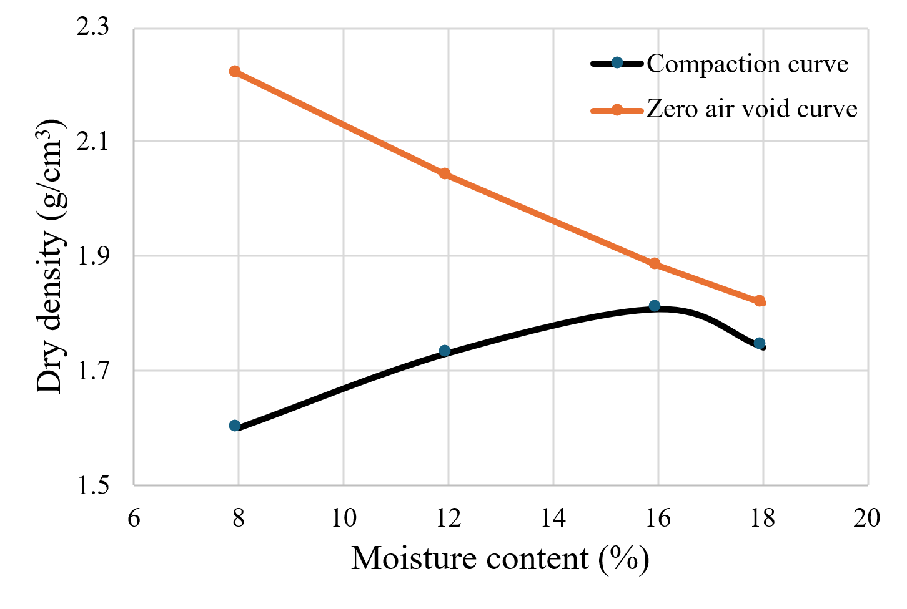
Figure 8-1. Compaction curve and zero air void curve

Important Numbers
In the Standard Proctor Compaction Test, understanding the typical ranges of Maximum Dry Density (MDD) and Optimum Moisture Content (OMC) for various soil types is essential for evaluating compaction efficiency and suitability for construction projects. These values serve as benchmarks to assess whether a soil has been compacted to its optimal state, ensuring structural stability and longevity.
Table 8-2. Typical values for different soil types
Soil Type | MDD (g/cm³) | OMC (%)
Sandy Soils | 1.75–2.10 | 8–12
Silty Soils | 1.60–1.90 | 10–16
Clayey Soils | 1.45–1.75 | 15–25
Gravelly Soils | 2.00–2.30 | 6–10
Note: These values are typical ranges and can vary based on specific soil conditions and compaction efforts.

Report Guidelines
Your report should include the following sections:
- Objective of the test
- ASTM standard
- Analysis of test results – complete the provided table for proctor compaction test and include one sample calculation, discuss the meaning of the results, and interpret the data
- Report source of error.
- Summary and conclusion - 1) what experiment was performed, 2) how it was performed, and 3) what the results were (comment on the soil type).

Lab 9 Constant Head Permeability

Overview
Water moves through soil via interconnected pores, driven by differences in hydraulic energy—from areas of higher energy (or hydraulic head) to areas of lower energy. This flow behavior is a fundamental concept in soil mechanics, as it influences everything from drainage and slope stability to foundation performance and groundwater management. The coefficient of permeability (k) quantifies the ease with which a fluid can pass through a porous soil medium and is a key parameter in evaluating the hydraulic conductivity of soils.
In geotechnical laboratories, permeability is commonly determined using two standardized methods: the constant head test and the falling head test. The constant head test is typically used for coarse-grained, cohesionless soils—such as sands and gravels—where water can flow readily and consistently. In contrast, the falling head test is more suitable for fine-grained, cohesive soils—such as silts and clays—where permeability is lower, and flow rates change over time. Each method provides valuable insight into the soil’s ability to transmit water under different conditions.

Learning Objective
The purpose of this experiment is to determine the permeability of sandy soil using the constant head permeability test.

Tools and Materials
- Balance (readability of 0.01 g)
- Constant head permeameter
- 1000 mL graduated cylinders
- Thermometer
- Filter paper

Reference Standards
ASTM D2434 Standard Test Method for Permeability of Granular Soils (Constant. Head).

Step-by-Step Guide
- Remove the cap from the permeameter and measure the inside diameter of the chamber.
- Place a porous stone on the base of the chamber, then place a filter paper on top of the porous stone.
- Pour the sand into the specimen tube in small layers, then compact it with vibration or other methods to achieve the desired density. Repeat until the sample is 1.5 inches from the top of the upper chamber.
- Level the soil's top surface, then place a filter paper on top, followed by the upper porous stone.
- Place the compression spring on the porous stone, then secure the chamber cap with the clamping knobs.
- Measure the sand sample length.
- Connect the flexible tube from the funnel to the top of the chamber. Allow the water to flow through the specimen. Adjust the water supply to the funnel so that the water level remains constant. Allow the flow to continue for approximately 10 minutes to saturate the specimen.
- Once a steady flow has been established, collect the water that flows out of the constant-head chamber in a graduated cylinder. Record the collection time.
- Repeat Step 8 three times. Maintain the same collection time and measure the volume of discharge each time. Then determine the average volume of the outflow volume.
- Change the head difference and repeat Steps 8 and 9 three times.
- Measure and record the temperature of the water.

Sample Data and Calculations
- Length of soil specimen, L = 13.2 cm
- Diameter of the soil specimen, D = 6.35 cm

Table 9-1. Sample data for constant head permeability test
No. | Constand head, h  cm | Outflow volume, Q  ml | Time, t  sec | Water temperature  ºC | Hydraulic conductivity, k  cm/sec | Coefficient of permeability @ 20ºC, k₂₀  cm/sec
1 | 60 | 305 | 60 | 25 | 0.035 | 0.031
2 | 70 | 375 | 60 | 25 | 0.037 | 0.033
3 | 80 | 385 | 60 | 25 | 0.033 | 0.030
Average |  |  |  |  |  | 0.031

Sample calculation
The coefficient of permeability of the soil can be calculated using the following equation:
$$k=\frac{QL}{Aht}$$
Where Q is the volume of water collected
A is the cross-sectional area of the soil specimen
L is the length of the specimen
t is the time for discharge

For trial 1,
$$k=\frac{QL}{Aht}= \frac{305 {cm}^{3} ×13.2 cm}{\frac{π}{4}{(6.35cm)}^{2}×60 cm×60 sec}= 0.035 cm/sec$$
The viscosity ratio can be used to calculate permeability at standard temperature, k₂₀º_{C}:
$$k_{20oC}= k_{T}\frac{η_{T}}{η_{20oC}}$$
Where η_{T} is the viscosity of water at temperature T ºC.
η_{20oC} is the viscosity of water at standard temperature, 20ºC
Table 9-1 lists variations in viscosity ratio.
Table 9-2. Variation of viscosity ratio, η_{T}/ η_{20oC}
Temperature T (ºC) | η_{T}/ η_{20oC} | Temperature T (ºC) | η_{T}/ η_{20oC}
15 | 1.135 | 23 | 0.931
16 | 1.106 | 24 | 0.910
17 | 1.077 | 25 | 0.889
18 | 1.051 | 26 | 0.869
19 | 1.025 | 27 | 0.850
20 | 1.000 | 28 | 0.832
21 | 0.976 | 29 | 0.814
22 | 0.953 | 30 | 0.797
The coefficient of permeability at 25ºC is 0.035 cm/sec. Therefore, the coefficient of permeability at 20 ºC is
$$k_{20oC}= k_{T}\frac{η_{T}}{η_{20 o_{C}}}= = 0.035×0.889=0.031 cm/sec$$

Important Numbers
Typical values of coefficient of permeability for various soil types are as follows (Das Geotechnical Engineering 10th Ed):
Table 9-3. Coefficient of permeability range for different soil types
Soil type | Coefficient of permeability, k (cm/sec)
Clean gravel | 10² - 10⁰
Coarse sand | 10⁰ – 10⁻²
Fine sand | 10⁻² – 10⁻³
Silty clay | 10⁻³ – 10⁻⁵
Clay | Less than 10⁻⁶

Report Guidelines
Your report should include the following sections:
- Objective of the test
- ASTM standard
- Analysis of test results – complete the provided table for constant head permeability test and include one sample calculation
- Summary and conclusions – comment on the coefficient of permeability value of the given soil sample

Lab 10 Direct Shear

Overview
The shear strength of a soil determines its ability to resist sliding along internal surfaces. This parameter is essential for evaluating the stability of foundations, retaining walls, embankments, and slopes. Shear strength is influenced by both cohesion and internal friction. The Direct Shear Test is a common laboratory method used to determine the shear strength parameters (cohesion c and angle of internal friction φ) of soils under controlled normal stress. This test involves shearing a soil specimen along a pre-defined plane using a shear box while measuring the applied shear and normal loads.

Learning Objective
To determine the shear strength parameters (cohesion and internal friction angle) of a soil sample by conducting a direct shear test under different normal loads.

Tools and Materials
- Shear box apparatus
- Loading frame
- Proving ring (for measuring shear force)
- Dial gauges (for measuring horizontal and vertical displacements)
- Weights for applying normal load
- Soil sample (remolded or undisturbed)
- Balance
- Straight edge
- Vernier caliper
- Spatula
- Water (for moistening soil, if required)

Reference Standard
ASTM D3080 – Standard Test Method for Direct Shear Test of Soils Under Consolidated Drained Conditions

Step-by-Step Guide
The test procedure follows the steps of ASTM D3080 Test Procedure. The steps for direct shear test are as follows:
- Weigh the soil's initial mass in the pan.
- Determine the shear box's height and diameter. 15% of the diameter in millimeters should be calculated.
- Place a porous stone and filter paper inside the shear box after carefully assembling it and placing it in the direct shear apparatus.
- Level off the top of the sand after placing it inside the shear box. On top of the sand, place a top plate (with ball), a porous stone, and filter paper.
- From the shear box, take off the big alignment screws. After opening the space between the shear box halves to about 0.025 inches using the gap screws, back out the gap screws.
- Calculate the quantity of soil by weighing the soil pan again.
- Complete the direct shear device's construction and set the vertical displacement gauge, horizontal displacement gauge, and shear load gauge to zero.
- Close the bleeder valve, set the vertical load (or pressure) to a preset value, and then raise the toggle switch to apply the load to the soil specimen.
- Take readings from the vertical displacement gauge, horizontal displacement gauge, and shear load gauge while the motor is running at the chosen speed to ensure that the shearing rate is consistent. On the data sheet, note the readings. (Note: If necessary, note the vertical displacement gauge readings.)
- Until the horizontal displacement reaches 15% of the diameter or the horizontal shear load peaks and then declines, keep recording readings.
For calculations, follow the following steps:
- Calculate the area of the soil sample (A₀) using the formula:
A₀​ = ​​ ${\frac{\text{π}{\text{d}}_{0}}{\text{4}}}^{\text{2}}$
Where:
d₀ = diameter of the sample
- Convert proving dial readings into force using the calibration factor:
F = (Proving Dial Reading) × (Calibration Factor)

Given:
Calibration Factor = 0.30239 lb/0.0001 in + 0.20636
You can apply this calibration to each proving dial reading to compute the shear force

- Calculate the Shear Stress (τ)
τ = ​ ​ $\frac{F}{A_{0}}$
Where:
F = shear force (lb)
A₀= cross-sectional area of the soil sample (in²)
- Look through the data and identify the maximum shear stress value for each applied normal stress (e.g., 14.3 psi, 28.9 psi, 43.5 psi).
- Plot the peak shear stress values (from step 4) against the corresponding normal stresses.
- From the linear relationship of the Mohr-Coulomb failure criterion, determine Cohesion (c) and Angle of Internal Friction (φ):
τ = c + σtan(ϕ)

- Use the plotted line's y-intercept to determine cohesion (c) and the slope to find tan(φ). Then,
ϕ=tan⁻¹(slope)

- You can draw a best-fit line through the points and solve for c and ϕ.

Sample Data and Calculations
- Height of sample (H₀) =1 in
- Diameter of sample (d₀) = 3.5 in
- Area of sample (A₀) = 9.621 in²
- Volume, (V₀) = 157.66 cm³
- Specific gravity, G_{s} = 2.67
- Calibration factor for proving dial: 0.30239 lb/0.0001 inch +0.20636

Table 10-1. Data sheet for normal stress 14.5 psi
Elapsed time, min | Shear dial, (0.001 in.) | Shear displacement, in. | Proving dial (0.0001 in.) | Shear Force, lb | Shear Stress (psi)
0 | 0 | 0 | 0 | 0 | 0
0.5 | 10 | 0.01 | 80 | 24.40 | 2.54
0.75 | 25 | 0.025 | 105 | 31.96 | 3.32
1 | 45 | 0.045 | 126 | 38.31 | 3.98
1.25 | 53 | 0.053 | 141 | 42.84 | 4.45
1.5 | 76 | 0.076 | 156 | 47.38 | 4.92
1.75 | 89 | 0.089 | 164 | 49.80 | 5.18
2 | 107 | 0.107 | 178 | 54.03 | 5.62
2.5 | 121 | 0.121 | 180 | 54.64 | 5.68
2.75 | 143 | 0.143 | 182 | 55.24 | 5.74
 | 167 | 0.167 | 182 | 55.24 | 5.74
 | 189 | 0.189 | 181 | 54.94 | 5.71
 | 222 | 0.222 | 179 | 54.33 | 5.65

Table 10-2. Data sheet for normal stress 30 psi
Elapsed time, min | Shear dial, (0.001 in.) | Shear displacement, in. | Proving dial (0.0001 in.) | Shear Force, lb | Shear Stress (psi)
0 | 0 | 0 | 0 | 0 | 0
0.5 | 7 | 0.007 | 115 | 34.98 | 3.64
0.75 | 20 | 0.02 | 162 | 49.19 | 5.11
1 | 30 | 0.03 | 201 | 60.99 | 6.34
1.25 | 46 | 0.046 | 224 | 67.94 | 7.06
1.5 | 62 | 0.062 | 257 | 77.92 | 8.10
1.75 | 77 | 0.077 | 279 | 84.57 | 8.79
2 | 93 | 0.093 | 296 | 89.71 | 9.32
2.5 | 108 | 0.108 | 315 | 95.46 | 9.92
2.75 | 124 | 0.124 | 334 | 101.20 | 10.52
 | 148 | 0.148 | 338 | 102.41 | 10.64
 | 169 | 0.169 | 343 | 103.93 | 10.80
 | 187 | 0.187 | 340 | 103.02 | 10.71
 | 207 | 0.207 | 335 | 101.51 | 10.55
 | 227 | 0.227 | 330 | 100.00 | 10.39

Table 10-3. Data sheet for normal stress 45.5 psi
Elapsed time, min | Shear dial, (0.001 in.) | Shear displacement, in. | Proving dial (0.0001 in.) | Shear Force, lb | Shear Stress (psi)
0 | 0 | 0 | 0 | 0 | 0
0.5 | 5 | 0.005 | 121 | 36.80 | 3.82
0.75 | 15 | 0.015 | 197 | 59.78 | 6.21
1 | 26 | 0.026 | 252 | 76.41 | 7.94
1.25 | 40 | 0.04 | 296 | 89.71 | 9.32
1.5 | 55 | 0.055 | 333 | 100.90 | 10.49
1.75 | 66 | 0.066 | 355 | 107.55 | 11.18
2 | 87 | 0.087 | 379 | 114.81 | 11.93
2.5 | 92 | 0.092 | 384 | 116.32 | 12.09
2.75 | 115 | 0.115 | 399 | 120.86 | 12.56
 | 130 | 0.13 | 405 | 122.67 | 12.75
 | 155 | 0.155 | 410 | 124.19 | 12.91
 | 173 | 0.173 | 415 | 125.70 | 13.06
 | 191 | 0.191 | 416 | 126.00 | 13.10
 | 211 | 0.211 | 412 | 124.79 | 12.97
 | 231 | 0.231 | 406 | 122.98 | 12.78

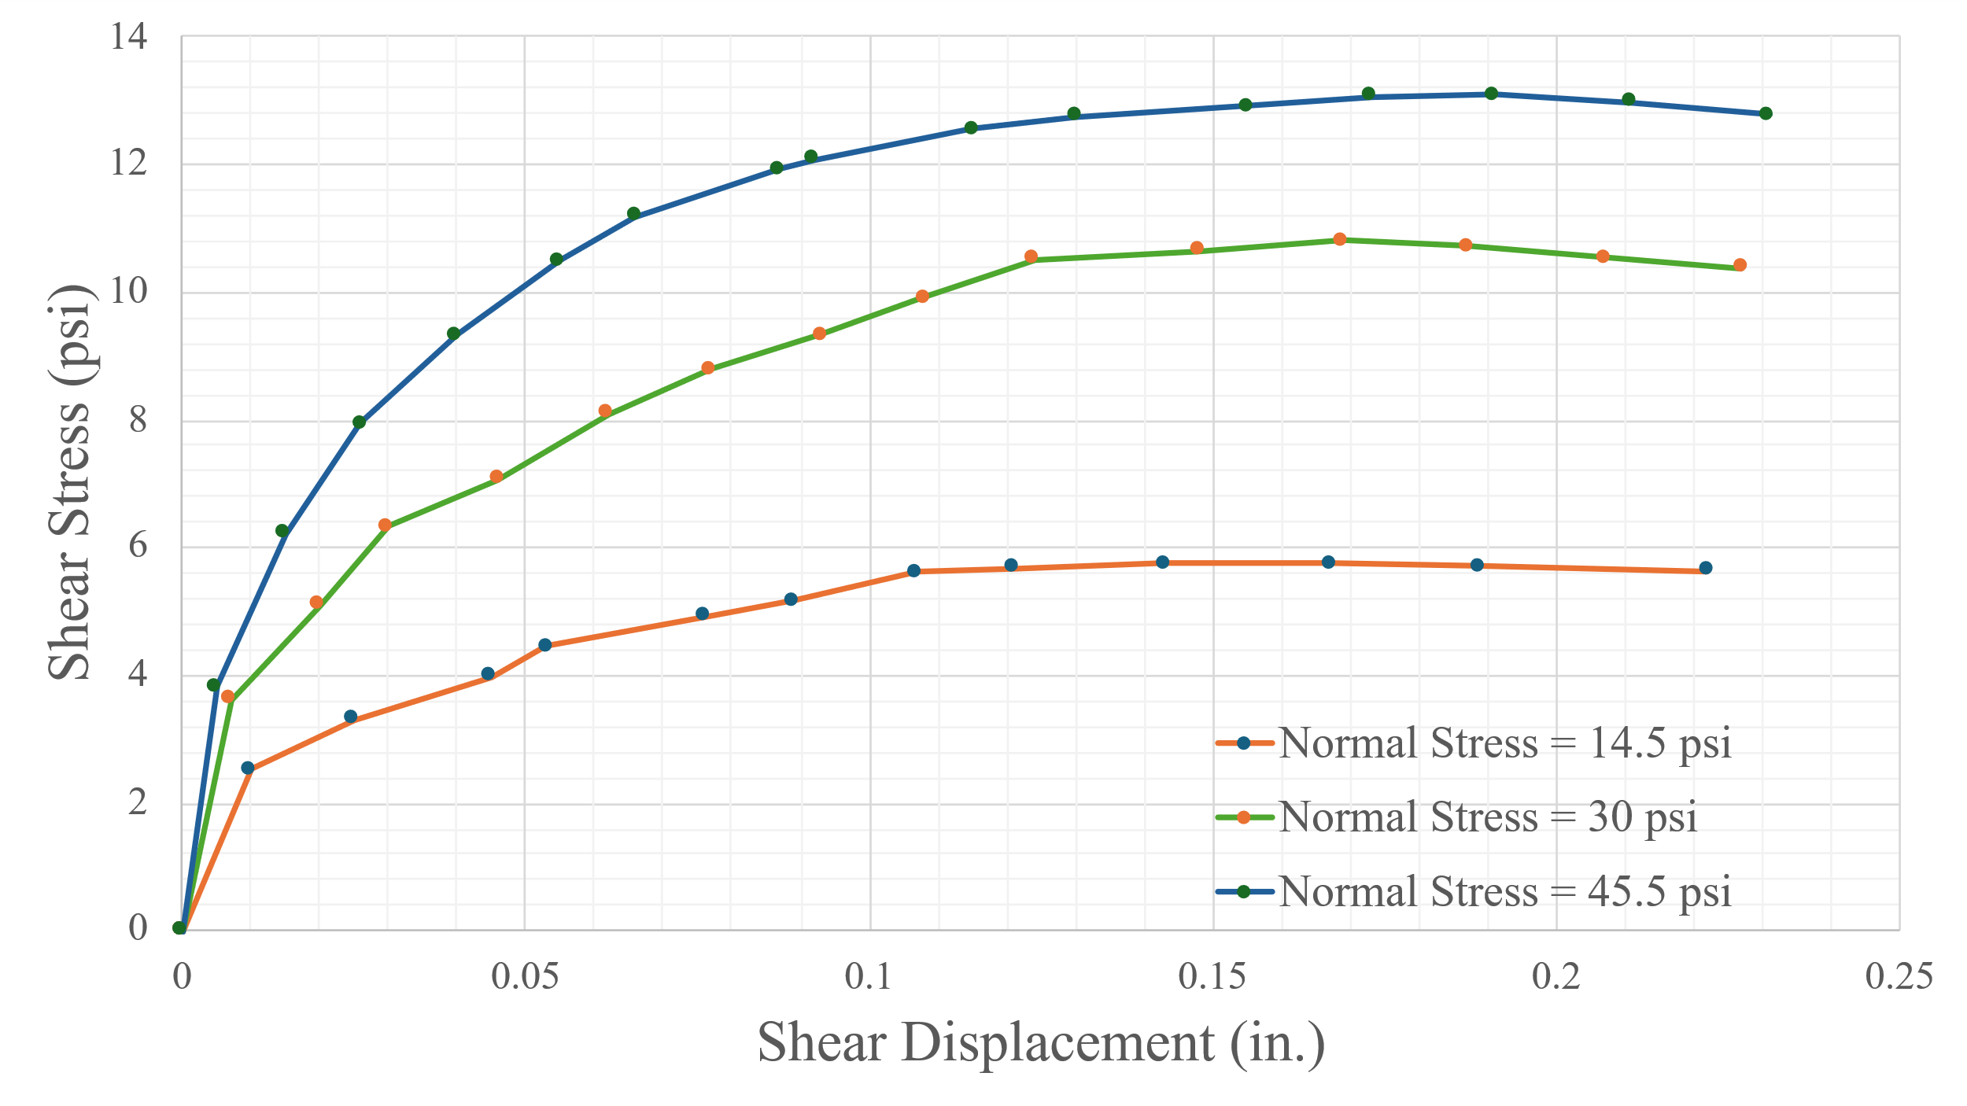
Figure 10-1. Variation of shear stress with displacement for different normal stress conditions
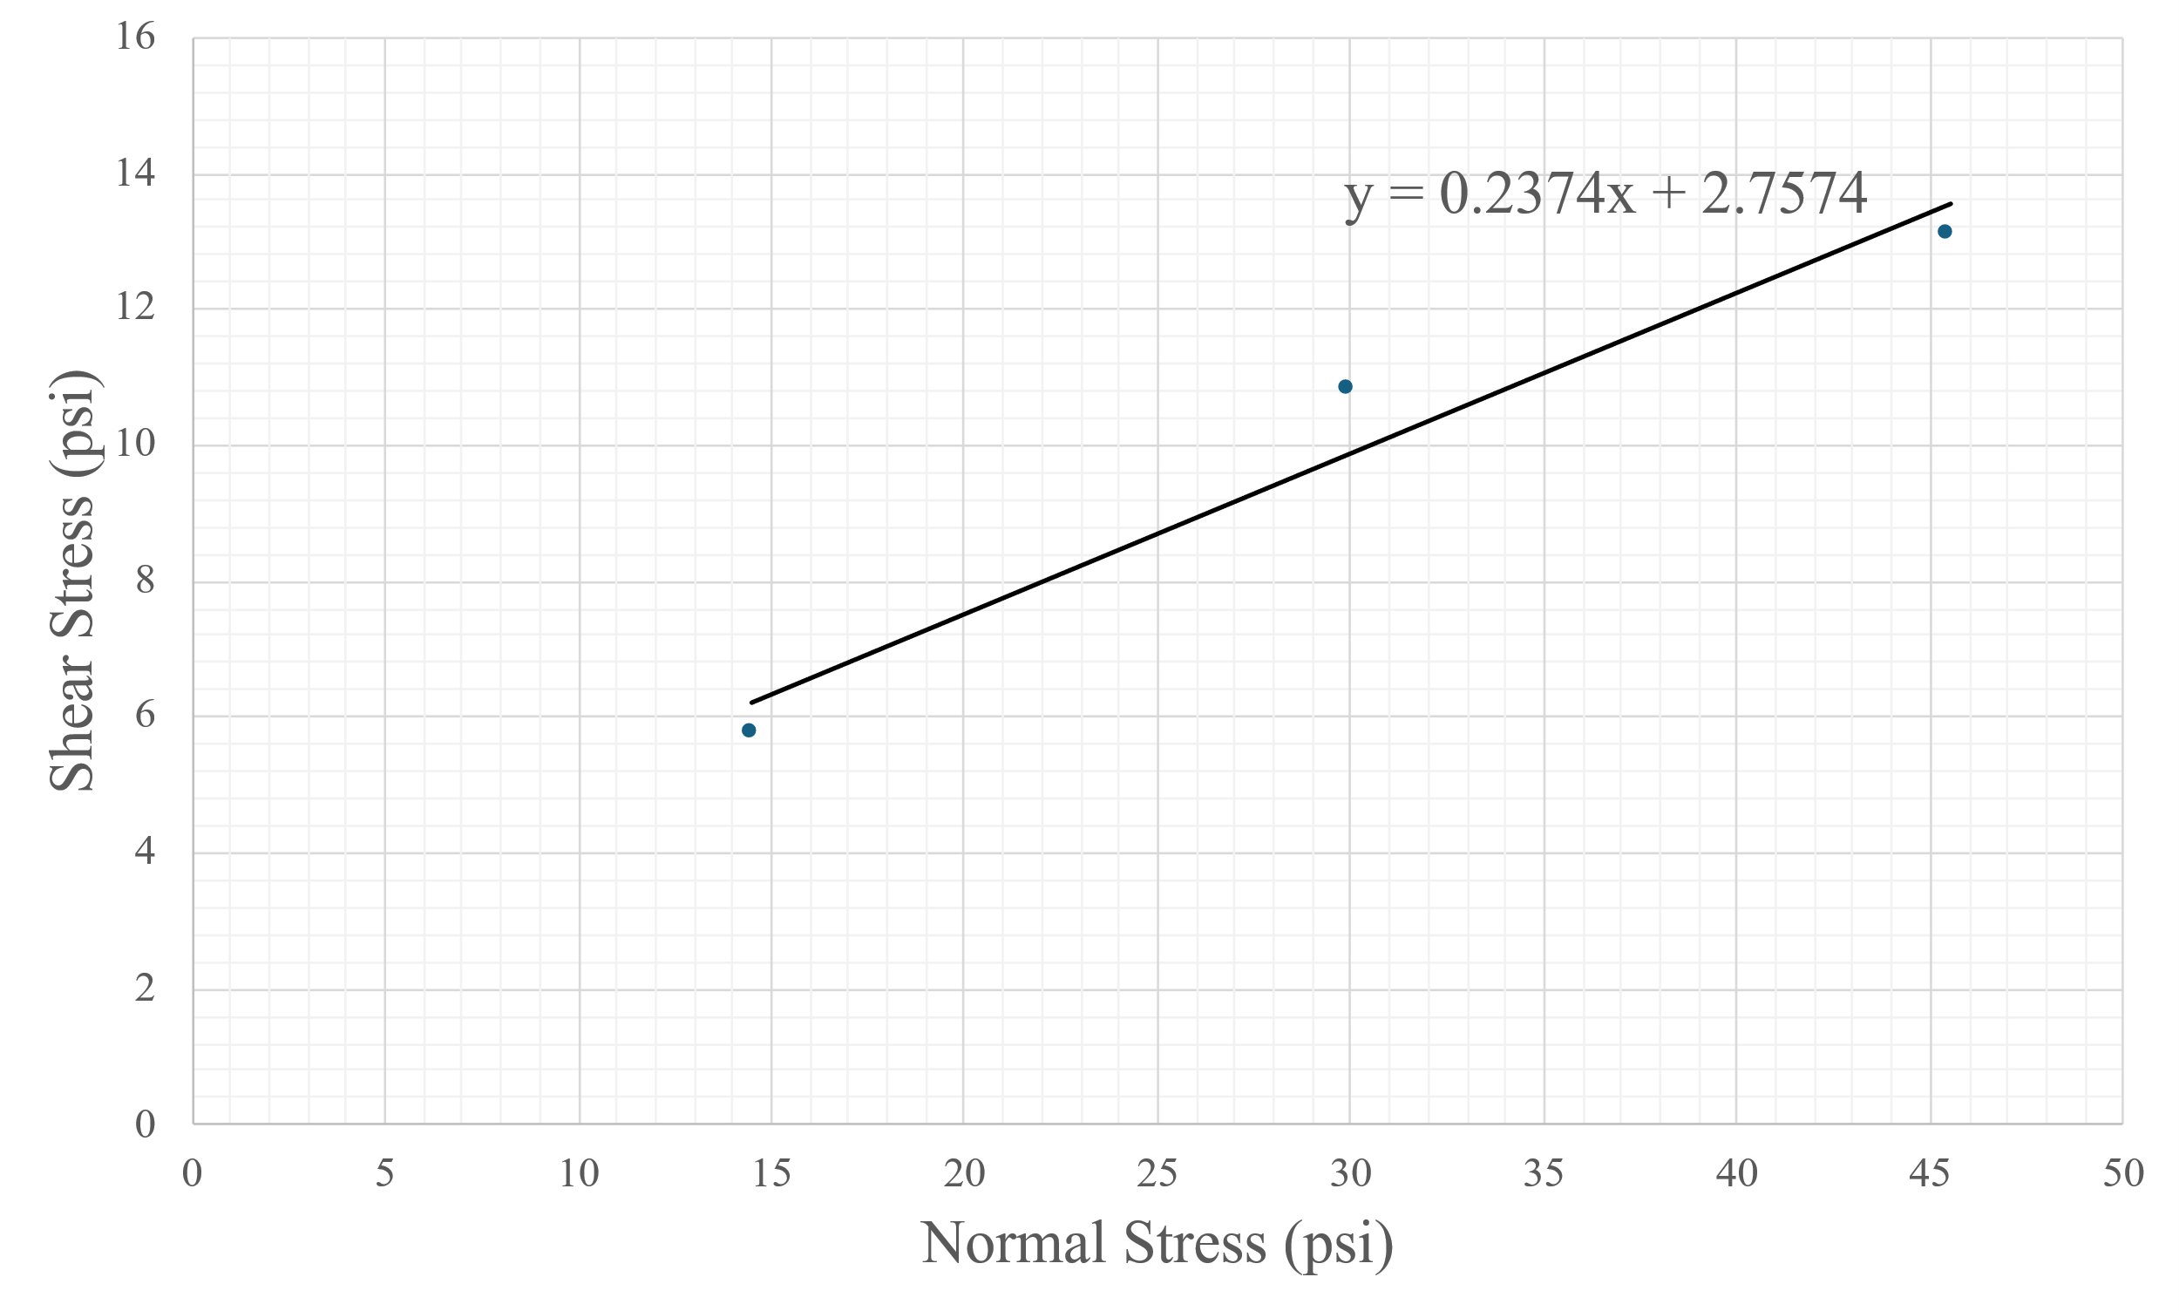
Figure 10-2. Shear stress vs normal stress plot

Important Notes
- Ensure the shearing rate is slow enough to maintain drained conditions (especially for cohesive soils).
- Use thin lubricated plates to minimize side friction.
- Failure is typically defined by the peak in shear force or a horizontal displacement of 10–15% of the specimen length.

Report Guideline
Your report should include the following sections:
- Objective: Clearly state the purpose of the test.
- Standard: Refer to ASTM D3080.
- Analysis of results
- Table with normal and shear stresses
- Shear stress vs. normal stress plot
- Determination of c and φ values
- Error sources: Discuss potential issues like uneven loading, inaccurate measurements, or equipment friction.
- Summary:
  - What was tested
  - How it was tested
  - Summary of results (c, φ, and behavior of the soil)

Lab 11 Unconfined Compressive Strength

Overview
The unconfined compressive strength (UCS) test is one of the simplest and most commonly used laboratory tests to determine the shear strength of cohesive soils, especially clays. The test involves applying axial compression to a cylindrical soil sample without any lateral confinement until failure occurs. This test is suitable for undisturbed or remolded cohesive soil specimens and is particularly useful for quick field quality control or assessment of soil strength in shallow foundations or embankments.
The UCS value is calculated by dividing the maximum axial load at failure by the original cross-sectional area of the specimen. Since the soil is unconfined, the principal stress is the axial stress at failure, and the minor principal stress is zero. This test helps estimate the undrained shear strength (s_{u}) of cohesive soils.
s_{u} = q_{u}/2
​where
q_{u} is the unconfined compressive strength.

Learning Objective
To determine the unconfined compressive strength and undrained shear strength of cohesive soil using the UCS test.
Tools and Materials
- Unconfined compression testing device
- Proving ring or load cell
- Dial gauge or displacement transducer
- Vernier caliper
- Balance (readability of 0.01 g)
- Soil sample (undisturbed or remolded, cylindrical shape)
- Straight edge
- Filter papers
- Trimming tools
- Stopwatch
- Moisture cans
- Oven
Reference Standard
ASTM D2166 / D2166M - Standard Test Method for Unconfined Compressive Strength of Cohesive Soil
Step-by-Step Guide
The test procedure follows the steps of ASTM D2166 Test Procedure. The steps for unconfined compressive strength test are as follows:
- Measure the initial length, diameter, and moist mass of the specimen.
- Place the specimen in the load frame and zero the load cell.
- Position and zero the dial gauge for deformation measurement.
- Begin loading the specimen at a strain rate between 0.5 to 2.0% / min.
For calculations, follow the following steps:
- Calculate the initial cross-sectional area of the cylindrical sample using the formula:
A₀​ = ​​ ${\frac{\text{π}d}{\text{4}}}^{\text{2}}$
- Calculate the volume of the specimen
V=A₀​×L₀
- Calculate wet density (ρ)

ρ = $\frac{Mass}{Volume}$

- Calculate water content (w%)

w = $\frac{M_{W}}{M_{S} }$ x 100

- Calculate dry density (ρ_{d})
ρ_{d} = $\frac{ρ}{1 + \frac{w}{100}}$

- As the sample deforms, the area changes. Calculate the corrected area at any point is as:

A = $\frac{A_{0}}{1 - ε}$
Where ε = axial strain = $\frac{ΔL}{L_{0}}$

- At each loading point, calculate stress (kPa) by using the formula:

σ = $\frac{P}{A}$
Where

P = axial load (converted from lb to kN)
A = corrected area (as above)

- The maximum axial stress recorded from the data is the unconfined compressive strength.
- Calculate undrained shear strength (s_{u})
s_{u} = $\frac{q_{u}}{2}$

Sample Data and Calculations
- Diameter (d) = 7.5 cm
- Length (L₀) = 15.75 cm
- Mass = 1522.6 g
Table 11-1. Sample data for moisture content determination
Sample No. | 1
Moisture can number - Lid number | A
M_{C} = Mass of empty, clean can + lid (grams) | 14.8
M_{C}MS = Mass of can, lid, and moist soil (grams) | 48.9
M_{C}DS = Mass of can, lid, and dry soil (grams) | 40.1
M_{S} = Mass of soil solids (grams) | 24.5
M_{W} = Mass of pore water (grams) | 6.8
W = Water content | 27.76

Area (A₀) = $\text{π}$ × (7.5)²/4= 44.18 cm²
Volume = $\text{π}$ /4 × (7.5)² × 15.75 = 695.81 cm³
Wet density = 1522.6/695.81= 2.19 g/cm³
Water content (w%) = 27.8%
Dry density (γ_{d}) = 2.19/ (1+27.8/100) =1.71 g/cm3
Table 11-2. Sample of unconfined compression test data (deformation dial: 1 unit = 0.10mm; load dial: 1 unit = 0.3154 lb)
Deformation  Dial  Reading | Load  Dial  Reading | Sample  Deformation  (mm) | Strain | %  Strain | Corrected  Area, A | Load  (lb) | Load (x10⁻³)  (kN) | Stress (x10⁻³)  (kPa)
0 | 0 | 0 | 0 | 0 | 44.18 | 0 | 0 | 0
10 | 5 | 0.1 | 0.0006 | 0.06 | 44.21 | 1.6 | 7.0 | 0.16
20 | 10 | 0.2 | 0.001 | 0.1 | 44.22 | 3.2 | 14.0 | 0.32
30 | 14 | 0.3 | 0.002 | 0.2 | 44.27 | 4.4 | 19.6 | 0.44
40 | 21 | 0.4 | 0.003 | 0.3 | 44.31 | 6.6 | 29.5 | 0.67
60 | 25 | 0.6 | 0.004 | 0.4 | 44.36 | 7.9 | 35.1 | 0.79
80 | 28 | 0.8 | 0.005 | 0.5 | 44.40 | 8.8 | 39.3 | 0.89
100 | 29 | 1 | 0.006 | 0.6 | 44.45 | 9.1 | 40.7 | 0.92
150 | 30 | 1.5 | 0.0095 | 0.95 | 44.60 | 9.5 | 42.1 | 0.94
180 | 33 | 1.8 | 0.011 | 1.1 | 44.67 | 10.4 | 46.3 | 1.04
200 | 36 | 2 | 0.013 | 1.3 | 44.76 | 11.4 | 50.5 | 1.13
250 | 45 | 2.5 | 0.016 | 1.6 | 44.90 | 14.2 | 63.2 | 1.41
300 | 54 | 3 | 0.019 | 1.9 | 45.04 | 17.0 | 75.8 | 1.68
350 | 64 | 3.5 | 0.022 | 2.2 | 45.17 | 20.2 | 89.8 | 1.99
400 | 74 | 4 | 0.025 | 2.5 | 45.31 | 23.3 | 103.9 | 2.29
450 | 84 | 4.5 | 0.029 | 2.9 | 45.50 | 26.5 | 117.9 | 2.59
500 | 93 | 5 | 0.032 | 3.2 | 45.64 | 29.3 | 130.5 | 2.86
550 | 102 | 5.5 | 0.035 | 3.5 | 45.78 | 32.2 | 143.2 | 3.13
600 | 112 | 6 | 0.038 | 3.8 | 45.93 | 35.3 | 157.2 | 3.42
650 | 120 | 6.5 | 0.041 | 4.1 | 46.07 | 37.8 | 168.4 | 3.66
700 | 130 | 7 | 0.044 | 4.4 | 46.21 | 41.0 | 182.5 | 3.95
750 | 129 | 7.5 | 0.048 | 4.8 | 46.41 | 40.7 | 181.1 | 3.90
800 | 128 | 8 | 0.051 | 5.1 | 46.55 | 40.4 | 179.7 | 3.86
850 | 125 | 8.5 | 0.054 | 5.4 | 46.70 | 39.4 | 175.4 | 3.76
Unconfined compressive strength, q_{u} = 3.95x10⁻³ kPa
Undrained shear strength, s_{u} = q_{u}/2= 1.98 x10⁻³ kPa
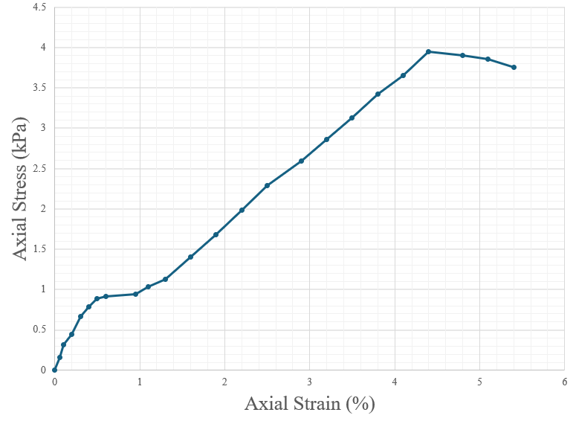
Figure 11-1. Axial stress vs axial strain graph

Important Numbers
- UCS results typically range from 25 kPa for very soft clay to over 400 kPa for very stiff clay.
- The undrained shear strength gives a direct indication of the soil’s resistance to shear under short-term loading.
Report Guideline
Include the following in the lab report:
- Objective of the Test
- ASTM standard
- Analysis of test results
- Complete provided data tables
- Include one sample calculation
- Interpret the results (e.g., classify the soil as soft, medium, stiff, etc.)
- Sources of error
- Misalignment, loading rate deviation, trimming defects, water content variability
- Summary
  - What was tested
  - How it was tested
  - What the results revealed

Lab 12 Consolidation

Overview
Structures transmit their loads to the underlying soil, compressing the stratum to a depth of roughly two-to-three times the footing width and lowering its overall volume, a phenomenon perceived in practice as settlement. The rate and magnitude of this volume change depend on the soil’s permeability, its saturation state, and the rigidity of its particle skeleton. In cohesionless sands, high permeability allows rapid dissipation of excess pore pressure, so compression is largely immediate; in cohesive clays, low permeability delays drainage, and the response unfolds over time. Volume reduction in any soil can arise from compression of the solid grains, compression of pore fluid, or the escape of water and air from the voids, but under typical engineering stresses, both the mineral grains and the pore water are effectively incompressible. Consequently, for saturated fine-grained soils, the critical mechanism is the gradual transfer of load from the pore water to the soil skeleton as water is forced out, the process termed consolidation.
Laboratory consolidation testing isolates this behavior by applying an incremental vertical load to a saturated clay specimen while permitting one-dimensional drainage, thereby measuring three settlement components: an undrained elastic “immediate” compression, primary consolidation governed by hydraulic flow through the fabric, and the slower secondary compression linked to viscous adjustment of the clay structure. Terzaghi’s spring-and-piston analogy visualizes the sequence: a sudden load first elevates pore pressure (water carries the stress), then drainage through a controlled outlet allows pressure to dissipate, and the springs, representing the soil skeleton, gradually assume the load until equilibrium is reached. Quantifying this time-dependent deformation is essential for estimating building settlements, judging construction schedules, and designing preloading or drainage schemes. The following laboratory exercise provides the experimental framework and calculations needed to determine a soil’s compressibility, rate of consolidation, and related engineering parameters.

Learning Objective
To determine the void ratio vs pressure curve, pre-consolidation pressure, and coefficient of consolidation.

Tools and Materials
- Consolidation test unit
- Filter paper
- Balance. The balance should have a readability of 0.01 g for specimens having a mass of 200 g or less
- Oven with temperature control. For drying the oven is generally kept between 105 ºC to 110 ºC
- Stopwatch
- Moisture can
- Container handling apparatus.
Reference Standard
ASTM D2435-04: Standard Test Methods for One-Dimensional Consolidation Properties of Soils Using Incremental Loading
Step-by-Step Guide
The test procedure follows the steps of ASTM D2435-04 Test Method. The procedure for the consolidation test is as follows:
- Weigh the empty consolidation ring with the glass plate and measure the height (h) of the ring and its inside diameter (d).
- Extrude the soil sample from the sampler, generally a thin-walled Shelby tube. Determine the initial moisture content and the specific gravity of the soil. (N.B. If such a sample is not available, the soil can be molded to prepare the soil sample.)
- Trim a soil specimen to roughly three inches in length. Set it on the consolidation ring, then shave the sides until they match the ring’s outer diameter. While slowly turning the ring, slice away any excess material so the specimen fits the ring’s inner diameter. Throughout, keep the cutting tool level and horizontal.
- Keep trimming by gently pressing the soil downward so it fills the ring completely and sticks out just a little from the lower edge, watching closely to avoid any gaps between the specimen and the metal. When a thin rim protrudes, carefully flip the ring over and, using a metal straight-edge, shave off the excess soil until the exposed face is perfectly level with the ring; remove the last thin slice very slowly and smoothly so the sample remains undisturbed.
- Place the pre-weighed, wrap-covered glass plate against the freshly trimmed face of the specimen, flip the ring to expose the opposite end, carefully trim this second face until it is flush with the ring just as before, and then determine the combined weight of the glass plate, ring, and soil specimen.
- Lift the ring and specimen off the plastic-wrapped glass plate, then peel the wrap from the exposed soil surface. Center the pre-soaked porous stones on the specimen’s top and bottom, adding a filter paper between each stone and the soil and pressing lightly so the stones stay in place. Lower the assembled unit into the reservoir base and add water until the specimen is fully submerged and saturated. While keeping the ring and porous stones steady, position the load plate squarely on the center of the top porous stone, then align and set the loading device.
- Reset the dial gauge to zero, then adjust the pressure gauge, using its calibration curve, until it applies a load of 0.5 tsf.
- Begin the test. Throughout the test, record dial-gauge readings at every elapsed-time interval shown on the data sheet, repeating this procedure for each pre-selected pressure, typically loading the specimen at 1.0, 2.0, 4.0, 8.0, and 16.0 tsf and then unloading it to 8.0, 4.0, 2.0, 1.0, and finally 0.5 tsf. After taking the last time reading, note the final dial value and time, release the load, and promptly disassemble the consolidation device. Remove the specimen and gently, but quickly, blot its surfaces with paper towels, as the soil will begin absorbing water once the pressure is removed. Finally, place the specimen and ring on the glass plate and weigh them together.
- Gently remove the soil specimen from the consolidation ring, avoiding any loss of material, and transfer it into the pre-weighed can. Place the can (with lid) in a drying oven for 12–18 hours to evaporate all moisture, then weigh the can and its now-dry specimen to obtain the final dry mass.
Sample calculation
- Weight of the ring = 156.8 g
- Inside diameter of the ring = 2.5 in (6.35 cm)
- Height of specimen, H_{i} = 1 in (2.54 cm)
- Area of specimen, A = 31.67 cm²
- Mass of specimen + ring = 312.1 g
- Initial moisture content of specimen, w_{i} (%) = 28.9%
- Specific gravity of solids, G_{s} = 2.67
- Final moisture content of specimen (after test), w_{f}= 27.3%
- Weight of solids (before test) =155.3 g
- Water content (before test) = 28.9%
- Weight of dry specimen = 120.5 g
- Specific gravity of soil, G_{s}= 2.72
- Height of solids, H_{s} = $\frac{M_{s}}{A*G_{s}*ρ_{w}}$ =$\frac{120.5}{31.67*2.72*1}$= 1.40 cm (0.55 in)
- Change in height of specimen after test, H =0.24 cm
- (H for all pressures – see t vs Dial Reading plots)
- Height of specimen after test, H_{f} = H_{i} – H = 2.54-0.24 = 2.3 cm
- Void ratio before test, e₀ = (H_{i}-H_{s})/H_{s} = (2.54-1.4)/1.4 = 0.816
- Void ratio after test, e_{f} = (H_{f}-H_{s})/H_{s} = (2.3-1.4)/1.4 = 0.645
The sample calculation depicts only one time-settlement graph (for 400 kPa), but it needs to be drawn for each pressure increments. From these graphs, t₅₀ can be determined which is useful for determining the coefficient of consolidation (c_{v}) values.
Specimen Used
Soil : Light Grey Clay
- BH No: 05
- Depth: 7 ft
- Specific gravity, G_{s} =2.72
- Vol. of solids = 2.7035 in³
- Ht. of Solid (2H₀) = 0.5507 in
- Ht. of Void (H_{v}) = 0.4493 in
- Initial void ratio (e₀) =0.8157
- Tare weight = 8.50 lbs.
- Deformation Dial Constant = 0.0001 inch/div.
Equipment used
- Height of ring= 1 in.
- Dia. Of ring = 2.5 in.
- Area of sample= 4.9087 in²
- Wt. of ring= 156.8 gm
- Wt. of ring + soil (before test)= 312.10 gm
- Wt. of soil (before test)= 155.3 gm
- Water Content (before test)= 28.9%
- Wt. of dry specimen= 120.50 gm

Table 12-1. Sample data for consolidation test
The sample calculation depicts only one time-settlement graph (for 400 kPa), but it needs to be drawn for each pressure increment. From these graphs, t₅₀ can be determined, which is useful for determining the coefficient of consolidation (c_{v}) values.
Results
- Compression Index (C_{c}) = 0.23
- Re-compression Index (C_{r}) = 0.06
- Pre-consolidation Pressure (P_{c}) or Maximum Past Pressure (v_{max}) = 115 kPa
- Coefficient of Consolidation (C_{v})= 4.2 to 7.25 m²/year (depends on the pressure)
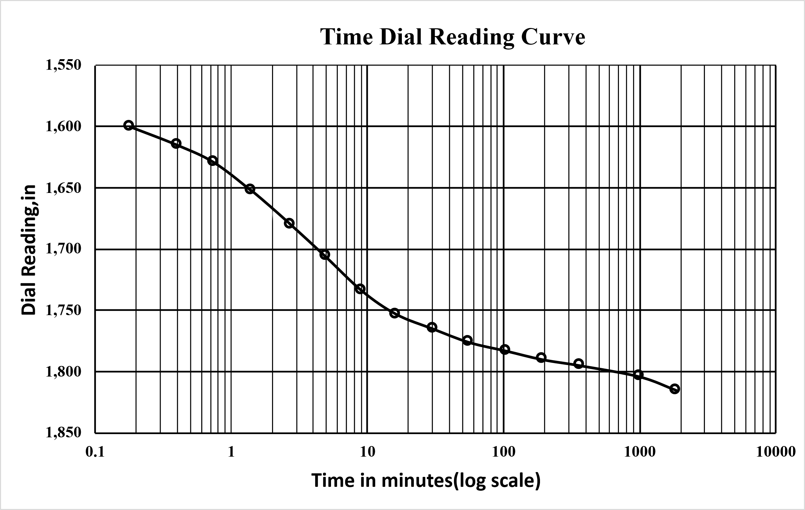
Figure 12-1. Time settlement graph (for 400 kPa pressure)

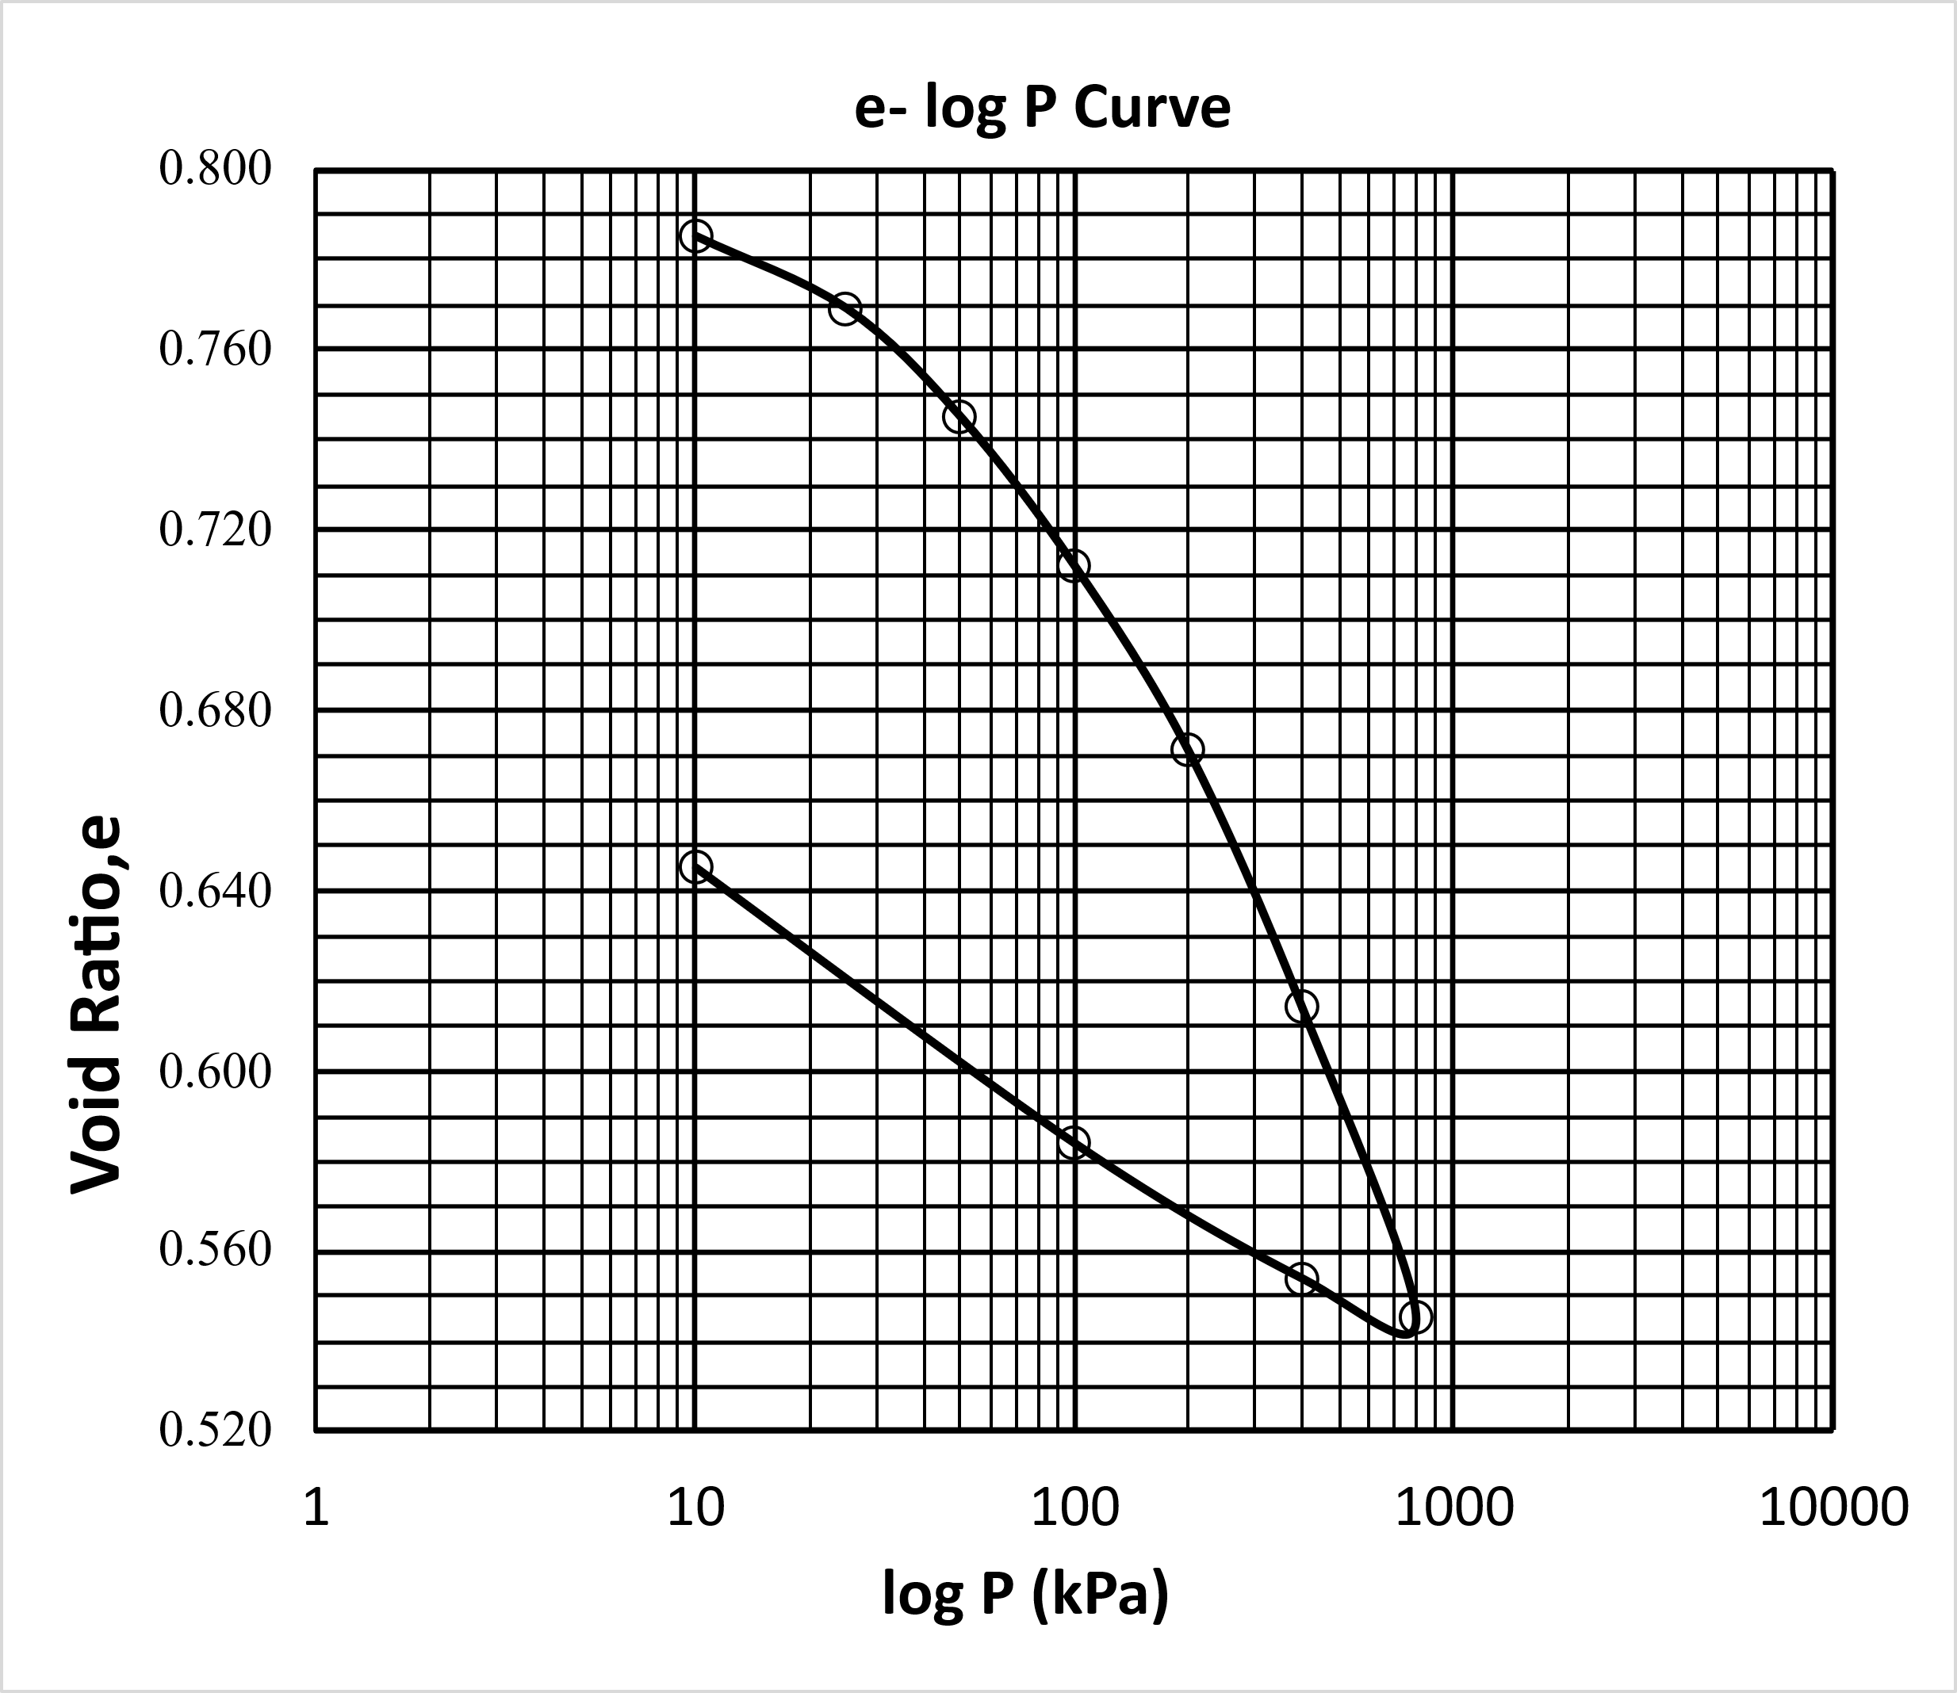
Figure 12-2. e-log P curve
Important Numbers
There are several correlations for C_{c} and C_{s}. Some of them are mentioned below:
- Skempton’s Formula : Skempton (1944) established a relationship between C_{c} and liquid limits (LL) for remolded clays as

$C_{c}=0.007(LL-10)$ (1)

Where LL is in percent.

- Terzaghi and Peck Formula Based on the work of Skempton and others, Terzaghi and Peck (1948) modified Eq. 1, applicable to normally consolidated clays of low to moderate sensitivity as
$C_{c}=0.009(LL-10)$ (2)
- Hough’s Formula Hough (1957), on the basis of experiments on precompressed soils, has given the following equation
$C_{c}=0.3(e_{o}-0.27)$ (3)

The Swell index C_{s} is usually about Cc/5 to Cc/10. Based on the modified cam model, Kulhawy and Maybe (1990) showed that
$C_{s}≈\frac{PI(\%)}{370}$ (4)
These empirical equations are very important for preliminary estimation purposes.
Report Guidelines
Your report should include the following sections:
- Objective of the test
- ASTM standard
- Analysis of test results – complete the provided table for consolidation test and include one sample calculation, plot the graphs, discuss the meaning of the results, and interpret the data
- Report source of error.
- Summary and conclusion - 1) what experiment was performed, 2) how it was performed, and 3) what the results were.

Acknowledgment of Sources
This lab manual incorporates educational content adapted or referenced from the following sources:
- Properties and Behavior of Soil – Online Lab Manual by MD Sahadat Hossain, Ph.D., P.E.; Md Azijul Islam; Faria Fahim Badhon; and Tanvir Imtiaz, available at https://uta.pressbooks.pub/soilmechanics/, licensed under a Creative Commons Attribution-NonCommercial 4.0 International License (CC BY-NC 4.0). Portions of laboratory procedures and sample data have been adapted for non-commercial, instructional purposes.
- Soil Mechanics Laboratory Manual by Braja M. Das, used solely as a reference for general guidance in lab procedure and technical explanation. All rights to this source are retained by the original author and publisher.
- Principles of Geotechnical Engineering by Braja M. Das, which is used solely as a reference for theoretical background and educational context. All rights to this source remain with the original publisher and author.
- ASTM Testing Standards, consulted to ensure that laboratory procedures and test methods follow industry-accepted practices. All referenced standards are copyrighted by ASTM International and used here for instructional reference only.
- Geotechnical Engineering: Principles & Practices (2nd Edition, 2010) by Donald P. Coduto, Man-chu Ronald Yeung, and William A. Kitch – used as a secondary reference for conceptual frameworks, typical values, and soil behavior characteristics. This text is the property of Prentice Hall and its authors and is referenced for educational support only.
Additional publicly available or institutional teaching materials may have been consulted to supplement procedural descriptions and pedagogical structure. This manual is intended exclusively for non-commercial, educational use in a university instructional setting.

