An Introduction to African and
Afro-Diasporic Peoples and Influences in British Literature and Culture before the Industrial Revolution
Jonathan Elmore and Jenni G Halpin
With funding from Affordable Learning Georgia and support from the Department of English, Languages, and Cultures at Savannah State University
© 2021
This work is licensed under a CC BY-NC-SA 4.0 license

Attribution-NonCommercial-ShareAlike 4.0 International
Affordable Learning Georgia, an Initiative of the University System of Georgia
2021
Contents
Preface for Instructors i
Reclamations Following a History of Exclusion 1
Imagining Africa: Entrenching Stereotypes 4
Race and Religion 6
Constructions of Race in Britain 11
An Interview with Josie Gill 15
An Interview with Angela F. Jacobs 20
An Interview with Miranda Kaufmann 30
An Interview with Onyeka Nubia 37
Brief Biographies of Black People in Britain 46

Preface for Instructors
Funded by the University System of Georgia’s “Affordable Learning Georgia” initiative, An Introduction to African and Afro-Diasporic Peoples and Influences in British Literature and Culture before the Industrial Revolution corrects, expands, and celebrates the presence of the African Diaspora in the study of British Literature, undoing some of the anti-Black history of British studies.
The easy narrative of British cultural history with which many American students are presented leaps from Beowulf to Chaucer to Shakespeare to Empire. The slave trade led to a volume of racial constructions and revisionist histories that has certainly bled over into the current curriculum of survey-level British literature. The erasure of the history of Black people in the British Isles, like the destruction of disembarkation cards of the Windrush generation, works to perpetuate a silencing and rejection of Black Britons as Britons. As Ian Grosvenor and Lisa Amada Palmer have separately underscored, the work of anti-racism requires one to be “vigilant to the politics of erasure” (Palmer 509). But it is virtually impossible “to build an alternative narrative of the nation that includes […] the history of black political agency” without learning, first, of the presence of Blacks in Britain since before it was Britain (Grosvenor 167). Our goal in this volume is to provide representations that build an understanding of race outside of the trade in enslaved African peoples and beyond its legacy of such a compendium of discriminations. This will not only help students understand the period but also show them how concepts of race have been historically constructed.
Our aim in creating this project is not just another textbook that is more inclusive or somehow more “woke.” Instead we direct this project at a set of problems that have always plagued the study of, and especially the teaching of, pre-Romantic period literature and history of the British Isles: namely the exclusion, erasure, and misrepresentation of the African Diaspora in Britain, especially from the late Medieval period onward.
This supplemental textbook is designed as a companion text to any number of existing anthologies and textual collections commonly used in undergraduate surveys and seminars in British literary studies up to the eighteenth century. It offers additions that genuinely augment and, at times, talk back to existing textbooks and approaches to teaching the literature and culture of this expanse of British history. As a freely available digital text, it is highly adaptable to various pedagogical styles and delivery methods and will be readily accessible to both faculty and students.

Interviews with scholars are a key feature of this text
Historians and literary scholars have already begun the work of recovering the lives, writings, and influences of Afro-Diasporic peoples in Europe and the British Commonwealth from the Medieval period through the Renaissance, revealing the broad and rich presence of peoples of African descent. While the work of these scholars is woven through our supplemental textbook in many ways, we want to bring not only their work but especially their voices and the sense of urgency that motivates this work to the students working with our volume. By including these interviews, we can not only reframe their scholarship for an undergraduate audience but especially humanize the importance of the work of these historians and literary scholars for students who are likely encountering such work for the first time.
As we prepared to undertake this project, we of course, both read widely in the growing body of scholarship that has been recovering the presences and voices of Afro-Diasporic peoples in Britain. What became almost immediately apparent was that merely reporting this work to an undergraduate audience was not going to be enough: finding histories, biographies, and literature and mentioning it to our students would not serve either our students or the material adequately. We realized that we needed to draw the voices of these scholars organically into this project. We desired strongly not to stand in the way of our students’ direct access to these voices, but instead to let them speak for themselves rather than attempting to translate or explain them as a means of appropriating their scholarship.
In this time of—we hope—significant change, soliciting commentary from leading scholars of Black British history, literature, and culture that is targeted from the beginning to undergraduates who will mostly be operating from a culturally-determined dearth of context for this history, literature, and culture provides an opportunity to increase not only students’ knowledge about Black Britons but also students’ ability to relate this knowledge to the present.
One of the interesting effects of being a white person teaching at an HBCU (as we both are) is that it makes one repeatedly aware of and especially sensitive to the coopting and silencing of Black voices that has gone on for centuries. For years the two of us have constituted the entirety of the British literature faculty at our university. As such, we have traded off the British literature surveys frequently and discussed curriculum endlessly. A recurring theme in these conversations was the glaring whiteness of the first half of the survey and anthologies which often pay lip service to African and Afro-Diasporic peoples through a slight inclusion of exoticizing sixteenth century travel narratives and Shakespeare’s Othello. Both of us experimented with different content, but there simply was not much available, especially not material pitched at a largely first and second year undergraduate audience, most of whom were not English or even humanities majors. After several years of collecting uneven and mismatched resources from disparate sources and experiencing a growing feeling of frustration every time we taught the course, we decided we simply had to make what we could not find.

Problems inherent in presenting this work
Our editorial work is, as is all editorial work, problematic. Mindful as we are of the need to center Black people and Black voices, our framing is inevitably produced by our white-centric educations and experiences and by the white-centric traditions of British literary studies against which we are presenting this collection. Introducing The Cambridge History of Black and Asian British Writing (2020), a critical literary history focused on the last three centuries, editors Susheila Nasta and Mark U. Stein write, such work “is a provocation in its necessarily mediated reconfiguration of the often eclipsed, discontinuous voices of Britain’s black and Asian past, present, and future” (1). The editorial and interpretive framing of any such project will increase the distinction and spacing between various vantages on the works under consideration. Through our work to highlight what can currently be known of Black people in Britain, we break them out of their historical and social contexts as much as we seek to break the monolithic whiteness of the dominant narrative.
The people we center do become exemplars, separated from their peers either by the unusual circumstances of their lives leaving historical traces or by our focus upon their Blackness. It is undeniable that records of Black people in Britain during the Renaissance and earlier are atypical, either in their selves and actions or in the mere fact of those being written down. Equally, it is nearly impossible to present these exceptional individuals without presenting them as strange, though our effort throughout has been to normalize Africans and Afro-Diasporic peoples as significant parts of the population of Britain. Still, this problem, insofar as it is one, is vastly superior to the problem of insufficient attention to these texts and peoples.

Anti-Racist objectives
Crucially, our collection aids in portraying African and Afro-Diasporic peoples well beyond slavery and the (white-dominated) abolition movement, portrayals which have had the clear effect of reinforcing racist narratives affirming the status of Black people as possessions rather than people. On 23 June 2020, Priyamvada Gopal tweeted “White Lives Don’t Matter. As white lives,” a response in part to a particularly public effort to proclaim the mattering of white lives (cited in Rawlinson). The anticolonialist, a reader at Cambridge, received extensive negative response, including efforts to have her removed both from Twitter and from her post, on the purported grounds that her efforts to call attention to and dismantle the ideologies of white privilege and of racist oppression are themselves racist (Rawlinson). On the contrary, part of the work of disassociating whiteness and value is done in emphasizing value-systems that recognize the worth of non-white people and their creations. We insist, therefore, that careful literary-critical analysis contributes to the affirmation of the significance of African and Afro-Diasporic peoples today and over thousands of years of history. From white Britons’ fascination with and othering of African peoples to the direct influences of Afro-Diasporic Britons—whether objectified, employed, or prized—the history of relations among Black and white people in Britain is central to the history and the present culture of Britain. Including, contextualizing, analyzing, and otherwise framing these texts not only affirms but moreover demonstrates that Black British literature is canonical literature.

What uses we imagine this being put to
Usability is an important element of this project. Large documents that resist downloading, disorganized assemblages that impede navigation, and read-only files all work to interfere with student and faculty use. Our text is natively digital, designed to be remixed and reused by faculty, formatted for easy reading on portable screens, structured and bookmarked for effective navigation, and equipped with descriptive captioning and other access design features. In this way we are promoting the voices speaking from our sources rather than allowing our curation of them to tax the students who will be reading.
On an instructional level, our collection of images of artifacts, biographies of historical persons, governmental documents, narratives of the constructions of race in British cultures, and interviews with scholars gives lively voice to a long-ignored facet of Britain. We created this collection to contribute to a transformation of student learning about the literatures of early Britain by highlighting the lived experiences of Black people in Britain and by re-presenting the cultures of British peoples over the course of more than a millennium. Affording faculty resources for cultural context and students clarity on the significance of Black British culture, with appropriate instructional and pedagogical apparatus, which does not assume familiarity with cultures outside of contemporary America, this supplement is suitable for use in 2000-level survey classes as well as upper level undergraduate courses focusing on topics from medieval to early modern literature and history.
This text is designed to supplement the traditional anthologies used in general education, literary survey courses as well as the textbooks used in upper-level undergraduate courses in British literature prior to the Industrial Revolution. Its texts can readily be assigned in a manner similar to the supplemental readings on the historical and cultural context so often provided by anthologies but also so often light or lacking in their treatment of the presence and influence of African and Afro-Diasporic peoples and influences on the trajectory of British history, culture, and literature.
The interviews additionally provide historical and cultural context and also introduce students to scholars currently working in the field. Instructors may use some or all of the questions and the diverse answers provided by the scholars published here as framing questions for in-class discussions of various texts. These interviews also present historical, interpretative, and analytical questions that are addressable to assigned literary texts and may serve as foundation questions for formal and informal writing assignments or group discussions or presentations.
We see the chronological survey of brief biographical notes on Black people in Britain not only as a compendium demonstrating the mattering of Black lives but also as a reference supplementing knowledge and recognition of context for more-commonly assigned readings such as the speeches of Elizabeth I, Walter Ralegh’s The Discoverie of Guiana, Aphra Behn’s Oroonoko, or Olaudah Equiano’s Interesting Narrative. These short entries can also serve instructors as jumping off points for research assignments and writing activities that involve students in the critical research work of unearthing and recovering the lives, contributions, and influences of Black Britons that is currently underway by historians, anthropologists, and cultural scholars around the world.
Furthermore the bibliographies and suggestions for further reading found throughout this supplemental text offer a substantial survey of the existing scholarship, archives, news media, and digital resources available on the lives of Black Britons and can serve instructors and students alike for various research activities, writing assignments, and discussions.

Bibliography to the Preface
Boyd, Andy, Matthew Woollard, John Macleod, and Alison Park. “The Destruction of the ‘Windrush’ Disembarkation Cards: A Lost Opportunity and the (Re)Emergence of Data Protection Regulation as a Threat to Longitudinal Research,” Wellcome Open Research 11 Sep 2018. https://doi.org/10.12688/wellcomeopenres.14796.1. Accessed 7 July 2020.
Grosvenor, Ian. “‘What Do They Know of England Who Only England Know’: A Case for an Alternative Narrative of the Ordinary in Twenty-First-Century Britain,” History of Education vol. 42, no. 2 (2018): pp. 148-168. https://doi.org/10.1080/0046760X.2017.1420240. Accessed 7 July 2020.
Nasta, Susheila and Mark U. Stein, editors. The Cambridge History of Black and Asian British Writing. Introduction. Cambridge UP, 2020. pp.1-21.
Palmer, Lisa Amanda. “Diane Abbott, Misogynoir and the Politics of Black British Feminism’s Anticolonial Imperatives: ‘In Britain too, it’s as if We Don’t Exist.’” The Sociological Review, vol. 68 no.3 (2020): pp. 508-523. https://doi.org/10.1177/0038026119892404. Accessed 7 July 2020.
Rawlinson, Kevin. “‘Abolish Whiteness’ Academic Calls for Cambridge Support.” The Guardian, 25 June 2020 https://www.theguardian.com/education/2020/jun/25/abolish-whiteness-academic-calls-for-cambridge-support Accessed 26 June 2020.

Links to other sections of this Introduction to African and Afro-Diasporic Peoples and Influences in British Literature and Culture before the Industrial Revolution
Preface for Instructors
Reclamations Following a History of Exclusion
Imagining Africa: Entrenching Stereotypes
Race and Religion
Constructions of Race in Britain
An Interview with Josie Gill
An Interview with Angela F. Jacobs
An Interview with Miranda Kaufmann
An Interview with Onyeka Nubia
Brief Biographies of Black People in Britain

Reclamations Following a History of Exclusion
Ongoing discussions about erasure in literary and cultural studies frequently circle back to English literature of the first millennium; Mary Rambaram-Olm and many others have pointed particularly to the racism inherent in characterizing the peoples and cultures of England between 400 and 1066 as a singular “Anglo-Saxon” group. These conversations have been going on for a while. In 1985 Susan Reynolds surveyed the history of the peoples of southern England across the period, recognizing that these were distinct peoples for much of the span concerned and that “When a single kingdom was formed” (suggesting in this formation the existence of a “sense of unity” among its peoples) that kingdom “was called the kingdom of the English” (414). There was no meaningful group of people well described by a label such as “Anglo-Saxon.” Despite this ongoing conversation many available anthologies continue, without acknowledgement of the problem, to label early literature of the British Isles as “Anglo-Saxon.” The scholarship is hardly new; the academy has been frustratingly slow to face its implications.
Moving forward to the Renaissance, we find another field in which the serious and significant work to be less exclusionary is present but insufficiently prominent. Shortly before our project was approved, Urvashi Chakravarty’s reflection on the state of Renaissance studies in relation to race was published in English Literary Renaissance. Framing her discussion in relation to the manner in which ELR scholarship has “naturalized” such a range of concerns (“scholarship has engaged not only with ecocriticism but the Anthropocene; with object-oriented ontology; with digital or post-humanisms; [...], even approaches using digital humanities”), Chakravarty points to the breadth of inclusions, in contrast to the treatment of critical race studies, and pointedly asks, “What, then, and (perhaps more importantly) who is assimilable?” (18) Certainly the past four years give ample reason to foreground this question. Chakrabarty cites Dennis Britton, Peter Erickson, and Kim F. Hall variously demonstrating the outsider status of critical race studies approaches to Renaissance scholarship broadly and to Shakespeare studies in particular.
The work of bringing attention to race in Renaissance studies has also been increasingly evident in lectures, events, and social media. For instance, The Globe Theatre and the University of Sussex offered a “Shakespeare and Race” event in August 2018. In January 2019 Ayanna Thompson convened a symposium on “Race Before Race” at the Arizona Center for Medieval and Renaissance Studies, and the work continued through both Twitter conversations (#RaceB4Race) and a sequel symposium (“Race and Periodization”) co-sponsored by the Center and the Folger Shakespeare Library in September 2019 (Chakravarty 22, 23; Newsom; Folger). Some of the scholars contributing to this important work include Miranda Kaufmann’s Black Tudors: The Untold Story, Onyeka Nubia’s England’s Other Countrymen: Black Tudor Society, Ania Loombia and Jonathan Burton’s Race in Early Modern England: A Documentary Companion, Imtiaz Habib’s Black Lives in the English Archives, 1550-1677: Imprints of the Invisible, and the many contributors to Susheila Nasta and Mark U. Stein’s The Cambridge History of Black and Asian British Writing.

Bibliography to Reclamations Following a History of Exclusion
Chakravarty, Urvashi. "The Renaissance of Race and the Future of Early Modern Race Studies," English Literary Renaissance vol. 50, no. 1 (Winter 2020): pp. 17-24. https://doi.org/10.1086/706214. Accessed 29 June 2020.
Folger Shakespeare Library. "2019-2020 Institute Scholarly Programs." Folger Shakespeare Library. <https://www.folger.edu/2019-2020-institute-scholarly-programs>. Accessed 29 June 2020.
Newsom, Leah. “ASU Medieval Center Brings Conversations about Race to Our Nation’s Capital.” ASU Now, 27 Aug. 2019. https://asunow.asu.edu/20190827-asu-medieval-center-brings-conversations-about-race-our-nation%E2%80%99s-capital Accessed 29 June 2020.
Rambaram-Olm, Mary. “Misnaming the Medieval: Rejecting ‘Anglo-Saxon’ Studies.” History Workshop, 4 Nov. 2019. http://www.historyworkshop.org.uk/misnaming-the-medieval-rejecting-anglo-saxon-studies/ Accessed 19 June 2020.
Reynolds, Susan. “What Do We Mean by ‘Anglo-Saxon’ and ‘Anglo-Saxons’?” Journal of British Studies, vol. 24, no. 4, 1985, pp. 395–414. JSTOR, www.jstor.org/stable/175473. Accessed 19 June 2020.

Suggested further reading beyond Reclamations Following a History of Exclusion
African American Registry. 2021. https://aaregistry.org.
BlackPast. 2021. https://www.blackpast.org.
“Black Perspectives.” AAIHS: African American Intellectual History Society. 2021. https://www.aaihs.org/black-perspectives/.
BOA: Books of Africa. 2021. https://booksofafrica.com.
Habib, Imtiaz. Black Lives in the English Archives, 1500-1677: Imprints of the Invisible. Routledge, 2016.
Hall, Kim F. Things of Darkness: Economies of Race and Gender in Early Modern England. Cornell UP, 1995.
Humanity Archive, The. 2021. https://www.thehumanityarchive.com.
Kaufmann, Miranda. Black Tudors: The Untold Story. London: One World, 2017.
Loomba, Ania, and Jonathan Burton. Race in Early Modern England: A Documentary Companion. Palgrave Macmillan, 2007.
Nasta, Susheila and Mark U. Stein, editors. The Cambridge History of Black and Asian British Writing. Introduction. Cambridge UP, 2020. Pp.1-21.
Nubia, Onyeka. England’s Other Countrymen: Black Tudor Society. Zed Books, 2019. Blackness in Britain.
Smith, Cassander L., et al., editors. Early Modern Black Diaspora Studies: A Critical Anthology. Palgrave Macmillan, 2018.

Links to other sections of this Introduction to African and Afro-Diasporic Peoples and Influences in British Literature and Culture before the Industrial Revolution
Preface for Instructors
Reclamations Following a History of Exclusion
Imagining Africa: Entrenching Stereotypes
Race and Religion
Constructions of Race in Britain
An Interview with Josie Gill
An Interview with Angela F. Jacobs
An Interview with Miranda Kaufmann
An Interview with Onyeka Nubia
Brief Biographies of Black People in Britain

Imagining Africa: Entrenching Stereotypes
To sail between England and Asia typically required a resupply break, which was a major purpose for English involvement in the Cape of Good Hope (on the southwest coast of Africa). Since the 1590s these stops exposed English sailors and traders to the peoples of the Cape, who would soon include not only the native peoples of the region but also a settlement of the Dutch East India Company (formally the United East India Company, a monopolist of the sea trade of the Netherlands). As the English (and other Europeans) traveled the world for exploration, exploitation, and commerce, English people at home had significant interest in reading their travel narratives. Many were extensively fabricated; for example, in Richard Hakluyt’s The Principal Navigations a letter from the sailor Thomas Stevens includes the observation, made from “no more than five miles from the Cape,” that “the land itselfe [was] so full of Tigers, and people that are savage, and killers of all strangers, that we had no hope of life nor comfort, but onely in God and a good conscience” (cited in Merians). As Linda E. Merians notes, Stevens’ expectations are so set that he reports far beyond what he could possibly have witnessed: he “never set foot on land at the Cape.” He imagines barbarous peoples just as he imports tigers (native not to Africa but to Asia).
English narratives about the Cape throughout the seventeenth century tend to praise themselves and the landscape of the Cape while dismissing and denigrating the peoples. Merians traces the transformation of blackness as a descriptive of skin color, generally without associating the people’s color with the travelers’ assumptions about their morals and culture, to a racist judgment where the description of blackness was tied to a judgment of barbarity.
The peoples of the Cape provided the English with a counter-example to one popular theory of skin color; as John Pory noted in Leo Africanus’s The History and Description of Africa, it could not be a hot climate that made the people of the Cape so dark skinned, as there are other even hotter climates where the people are much lighter skinned. Pory concludes that skin color must be hereditary (cited in Merians).
These beliefs, connected to the peoples in Africa, reinforce and are reinforced by widespread English perceptions of blackness as signaling immorality. As Matthieu A. Chapman writes, “most scholars [...] today [believe] that the early modern English placed blacks at one of two extremes: either as objects to be feared and loathed or as objects of exoticism and wonder” (78). Chapman notes that these prejudices connect to A Summary of the Antiquities and Wonders of the World, a travelogue by Pliny the Elder (a first century Roman) that was published in English in 1566; the renaissance veneration of classical Greek and Roman literature and philosophy brought with it those cultures’ prejudices as well.

Bibliography to Imagining Africa
Chapman, Mattieu A. “The Appearance of Blacks on the Early Modern Stage: Love’s Labour’s Lost’s African Connections to Court.” Early Theatre vol. 17, no. 2, 2014, pages 77-94. http://dx.doi.org/10.12745/et.17.2.1206.
Merians, Linda E. “‘Hottentot’: The Emergence of an Early Modern Racist Epithet.” Shakespeare Studies vol. 26, 1998. International Bibliography of Theatre and Dance with Full Text.

Links to other sections of this Introduction to African and Afro-Diasporic Peoples and Influences in British Literature and Culture before the Industrial Revolution
Preface for Instructors
Reclamations Following a History of Exclusion
Imagining Africa: Entrenching Stereotypes
Race and Religion
Constructions of Race in Britain
An Interview with Josie Gill
An Interview with Angela F. Jacobs
An Interview with Miranda Kaufmann
An Interview with Onyeka Nubia
Brief Biographies of Black People in Britain

Race and Religion

Revisions to Biblical/Theological sources
It is common knowledge that those who owned and traded in enslaved people as well as various governments, civil institutions, and judicial courts twisted theological and Biblical writings and teachings to be used as justifications for the enslavement of Africans throughout the Atlantic slave trade and for the ongoing disenfranchisement of Africans and Afro-Diasporic peoples after the trade itself had formally been abolished. In particular, the story of “The Curse of Ham” still stands as the most well-known example of these kinds of theological abuses. In fact, we will be exploring the origins and history of how that particular story was revised to serve nefarious purposes a bit later in this section. However, the history of theological—specifically Biblical—justifications for racism goes back to the earliest stirrings of Christianity itself and were therefore embedded in the Christianity that found its way to the British Isles during the Roman conquest of what would become known as England.
On the face of it, Christian theology seems antithetical to racism, given its universalizing claims that all peoples, and in fact all creatures on Earth, are the creations of God and beloved by God. In fact, as Denise Kimber Buell points out, Christian scriptures highlight the movement as having a “universal scope” both “by portraying its founding members - the apostles - as part of a movement with global spread when they receive the ability to speak all the languages of the Jewish diaspora (Acts 2:5-11)” and by underscoring the global reach of the faith in showing “an Ethiopian court official [as] one of the first named men to be baptized (Acts 8:26-38)” (110). Hence not only are the theological commitments of early Christianity necessarily inclusive, there are specific instances of ethnic and racial diversity and community in the Bible itself.
While early Christian theology was inclusive, even universalist, as Buell describes, it also had both “antiracist” and “racist potential” (110). Moreover, the racism implicit in early Christian thought and theology was connected to older patterns of discrimination and carried these into the faith, extending support for contemporary racist thought and action (111). This is of course the significant point for the racial implications of early Christian beliefs and attitudes toward race for the study of the role of race and racism in medieval and early modern Britain. The fact that racist and denigrating attitudes, messages, and teachings were baked into Christian theology and writings meant that these destructive ideas were elevated, spread, and reinforced along with Christianity itself throughout Britain's history. Buell finds much of this racist and protoracist potential in what she calls “ethnic reasoning,” a “rhetorical strategy that employs ideas of peoplehood to communicate what it means to become and be Christian” (111). Certainly modern Christianity is very familiar with notions of rebirth into a new Christian life or life inside the church, and thus the idea that one becomes a new person living a new life once one accepts Christ and joins a church. Buell identifies the origins of such notions in “Christian texts from the late first through the early third centuries” (111). She argues that these early texts “do not simply instruct readers to understand themselves as simply members of a new ‘religion’” (111). Alternatively, the earlier Christian texts and teachings “explicitly guide their audiences to see their birth into their lives as Christians as transformational, that is to say evolving from” one descent group, tribe, people, or citizenship to a new and better one (111-112). While such theology is not in itself necessarily racist, the potential of bigotry is clearly present in that “claims that Christian belonging is both membership in God’s people and the full expression of humanness” imply (and sometimes state outright) that to be a Christian is both to exist on a higher plane than non-Christians and to be more human than non-Christians (113). This conception would have especially appealed to racists in England, where the largely white inhabitants would easily transfer their attitudes of superiority stemming from their religious teachings onto the physical and cultural characteristics of other peoples and races they would increasingly encounter.

Crusades and Constructions of Race
Judaism, Christianity, and Islam all share historical and theological roots and figures; as a result, many sites are of sacred significance in all three religious traditions. Tensions surrounding control of these shared holy sites, most notably Jerusalem, continue to this day, and the centuries-long violence associated with these tensions has claimed untold millions. Notable in this history of violence are the Crusades, a series of wars launched from various parts of Europe, including England, to take the “Holy Land” from Muslim control, and also to pursue the more general goal of destroying those seen as enemies of Christ throughout Europe, the Mediterranean, and the Middle East. There were eight separate crusades, with many smaller incursions and campaigns from the end of the eleventh century through the end of the thirteenth century. While no significant lands were permanently claimed by European Christians throughout the Crusades, the cultural, historical, political, and religious impacts of the Crusades cannot be overstated and still have impacts today. For our purposes here, one of the most significant results of the Crusades was how they shaped attitudes toward race in the minds of Europeans, including the English.
The Crusades themselves were not discrete, well-organized campaigns. Even the First Crusade, the only invasion that actually captured Jerusalem, was hardly a well-conceived military operation. Rather, disparate groups of Europeans, many not trained soldiers, made their largely uncoordinated ways from Europe into the Middle East over several years. Thus many Europeans from various nations and from all walks of life found themselves in hostile and radically unfamiliar lands facing difficult terrain, starvation, thirst, disease, and death; they also suffered and inflicted the horrifying tactics and actions of war, all conducted in the name of God. This collectively contributed to what Geradine Heng calls the “process of race-making” (119). Heng argues that the enemies Europeans encountered were not perceived as “fully human” by the invading force. Similarly Tomaz Mastnak argues that the racially-other inhabitants of the Middle East were often viewed as a kind of living “dirt”—as Bernard of Clairvaux writes “pagan dirt [which] had to be eliminated from the Holy Land” (Bernard, quoted in Mastnak 128). Hence, as is often the case in wars, especially between peoples of marked racial difference, the enemy is figured as “less than human,” an evaluation articulated along lines of racial inferiority.
In fact, there are direct parallels between the figurations of Muslim peoples and Islamic regions during the Crusades that align directly with figurations of the same peoples, religious stereotypes, and regional affiliations that persist into the twenty-first century. Perhaps the clearest example of these parallels is the myths of the Assassins of Alamut. As various legends have it, the assassins were a secretive group of heretical Muslims who were highly trained killers devoted to a mysterious leader often referred to as “The Old Man of the Mountain.” This group was purported to operate from the mountainous regions of Persia, Iraq, and Syria, exerting enormous power through their assassinations of highly ranked political, social, and religious figures who opposed them. While these legends were largely without historical truth, as Farhad Daftary explains, these myths “found wide currency in Europe, where the knowledge of all things Islamic verged on complete ignorance and the romantic and fascinating tales told by returning Crusaders could achieve ready popularity” (2). The far-reaching appeal of the assassins legend in Europe was spread widely through various mouthpieces, but by none more so than through Mandeville’s Travels. This medieval text appeared in every major European language and hundreds of copies still exist to this day. The significance of the Travels cannot be overstated in regards to how it shaped European attitudes and beliefs about the Islamic world and Muslims in general. Though Heng notes that the Travels offers examples of different peoples and locations from the region, he observes that “it also remarkably demonstrates how Islamic civilization can be compactly and economically summoned by means of a single cultural fantasy with which it was linked for centuries—the fantasy of the Assassins” (127). The figurations of Islamic peoples as violent, secretive murderers should sound very familiar to twenty-first century ears. In fact, the assassins legend still holds enough sway even into the twenty-first century that scholars such as Salam Abdulqadir Abdulrahman have drawn parallels between the Assassins and modern suicide bombers.

Biblical Revisions Inscribing Racism
During the Renaissance the Bible underwent an explosion of production, translation, and reinterpretation across all of Europe. The introduction of movable type printing allowed the mass production of books, which led to the famous Gutenberg Bible in the 1450s. Martin Luther’s influence on the Protestant Reformation in the early 1500s instilled the desire for Bibles translated out of Latin and into the many languages spoken by the people of Europe, the most well-known example of these being The King James Bible, which King James I of England commissioned in 1604. A team of nearly fifty clergy worked for a decade producing what has become the most widely published and distributed Bible in the world. Across the vast array of versions, translations, and reinterpretations, various political, social, and cultural commitments and agendas were woven into the these Bibles including expressions of and justifications for racism and slavery.

Bibliography to Race and Religion
Abdulrahman, Salam Abdulqadir. “The Assassins: Ancestors of Modern Suicide Bombers.” JUHD: Journal of University of Human Development, vol. 2, no. 4, 2016: 399-409.
Daftary, Farhad. “Introduction,” The Assassin Legends: Myths of the Isma’ilis. The
Institute of Islamic Studies, 2003.
Heng, Geraldine. The Invention of Race in the European Middle Ages. Cambridge
University Press, 2018.
Kimber Buell, Denise. “Early Christian Universalism and Modern Forms of Racism.” The
Origins of Racism in the West. Edited by Miriam Eliav-Feldon, Benjamin Isaac,
and Joseph Ziegler. Cambridge University Press, 2009: 109-131
Mastnak, Tomaz. Crusading Peace: Christendom, the Muslim World, and the Western
Political Order. University of California Press, 2002.

Suggested further reading on Race and Religion
Bethencourt, Francisco. Racisms: From the Crusades to the Twentieth Century.
Princeton University Press, 2013.
Byron, Gay L. Symbolic Blackness and Ethnic Difference in Early Christian Literature.
Routledge, 2002.
Hood, Robert E. Begrimed and Black: Christian Traditions on Blacks and Blackness.
Fortress, 1994.
Isbell, Charles David. “The Curse of Ham: Biblical Justification for Racial Inequality.”
Socio-Historical Examination of Religion and Morality, vol. 2, no. 2,
2020: 1-10.

Links to other sections of this Introduction to African and Afro-Diasporic Peoples and Influences in British Literature and Culture before the Industrial Revolution
Preface for Instructors
Reclamations Following a History of Exclusion
Imagining Africa: Entrenching Stereotypes
Race and Religion
Constructions of Race in Britain
An Interview with Josie Gill
An Interview with Angela F. Jacobs
An Interview with Miranda Kaufmann
An Interview with Onyeka Nubia
Brief Biographies of Black People in Britain

Constructions of Race in Britain
“Black” in America usually refers to a person who appears to have African ancestry. In British contexts the label, historically, has been used more broadly. The Cambridge Dictionary qualifies its definition (“relating or belonging to people with black or dark brown skin”) as signifying “especially people who live in Africa or whose family originally came from Africa” (“Black”). That is, “Black” does not only mean people of African ancestry. In fact, the label has been applied to Irish, Italian, and Asian peoples.
It is important to bear in mind that nearly any time a region sees a recognizable immigration from a particular area, those immigrants are likely to be stereotyped and treated as a group—all those ____ from ____. Celts, Romans, Angles, Saxons, and Normans have all immigrated, often as invading and conquering forces (e.g., the Norman Conquest of 1066, to which the present monarchy traces itself). Afro-Diasporic peoples have been in Britain since at least the Roman occupation (43-410 AD), serving as part of the Roman military.
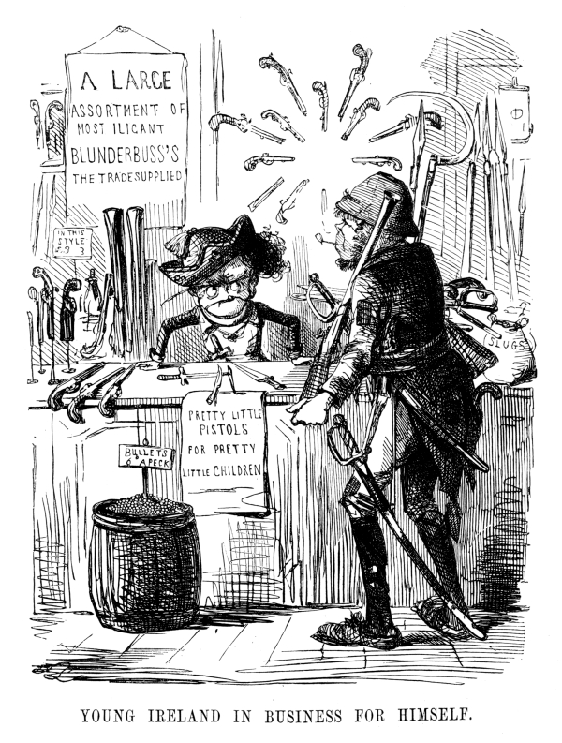
Historic records of Afro-Diasporic peoples in Britain become more substantial and available within the last five centuries. These show a general tendency to disparage or fear immigrants who were poor or working class but welcome and include immigrants who were wealthy. It is in the late-1700s that documentation of the writings of Black Britons begins to be readily found, whether in the form of personal writings such as letters or political publications (Nasta and Stein, Introduction 5).
1 Two Irishmen in a shop, both identified with violence through the prevalence of weapons, and both drawn with facial features similar to those with which Africans and Afro-Diasporic peoples have been caricatured.
Despite pale skin color, Irish and Polish people, as well as Traveller communities, “are sometimes approached by the majority as though [their identities] are innate and unchangeable, and at other times as though [their identities] are simply a choice that people ought to be able to opt into or out of” (Samanani 8). Disempowered groups are both maligned as inherently inferior and condemned for failing to leave their racial, ethnic, or cultural distinctiveness, as a means of maintaining the power differential.
One manifestation of the tendency to group together all disparaged migrants is in political cartooning. “Young Ireland in Business for Himself,” a 1846 cartoon by John Leech shown above, portrays William Smith O’Brien, one of the leaders of the “Young Ireland” movement (and at the time a member of the House of Commons), sitting behind the counter of his shop with an “ASSORTMENT OF MOST ILICANT” weapons. From mocking the Irish accent by the misspelling of “illicit” to identifying the Irish with violence through the prevalence of weaponry in the shop, the cartoon extensively denigrates the Irish. Because the “Young Ireland” movement was distinguished from the larger Irish self-government movement specifically over the larger movement’s repudiation of the use of force, the emphasis on “Young Ireland’s” violence is perhaps fair of the cartoonist.
“Young Ireland’s” cap is of the style called a “Repeal” cap, referring to the movement to repeal the unification of the Irish and British parliaments; the 1801 Act which brought them together in effect afforded the Irish a few seats in a parliament that met in London and was seen by the Irish emancipationists as working against self-government.
His customer is already heavily armed, though one of his “weapons” is a long-handled sickle—a grass-cutting farmer’s tool. The weapons display is cluttered, and the bullets are being sold by the peck (a volume close to two gallons).
Notice both Irishmen are caricatured to resemble apes, a common tactic of editorial cartoonists at the time, in both the US and the UK, suggesting that these men were somehow less than human.
The realities of multiple, similar discriminations against different minority communities in Britain produced a collectivist idea of “political blackness,” a concept highlighting the commonalities shared among different non-white experiences of life in Britain. Inasmuch as there was a tendency to offer racist denigration of many different peoples under the label “Black,” the people subjected to it recognized the potential in working together, sort of an “as far as the racists are against us all, we are all kind of Black” attitude, producing a coalition working against a range of racial and ethnic discriminations. Obviously, “political blackness” is also a problematic identity marker, as it “was defined largely in terms of exclusion or oppression” (Samanani 7).
In Britain today, “Black” tends to be most focused upon two groups: people with recent African ancestry and people with recent Caribbean ancestry. Contemporary conversations about immigration tend to note the “Windrush Generation,” the people who came to Britain from the rest of the former British Empire—especially from the Caribbean—following the Second World War, when a shortage of workers led Britain to legislatively promote such migration from the former colonies.
This kind of understanding of Blackness that is clearly manifest in recent centuries and has been tied to the trade in enslaved peoples as well as ongoing discrimination is rooted in history. The various ways that “dark” and “black” became marks of inferiority and linguistic and visual cues for the discrimination against and denigration of peoples of many different geographical origins and physical complexions is complex and situated in many different historical moments and contexts. Signs and traces of characterizations of people who are less valued or less influential as ‘black’ or as related to Africa exist since before the island of Britain became home to England.

Bibliography to Constructions of Race in Britain
“Black.” Cambridge Dictionary, Cambridge UP, 2020, https://dictionary.cambridge.org/dictionary/english/black. Accessed 28 Dec. 2020.
Leech, John. “Young Ireland in Business for Himself.” Punch 22 Aug. 1846. “File:Young Ireland in Business for Himself - Punch (22 August 1846).jpg.” Wikimedia Commons https://commons.wikimedia.org/wiki/File:Young_Ireland_in_Business_for_Himself_-_Punch_(22_August_1846).jpg Accessed 16 June 2020.
Nasta, Susheila and Mark U. Stein. Introduction. The Cambridge History of Black and Asian British Writing, Cambridge University Press, 2020, pages 1-21.
Samanani, Farhan. “Race in Britain: Inequality, Identity, Belonging.” Runnymede Trust, 2018. www.runnymedetrust.org/uploads/Race-in-Britain-briefing.pdf Downloaded 28 Dec. 2020.

Suggested further reading on Constructions of Race in Britain
Baucom, Ian. Out of Place: Englishness, Empire, and the Locations of Identity. Princeton UP, 1999.
Baumann, Gerd. Contesting Culture: Discourses of Identity in Multi-Ethnic London. Cambridge UP, 1996.
Cesarani, David and Mary Fulbrook, eds. Citizenship, Nationality and Migration in Europe. Routledge, 2002.
Gilroy, Paul. There Ain’t No Black in the Union Jack. Routledge, 2013.
Goldenberg, David. “Racism, Color Symbolism, and Color Prejudice.” The Origins of Racism in the West. edited by Miriam Eliav-Feldon, Benjamin Isaac, and Joseph Ziegler. Cambridge UP, 2009: 88-108.
Ignatiev, Noel. How the Irish Became White. Routledge, 2009.
Innes, Lynn. A History of Black and Asian Writing in Britain, 1700-2000. Cambridge UP, 2000.
Modood, Tariq. “The Rise and Fall of an Anti-Racism: From Political Blackness to ethnic Pluralism.” In New Left, New Right and Beyond: Taking the Sixties Seriously, edited by Geoff Andrews, Richard Cockett, Alan Hooper, and Michael Williams, 168-81. Palgrave Macmillan UK, 1999.

Links to other sections of this Introduction to African and Afro-Diasporic Peoples and Influences in British Literature and Culture before the Industrial Revolution
Preface for Instructors
Reclamations Following a History of Exclusion
Imagining Africa: Entrenching Stereotypes
Race and Religion
Constructions of Race in Britain
An Interview with Josie Gill
An Interview with Angela F. Jacobs
An Interview with Miranda Kaufmann
An Interview with Onyeka Nubia
Brief Biographies of Black People in Britain

An Interview with Josie Gill
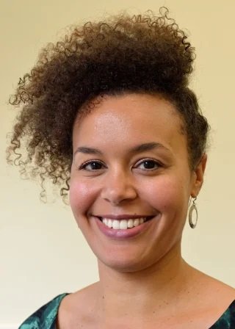
Dr. Josie Gill is Senior Lecturer in Black British Writing in the Department of English and at the Centre for Black Humanities at the University of Bristol. She is the author of Biofictions: Race, Genetics and the Contemporary Novel (Bloomsbury), which won the British Society for Literature and Science Book Prize 2020. She is the Principal Investigator of the Black Health and the Humanities project, which investigates how Black scholarship and creativity shapes and responds to Black Health and wellbeing.
Why should we pay attention to what Black people have historically done in Britain?
For the same reason we should pay attention to what any other people have historically done in Britain. Because it helps to enrich our view of the past, a past which is all too often reduced to narrow narratives and stories that do not capture the complexity and depth of human societies and cultures. Of course, we need to understand that past in order to understand ourselves, and paying attention to what Black people have done in particular helps us to comprehend the mainstream stories that are told about history in a different way; to understand the long histories of globalisation and environmental destruction, for example, that are often positioned as relatively recent phenomena but which are in fact inseparable from colonialism.
In surveys such as the one for which this volume is intended, the main presence of Black people has been in connection with the trans-Atlantic slave trade; while these connections are essential to understanding the history and culture of the period, overemphasizing them skews the history of Black people in Britain. To your mind, what are the most significant effects caused by this distorted emphasis?
I think that the two popular narratives about Black people that historians and others are always striving to overcome are the idea that Black people were enslaved only in the Caribbean, and that Britain has only really had a Black population since the end of World War Two. Both are wrong, as many historians, writers, and artists have shown. Enslaved Black people were routinely brought to Britain in the eighteenth century, often to work in the British houses of (white) West Indian plantation owners. It was at one stage fashionable to have Black servants and many were treated like accessories. In Bristol, where I live and work (and where the statue of the slave trader Edward Colston was torn down in the summer of 2020), two enslaved people, Pero Jones and Fanny Coker, were brought to live at the house of John Pinney, who owned a plantation on the island of Nevis. His house is now a museum, but the stories of Jones and Coker, which have been told by local historians, archivists, and activists, contribute to a re-writing of the narrative that slavery somehow took place elsewhere. They, and many others like them, also challenge the idea that the Black presence in Britain is a twentieth century phenomenon. We know through archaeological analysis that there have been Black people in Britain since Roman times and in 2019 it was revealed by scientists that Cheddar Man, the name of the oldest human skeleton to have been found in Britain, likely had dark skin. Of course, many people do not want to hear these things and I guess the most significant effect of a focus on the trans-Atlantic slave trade is that it potentially drowns out findings such as this, although historians and writers, such as Bernardine Evaristo, have attempted to bring these lesser-known histories to the fore in their work.
A significant element of the recovery of Black history has been the identification of the Black people who have been overlooked; is there a specific individual you find particularly indicative of a lost aspect of that history?
One of the things that I’ve explored in my work is the Black people whose names and identities we will never know; ordinary people who left no material traces other than their bodies. As part of the Literary Archaeology project, I worked with two bioarchaeologists and with seven creative writers to think about how the life experiences of enslaved individuals can be comprehended in the present. Bioarchaeologists examine skeletons and human remains, which in the context of slave burial grounds can tell them where a person was born, how old they were when they died, the diet they had, the kind of work they did, and other information about their health and wellbeing. Looking at individuals from burial grounds in Barbados and Gran Canaria, the project was as much concerned with the ethics of bringing their lives into being through creative writing as it was with what their life experiences were. It’s a way of approaching history that was new to me but which I found incredibly enriching and provoking. We were looking at people who had neither told their own story nor had stories told by others about them. But it is these individuals that I think can tell us new stories about Black history.
For African American students (the majority of our student body), the initial impression of British literature, especially British literature prior to the nineteenth century, is its alienness, as a literature by and for people of another time, country, and race. How far would you say this impression could stand to be corrected?
As a researcher, some of the most interesting discoveries I make, the things that spark ideas and new trains of thought, are often those which come from reading outside of the period and field in which I work. Which is to say that if we only read literature that we think relates to us, speaks to us, is relevant to us and our time, country, and race, then we risk only reading about what is already familiar, known, or understood, even if that literature reveals to us new ways and new approaches to thinking about a certain issue. While it is true that much literature that was written prior to the nineteenth century, or even prior to the twentieth, may not have been concerned with the lives of Black people, it is arguably still our role to understand why that was the case, and the role that the representation of Black people had in the development of literary production and more widely in various societies. But also, I’m not convinced that the answer to white supremacy and the exclusion of Black voices from the curriculum is to reverse this so that we only consider the literature written by one ‘race’ of people, so that we adopt the limited and myopic view of what matters that has characterised many traditional literature curricula. A close reading of Renaissance and eighteenth century literature, while at first challenging, may reveal some of the roots of our current literary and social worlds, enhancing our understanding of forms of thought and expression which still occur today, albeit in different form.
One register that particularly impedes American understandings of the history of Black people in Britain is class. Would you discuss the importance in your work of distinguishing the often-overlapping categories of race and class?
What is interesting about many of the West Indian migrants who came to Britain from the 1950s onwards is that many of them were middle class; many were qualified teachers or professionals who found themselves, once in Britain, only able to access jobs in factories or in trades in which people with their levels of education were rarely found. Others were recruited to work for London Transport as bus conductors or tube train drivers or as nurses to work in the NHS. But whatever background they may have come from in the Caribbean, once in Britain they were all treated in the same way. So I think a lot of the divisions between people that may have existed before they emigrated dissolved in the face of British racism, and it is important to understand that West Indians only began to understand themselves as West Indian or Caribbean when they came to Britain.
How would you compare the legacy of the Black experiences in Britain to the weight of the enslavement of African Americans in the context of 21st century America?
I think there are many similarities between Black experiences in Britain and America, police brutality being one, although there is sometimes a tendency for American racism to be the focus of popular and public attention in the UK. This may be changing though, as the global BLM movement of 2020 placed renewed attention on Black deaths at the hands of the police in Britain. The stories of Black people who have been killed or injured by the police are increasingly being told through art and writing. Steve McQueen’s Small Axe (2020) series of films foregrounds the pervasiveness of the racism experienced by Black Britons in the 1960s and 1970s; Lee Lawrence’s The Louder I Will Sing is an account of his mother Cherry Groce’s death, after she was permanently disabled following a police shooting; Roy McFarlane’s poetry collection The Healing Next Time (2018) takes inspiration from Claudia Rankine’s Citizen to address police killings in the wake of the shooting of Mark Duggan, which sparked the London riots in 2011.
The Centre for Black Humanities, which you recently directed, supports scholarship on "the artistic and intellectual work of people of African descent"; such deliberatively broad framing does a lot of work. It also risks blurring together a lot of cultural distinctions. Could you discuss the benefits that make this risk worthwhile?
Well we discussed these issues a lot when we were setting up the CBH! They are actually more complicated than you might imagine, because in Britain the term ‘Black’ was used in the 1970s and 80s by some coalitions of ethnic minority groups who came together to fight racism under that banner (see for example the Southall Black Sisters). Today, when people use the term ‘Black’ in Britain they are referring to people of Afro-Caribbean or African descent. But yes, this still encompasses a lot of different histories and geographies, and we have people in the Centre working on Black histories and cultural production in Africa, Britain, the Caribbean, the US, South America, and beyond. I guess one of the main benefits for us is institutional and structural. As a group of scholars we are all broadly committed to eradicating racism within our university and to addressing lacunas in the curriculum, so having a space (albeit a virtual one right now!) where we can support each other in these endeavours, and engage with one another’s work is important. Each of us are engaged with our own specific projects, and while it could be argued that organising under the name ‘Black’ is somehow essentialising Blackness and playing into the hands of those who would rather not have to consider it, we have found strength and solidarity in framing the Centre in this way, as well as intellectual congruences in our work.

Links to other sections of this Introduction to African and Afro-Diasporic Peoples and Influences in British Literature and Culture before the Industrial Revolution
Preface for Instructors
Reclamations Following a History of Exclusion
Imagining Africa: Entrenching Stereotypes
Race and Religion
Constructions of Race in Britain
An Interview with Josie Gill
An Interview with Angela F. Jacobs
An Interview with Miranda Kaufmann
An Interview with Onyeka Nubia
Brief Biographies of Black People in Britain

An Interview with Angela F. Jacobs
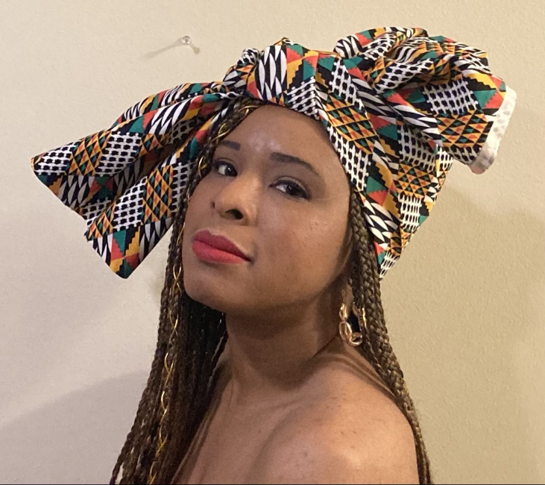
Angela F. Jacobs, a California native, is a PhD Candidate at Old Dominion University. She currently teaches Freshman Composition at North Carolina A&T State University. Her research interests are in Rhetoric and Writing Studies, Black British Literature and History, and Feminist Rhetorics. Jacobs’ first published play is Ode to a Saturday Nighter. She received her BA in English Literature from Catawba College and her MA in English Literature from the University of Dayton. She has been published in Watchung Review, Media Commons, and Virginia Humanities Conference Journal Proceedings where she explored issues of race, representation, and gender.
Why should we pay attention to what Black people have historically done in Britain?
Both Edward Scobie and Gretchen Gerzina, scholars of Black British history, assert that there is ample evidence that Britain has maintained a consistent African presence from around the sixteenth century (after an initial introduction by the Romans in the fourth and fifth centuries). There were also roughly around 20,000 African people who lived in London during the eighteenth century alone (Gerzina, “Black London”), which means this continued presence of Africans on British soil changes the perception of Britain’s make-up and its relationship with Africa. Not only did Africans reside in Britain before the twentieth century, they made their mark on the culture and society of Britain as well. In fact, even the BBC article “Britain's First Black Community in Elizabethan London” includes several examples of Africans who resided during this famous and influential period, such as John Blanke, a Black trumpeter for both Henry VII and Henry VIII. This article also states, in regards to the “remarkable works of prose, poetry and music” by Black Britons, that “the likes of Olaudah Equiano, Ottobah Cugoano and Ignatius Sancho deserve their place in any list of Great Britons.” A few examples of notable Black Britons include Dido Elizabeth, the grandniece of Lord Mansfield, Chief Justice who presided over the Zong Massacre (1781), which undermined the slave trade in Britain; Samuel Coleridge-Taylor, a Victorian composer; Mary Seacole, a British Jamaican business woman who served during the Crimean War; wrongfully-enslaved African prince, Job ben Solomon (1701-1733), the inspiration of several characters in plays and novels); and Sarah Forbes Bonetta, Queen Victoria’s goddaughter, who assisted with the Sierra Leone project.
However, as several scholars have noted, many Black Britons were ordinary people who lived ordinary lives, the same as their white counterparts. They were citizens who lived, worked, married, were baptized, and died, basically showing that their existence, though extraordinary to us now, were mundane, showing how they were integrated into regular British society. This is particularly important since their stories are mostly lost. As Audrey Fisch notes, since most students of Victorian literature learn this literature through anthologies, with anthologies not being known for staying abreast of cutting edge scholarship, “[t]he problem is that my students’ only exposure to the Victorian period comes from a survey of the Romantic/Victorian period...Since many of my students are going on to teach secondary and elementary school, mostly in urban environments, the political ramifications of the Norton’s omissions are troubling” (354). This is true for the majority of English literature courses, with anthologies being the preferred choice of text due to their costs and efficiency. Unfortunately, much is sacrificed for efficiency, such as these types of narratives, which often get lost in the failure to fully explore the complexities of life in Britain, such as its true multicultural nature. It is important to correct and complete this narrative (the Black Britons were free, not enslaved, as slavery was not allowed in England). This knowledge gives more layers to British literature, making it more accessible to students and readers of color.
In surveys such as the one for which this volume is intended, the main presence of Black people has been in connection with the trans-Atlantic slave trade; while these connections are essential to understanding the history and culture of the period, overemphasizing them skews the history of Black people in Britain. To your mind, what are the most significant effects caused by this distorted emphasis?
The distortion greatly minimizes Africa’s agency as a continent rich with its own history and culture outside of outside influence. It also negates the positive interactions Africa has had with other continents, such as with Europe. This distorted picture paints Africa as a mere pawn in the building of the greatness of Western Europe instead of a major site of greatness in its own right. It’s also an oversimplification of the history of the slave trade, which many scholars have noted that Africa was already engaged in before the British. As Miranda Kaufmann notes, Portugal brought enslaved Africans to Europe in 1444. Also, Kaufmann notes how not all slaves were African, with the word ‘slave’ being a derivative of the word ‘Slav,’ referring to the Slavonic people of Eastern Europe who were enslaved by the Holy Roman Empire starting in the tenth century.
As it concerns Britain's history with Africa, which spans from just before the fall of the Roman Empire, this distortion greatly minimizes the true complexity of their interactions, making these interactions merely transactional and superficial. It also creates a false mirror with that of America’s history with the trans-Atlantic slave trade, also a minimized and distorted history. Britain has a rather complicated history with Africa, filled with a multitude of reciprocal transactions. Typically, this transactional aspect obviously includes slavery, but also other forms of labor, which include cultural work. As stated in the previous question, the Black Britons weren’t slaves as slavery wasn’t allowed in England (though a Black servant did run the risk of being sold into slavery and shipped to places like Jamaica, as evidenced by the plight of Jonathan Strong, a seventeen-year-old African during the late eighteenth century) (Gerzina, “Black London”). However, the history of Black Britons before the eighteenth century is equally as rich, especially during the Tudor Age. In fact, according to Kaufmann, “In many ways, [Black] lives were no worse than those of the vast majority of Tudors: ‘nasty, brutish, and short,’ but this was the result of having no social standing, not of having dark skin” (5-6), with Kaufmann also noting how social status determined the person’s treatment, regardless of skin color and that all outsiders were initially distrusted (though xenophobia was still an issue). The cultural implications included all forms of the arts, such as plays, music and musical compositions, cultural exhibitions, and literature, though these were primarily written about Africans rather than by Africans in Britain; however, several Black Britons did lend their unique voices to Britain's cultural past, such as Olaudah Equiano, Samuel Coleridge-Taylor, and Mary Seacole. In fact, Britain was very much enamored with all things African, as the eighteenth and nineteenth century blackamoor art and African bizarres can attest, though Africans themselves lived a precarious existence.
The distortion also undermines the necessity of Africa to Britain’s struggle towards identity. Although Britain recognizably struggled with its identity at the apex of its empire, this struggle began much earlier. As Gerzina notes, the British only became white once Africa entered the picture (“Black London”). As Kaufmann points out, before the sixteenth century, Britain was a fledgling kingdom compared to its more powerful continental counterparts, Spain, Portugal, and France, with Spain and Portugal initially beginning the trans-Atlantic slave trade in the fifteenth century (Britain didn’t “successfully” join the trans-Atlantic slave trade until the 1640s after an unsuccessful attempt by John Hawkins in the 1560s). Obviously fortunes changed for Britain, through successful battles against Spain, especially, so much that by the end of the nineteenth century (the Victorian Age) Britain emerged as the world superpower, with slavery helping to drive Britain’s economic success. However, as Antoinette Burton notes in her analysis of Jane Eyre, though Britain was embroiled in the slave trade and other acts of imperialism, they did not like being reminded of this connection for, as the Somerset case (1772) re-asserted, there were to be no slaves in England, which I’m sure would surprise many people.
A significant element of the recovery of Black history has been the identification of the Black people who have been overlooked; is there a specific individual you find particularly indicative of a lost aspect of that history?
There are so many people who I have discovered who I would love to learn more about, such as John Blanke and the lives of the Black Tudors, who I recently discovered. However, due to the gendered nature of canonical literature, with male voices, regardless of race, getting more attention than female voices, I would posit that Mary Seacole definitely qualifies as being part of the lost history of Black people in Britain. Although she technically hails from Jamaica, a British colony at the time, she was a business woman who wrote her own autobiography, in which she details her own experience working as a nurse during the Crimean War, despite getting little attention compared to her much-celebrated English counterpart, Florence Nightingale. What I find especially remarkable is this text is written in her own words during the Victorian Era, where Black British voices seem to have been practically silenced. Not satisfied with her efforts being ignored, her narrative provides a first-hand account of her own experiences and reveals the manner in which she carefully crafted her narrative to appeal to a predominantly white British audience. As a mixed-race woman (Scottish father and Jamaican mother), Seacole’s experiences give a glimpse into the delicate nature of her social status: free, but with limited civil rights (BBC: History). It also gives a name and face to a Black British citizen during a time period where she, according to popular thought, was not thought to exist. Her tenacity and cultural experiences provides readers with a snapshot of Black British Victorian life.
For African American students (the majority of our student body), the initial impression of British literature, especially British literature prior to the nineteenth century, is its alienness, as a literature by and for people of another time, country, and race. How far would you say this impression could stand to be corrected?
So much needs to be corrected about the lack of representation within British Literature overall. As an African American undergraduate student, I was so intrigued by British Literature and greatly enjoyed it, especially Shakespeare and Austen. This love carried over into my English master’s program, where I learned more about Chaucer. I also have British cousins, with my uncle having moved to the UK over 40 years ago and marrying an English woman. Having this connection has always been a point of pride for me, my imagination running wild with what my uncle and cousins must be experiencing over in Britain. However, I remember a chance encounter with The Cambridge Companion to Black British History at the Wright State University Paul Laurence Dunbar Library (Dayton, OH), which started me thinking about the Black British experience, in general. Discovering this text made me wonder even more about the experiences of other Black British people outside of my family. I also started wondering how could a former slave-holding nation not have slaves on their soil, as in the U.S.?
After conducting research for a Victorian Institute conference in 2018, I was finally provided the opportunity to delve more into the Black British experience, especially during the Victorian Era and parts of the history leading up to this time. What I learned shook my entire understanding of the Black British experience, opening up a whole new world of British history I feel I had previously been denied. As a former Victorian Lit instructor, I have first-hand knowledge of just how much further British Literature instruction has to go in order to be much more inclusive so that all students understand the true diversity within British literature, culture, and history. My question earlier about slavery in Britain would certainly cross the mind of an African American student, seeing as how Britain helped bring slavery to the America colonies. However, understanding that English law practically banned slavery on English soil would most definitely intrigue students, especially combined with the knowledge of the rich communities and lives of Black Britons since the fifteenth century. In addition, many African American students will be able to relate to the concept of being both insider and outsider and feeling like a racialized Other, a concept practically intrinsic to the experiences of Black Britons. There are many gaps in knowledge, but with projects like these, these gaps should be getting closer to narrowing.
One register that particularly impedes American understandings of the history of Black people in Britain is class. Would you discuss the importance in your work of distinguishing the often-overlapping categories of race and class?
Race and class are especially vital as it pertains to the Black British. Despite their precarious existence, they basically covered all the class systems, from the royal court to enslavement. Even though there is still debate as to whether or not Queen Charlotte (wife of notorious King George III) was Black, there are instances of a Black presence in the royal court, such as King Henry VII’s trumpeter, John Blanke, and Queen Victoria’s goddaughter, Sarah Forbes Bonetta. There is also Chief Justice Lord Mansfield’s grandniece, Dido Elizabeth, as part of the wealthy elite. There are also several examples of African kings sending their sons to be educated in Britain (Gerzina, “Black Victorians”). However, the vast majority of the Black British lived far from such privileged experiences. For example, during the reign of King James I, there are instances of young Black boys basically being the pets of wealthy white families, complete with collars to symbolize the wealth of their owner. As Scobie notes, “At about this time it became the vogue for titled and eminent persons to keep blackamoors as pets...There was a good reason for the popularity of these plump-faced little boys whom society women dressed exotically in eastern rather than African dress. A black-skinned attendant showed off the whiteness of his mistress’ skin to great advantage” (9). Despite these kept few, most Black British lived amongst the working classes, working alongside their white counterparts in various occupations, such as servants (“Britain's First Black Community”). However, it was not uncommon to find Black Britons in entertainment occupations. As Scobie notes, “This English love of the ‘Noble Savage,’ the Black man of talent and accomplishment, has never failed to excite wonder and bewilderment; for, while the English will put up all sorts of social and constitutional barriers in order to prevent Black people from entering and living in Britain, they will, at the same time, sing the praises of Black writers, poets, singers, musicians, cricketers, athletes, or boxers” (87). These social and constitutional barriers were much the same as in America, with Black Britons having few civil rights.
It is important to understand the complete story of the intersection of race and class amongst the Black British in order to dispel any misconceptions about Blackness, namely the stereotypical image of the enslaved African or the poor Black person in an urban area. As British history can attest, the Black British experience ran the gamut of class well before the twentieth century. As scholars have noted, Black Britons were integrated into British society: intermarrying, attending church, and receiving proper Christian burials (“Britain's First Black Community”). They were not in the shadows or nameless, faceless denizens ignored by the greater British society. They were not entirely treated as second-class citizens as might be supposed or expected.
How would you compare the legacy of the Black experiences in Britain to the weight of the enslavement of African Americans in the context of 21st century America?
The erasure of the Black British experience from prior to the twentieth century, is almost more tragic than the African American experience. Although we have faced so much discrimination throughout our history in America, with the weight of enslavement hanging heavy upon our shoulders, at least our history and our voices exist and have been given meaning in the greater American history and American literature. Our experiences matter and are well-known. We are visible, which makes a huge difference in our legacy, even as we still grapple with the implications of this complex history. Unfortunately, for the Black British, their history practically starts after 1945, with the docking of the Empire Windrush at Tilbury in 1948 (Kaufmann 1). Obviously, this is incorrect, as several scholars have noted. However, their history prior to the 20th C is erased, either being relegated to African or Caribbean history instead of British history or completely reduced to the history of the trans-Atlantic slave trade. This separation further ‘others’ the Black British experience and gives the false impression that the Black British story is simply one of immigration instead of one of integration. The lack of visibility negates the true depth of their belonging to Britain proper.
It also negates the true depth of the racialization of people of African descent by the British, a racialization that Kim F. Hall posits in her exploration of the racial linguistic markers in British works. While most scholars relegate the mentions of blackness to religious meanings, Hall notes their double meaning to include the material nature of blackness with that of African people, which she notes started in the mid-sixteenth century and can even be seen within many of Shakespeare’s plays, such as A Midsummer Night’s Dream and Othello (22, 8). This racialized language could only truly result due to the physical presence of African people at the time this language morphed to include racial, and not just religious, implications. As I watched videos from the summer of 2020—in particular, the impassioned speech by John Boyega, a Black British actor, condemning the current state of affairs for current Black Britons and the work of Steven R. McQueen’s Small Axe film series exposing the history of Britain’s Caribbean population—it is very telling that, much like in the US, more work is needed for understanding the depths of institutionalized racism in Western nations. While African Americans can point to the institution of slavery as the catalyst, Black Britons, and Britons in general, are largely ignorant of just how far back their catalyst begins, which is important for their journey towards racial justice.
You have published work on the exclusion of Black peoples and authors from canonical literature. Can you speak to how best these people and figures deserve to be included and celebrated in the history of Western Literature?
Although many institutions have already created specific courses on literature of people of color as standalone courses, which I believe is truly amazing work, I would argue that these works should not solely be separated from the general context from which they emerged. In other words, although many institutions have a standalone African American Literature course (or courses), these types of separate courses should not be the only way in which literatures of people of color should be addressed. While these standalone courses can provide more in-depth focus on the issues and the voices of a specific group of authors and their works, this separation can be argued to further mark these literatures as ‘Other’ instead of being part of the bigger picture of the canons themselves. In my article “The Canon Takes No Notice of the Negro: Recovering the Victorian Hunger of Blackness for the Victorian Literature Course,” I argue for this inclusion under the concept that the African experience is already integrated within the Victorian literature, even if this integration seems minute, such as within Vanity Fair (Miss Swartz) and Jane Eyre (Bertha Rochester). Yes, I love that there are standalone specialty literature courses for peoples of color; however, these courses should not be the sole means by which students learn of these literary works. Much like works by women authors are not typically separated from their male counterparts, so should the works of people of color or minorities be integrated into the larger literary canon in which they exist. These works should be considered just as important within Western Literature as the works of white authors. Integrating these works provides a fuller picture of Western Literature, illustrating the true complexity of the Western experience. At the risk of minimizing these works in any way, it would be helpful for students to see these works as not being extraordinary inclusions, but routine or pedestrian in their inclusion so that it does not seem special, but natural, for these works to be included. Why shouldn’t an Eighteenth Century Literature course include William Ansah Sessarakoo’s The African Prince: Or, Memoir of the Young Prince of Annamaboe (1750), a true account of an African prince being sold into slavery? Why shouldn’t a Victorian Literature course include The Wonderful Adventures of Mrs. Seacole in Many Lands (1857)? Students should be exposed to these works and others like them in order to become accustomed to seeing diversity in practice. Yes, these works should be celebrated (with a standalone Black British Literature course being created, as well!), but these celebrations should not further ‘other’ these works of literature; these celebrations could simply be their inclusion alongside their white counterparts, elevating their voices, even when serving as counters to the messages and issues white authors address within their works or as a means of showing how particular issues, regardless of race, class, or gender, can be rather universal.
Queen Elizabeth has been held up for centuries as one of the most influential and powerful monarchs in England’s long monarchy. Can you speak to her role in the erasure of Black people in Renaissance England?
As Hall notes, while King James I seemed to welcome Africans into the country, Queen Elizabeth I sought their expulsion, signaling a desire towards insularity and herself “as the pure and fair national body” (176). Although Kaufmann contradicts accounts of Elizabeth I’s attempts to expel Africans from England in 1596 (her Privy Council gave a merchant, Casper Van Senden, a special license to remove Africans with their master’s permission—which he didn’t always attain), it cannot be argued that Elizabeth I was a fan of the growing number of Africans entering England under her reign (Kaufmann 2). According to Gerzina (“Black London”), Queen Elizabeth I tried to have Africans expelled from England based on the idea that they were taking jobs from low-wage white workers. She also saw the growing African population being un-Christian, despite reports of Black Britons having baptisms, marriages, and burials as evidenced in parish records (“Britain's First Black Community” and Kaufmann 5). Clearly, she saw the African presence within England as being a threat to the English people, despite their integration into British society.
Ironically, despite these edicts, Elizabeth I’s stance against the growing African population was in conflict to her actions. As Gerzina (“Black London”) stated, like her father before her, Elizabeth I employed African entertainers and she helped bankroll the slave trading efforts of Sir John Hawkins, which actually increased Britain’s African population, along with the freed slaves from captured Spanish ships (“Britain's First Black Community”). Whatever the reality of the lack of enforcement of African repatriation attempts, the fact remains that lines were drawn: Elizabeth I did not want Africans in England or any others who she saw as damaging to British national identity. The relegation of Africans to forms of entertainment also aided in this erasure as Africans were deemed merely as sources of entertainment, thus not real people. My research also failed to turn up any evidence that Africans born on English soil were to be considered English in terms of their national identity. In essence, Africans were reduced in public thought and representation, with various attempts made to remove them from Britain altogether.

Bibliography to Angela F. Jacobs Interview
“Britain's First Black Community in Elizabethan London.” BBC News, BBC, 20 July 2012, www.bbc.com/news/magazine-18903391.
Burton, Antoinette. “Recapturing Jane Eyre: Reflections on Historicizing the Colonial Encounter in Victorian Britain.” Radical History Review, vol. 1996, no. 64, 1996, pp. 59–72.
Fisch, Audrey. “Black British Studies in the Victorian Period.” Victorian Literature and Culture, vol. 30, no. 1, 2002, pp. 353–364., https://doi.org/10.1017/S1060150302301189.
Gerzina, Gretchen. Black London Life before Emancipation. Rutgers University Press, 1995.
----. Black Victorians/Black Victoriana. Rutgers University Press, 2003.
Hall, Kim F. Things of Darkness: Economies of Race and Gender in Early Modern England. Cornell UP, 1995.
“History - Historic Figures: Mary Seacole (1805 - 1881).” BBC, BBC, 2014, www.bbc.co.uk/history/historic_figures/seacole_mary.shtml.
Kaufmann, Miranda. Black Tudors: The Untold Story. London: One World, 2017.
Scobie, Edward. Black Britannia: A History of Blacks in Britain. Chicago: Johnson Pub. Co, 1972.

Links to other sections of this Introduction to African and Afro-Diasporic Peoples and Influences in British Literature and Culture before the Industrial Revolution
Preface for Instructors
Reclamations Following a History of Exclusion
Imagining Africa: Entrenching Stereotypes
Race and Religion
Constructions of Race in Britain
An Interview with Josie Gill
An Interview with Angela F. Jacobs
An Interview with Miranda Kaufmann
An Interview with Onyeka Nubia
Brief Biographies of Black People in Britain

An Interview with Miranda Kaufmann

Dr. Miranda Kaufmann is the author of the Wolfson History Prize and Nayef Al-Rodhan Prize shortlisted book Black Tudors: The Untold Story (2017). She studied History at Christ Church, Oxford and is now an Honorary Fellow of the University of Liverpool, a Fellow of the Royal Historical Society and of the Royal Society of Arts, and a Senior Research Fellow at the Institute of Commonwealth Studies, School of Advanced Study, University of London, where she co-convenes the 'What's Happening in Black British History?' workshop series. She is currently working on her second book, Heiresses: Slavery & The Caribbean Marriage Trade; is Lead Historian for the Colonial Countryside project; and is taking her work into schools with her Teaching Black Tudors project. www.mirandakaufmann.com
2 Photo credit: Rose Collins
Why should we pay attention to what Black people have historically done in Britain?
Firstly, because their histories are intrinsically fascinating in their own right and are too little known. Telling their stories is a form of restitution, putting Black lives back into the narrative that has often excluded them. It is also vital to have an understanding of Black British History in order to understand the history of racism, when and how it emerged and manifested itself, to better equip us to take antiracist action today. Part of that history is that before, after and even during the period of British involvement in enslavement, Africans had diverse experiences in England, Scotland, Wales and Ireland, which were very different environments to that of the British colonies. In the period I have studied in most depth, the Tudor and early Stuart period, from around 1500 to 1640, Africans were not enslaved: in fact they intermarried with English people, were baptized and allowed to testify in court: civil liberties that are sometimes unexpected.
In surveys such as the one for which this volume is intended, the main presence of Black people has been in connection with the trans-Atlantic slave trade; while these connections are essential to understanding the history and culture of the period, overemphasizing them skews the history of Black people in Britain. To your mind, what are the most significant effects caused by this distorted emphasis?
Reducing Black British History to the enslavement narrative has several negative effects. It can actually bolster racist views of the past, along the lines of “Africa had no history before the Europeans arrived,” “Africans never achieved anything,” “Africans had no personhood,” “Africans were all the same,” etc. Another problem is when the only images or presentation of Africans that children see in their school textbooks or in museum displays is of Black bodies half naked and in chains. This can not only turn Black children off history, but also undermine their sense of self-worth. It can also perpetuate the negative stereotypes I mentioned in all young people.
A significant element of the recovery of Black history has been the identification of the Black people who have been overlooked; is there a specific individual you find particularly indicative of a lost aspect of that history?
In my book Black Tudors, I focused on ten individuals, out of the hundreds I discovered living in England (and to a lesser extent, in Scotland) in the period. It’s hard to choose just one person to talk about now! John Blanke, the court trumpeter; Jacques Francis, the salvage diver who worked on the wreck of the Mary Rose; and Reasonable Blackman, the Southwark silkweaver are examples of people who had lucrative skills. Edward Swarthye, who whipped a white man (who would become a future colonizer) in Gloucestershire in 1596 confounds our assumptions about who wielded the whip in history. Dederi Jaquoah, a prince from modern day Liberia who visited London in 1610-12 is of a higher status that people might expect Africans to be in that place and time. Cattelena of Almondsbury shows that not all Africans lived in port cities, but might also be living quiet rural lives. That John Anthony worked as a waged sailor aboard a ship bound for Virginia in 1619 is a fascinating contrast to the lives of the 20 or more Angolans who arrived in Jamestown that same year.
For African American students (the majority of our student body), the initial impression of British literature, especially British literature prior to the nineteenth century, is its alienness, as a literature by and for people of another time, country, and race. How far would you say this impression could stand to be corrected?
Well, as they say, “The past is a foreign country; they do things differently there.” To some extent, the practice of history is to take an imaginative leap and try to understand people who are alien to all of us in the way they thought and acted. At the same time, there are human qualities that unite us all, regardless of race, class, gender or time period, and they are there to be found in all literature: which is why we still perform plays and read novels or poetry written hundreds of years ago. That said, there is plenty of British literature that features characters of African descent. This goes way beyond Shakespeare’s Othello, Aaron, Cleopatra, Caliban and the Prince of Morocco. A man named Gormund, King of the Africans, appears in Geoffrey of Monmouth’s 1137 History of the Kings of Britain, where he is said to have brought his people to settle in Ireland and help the Saxons invade Britain. In the early modern period, Black characters also appear in the works of Webster, Massinger, Dekker, Fletcher and others. In total, Eldred Jones listed 43 masques, plays or pageants including Black characters between 1510 and 1637, while Elliot Tokson has identified some 44 Black characters in 29 plays written between 1588 and 1689. It has been suggested that Shakespeare’s Dark Lady sonnets be renamed the “Black woman sonnets” – and indeed a whole series of 17th century poems, such as Eldred Revett’s “One Enamour’d on a Black-Moor” were clearly addressed to African women. And Black characters continue to appear in the 18th century, though that’s a period I know less about. Of course these are all texts written by white men (with the exception of Aphra Behn’s 1688 novel Oroonoko. But there are works by people of colour published in Britain before the 19th century. These include the autobiographical so-called ‘slave narratives’ of Ukawsaw Gronniosaw (1772), Olaudah Equiano (1789), Boston King (1798), Mary Prince (1831)—obviously 19th century, but still relevant I feel!—and abolitionist texts such as Thoughts and Sentiments on the Evil and Wicked Traffic of the Commerce of the Human Species by Quobna Ottobah Cugoano (1787). Not all writing published by people of colour was directly related to enslavement: The Letters of the Late Ignatius Sancho, An African (1782), covered topics from the arts to politics, from family life to street life, and revealed the life of a man who was simultaneously a London grocer, man of letters who corresponded with the great and the good, and the first Black Briton to vote in an election, who had his portrait painted by Thomas Gainsborough. Though Phyllis Wheatley was from Boston, her poetry was published in London in 1773. The first Indian I’m aware of to publish a book in English was Sake Dean Mohammed, a shampooing surgeon, restaurateur, and entrepreneur, whose The Travels of Dean Mahomet came out in 1794. So there’s plenty to challenge impressions there!
For more see:
- my article “‘Making the Beast with two Backs,’ – Interracial Relationships in Early Modern England,” especially the Bibliography, here: http://www.mirandakaufmann.com/uploads/1/2/2/5/12258270/kaufmann-2015-literature_compass.pdf ;
- Vincent Carreta, Unchained Voices: An Anthology of Black Authors in the English-Speaking World of the Eighteenth Century (1996);
- Ryan Hanley, Beyond Slavery and Abolition: Black British Writing, C.1770-1830 (2018);
- C L Innes, A History of Black and Asian Writing in Britain, 1700–2000, 2nd edition (Cambridge: Cambridge University Press, 2008);
- The Cambridge History of Black and Asian British Writing, edited by Susheila Nasta and Mark U. Stein, Cambridge, Cambridge University Press, 2020.
- And some useful webpages on the British Library website: https://www.bl.uk/romantics-and-victorians/articles/british-slave-narratives; https://www.bl.uk/restoration-18th-century-literature/articles/african-writers-and-black-thought-in-18th-century-britain
One register that particularly impedes American understandings of the history of Black people in Britain is class. Would you discuss the importance in your work of distinguishing the often-overlapping categories of race and class?
I’m not sure American society is as classless as this question implies. Perhaps it would help to think about the issue in terms of wealth? While wealth is not the only element of the British class system (what one might call “birth” or “lineage” or cultural capital is also key), I think everyone can understand the concept of gradations between a rich elite and those on the poverty line. And many “upper class” people in fact bought their way into that position over the centuries, usually by buying land, building a big house, etc., having made money as a merchant for example. In the reign of James I, you could buy a baronetcy (the lowest rung on the aristocratic ladder) for £1000. As you say, there are often intersections between race and class. In the early modern period, race does not appear to be the primary determinant of how a person is treated. For example, when the Moroccan embassies visit the court of Elizabeth I, they are treated with diplomatic courtesy. When Francis Drake needs the help of the Panama Maroons in the 1570s, they are treated as military allies. Princes from West Africa like Dederi Jaquoah are treated with dignity and returned home. However, when Africans arrive in England having been captured by privateers for example, they have to start from scratch. Besides class and race (which was not conceived of in the way it is now), religion was perhaps the most important factor of all in Tudor society that governed how people were treated. There were fierce divisions between Catholics and Protestants, and non-Christians were not tolerated. The small number of Jewish people had to practice their faith in secret, while openly conforming, including attending Church services (people who did not attend were subject to fines). This is likely why many Africans converted to Christianity and were baptized after arriving in England, as it was necessary to make one’s way in Tudor society.
How would you compare the legacy of the Black experiences in Britain to the weight of the enslavement of African Americans in the context of 21st century America?
This is a huge topic, and really not my area of expertise, but I’ll throw out some thoughts. I think it’s important to remember that although there were no plantations reliant on the forced labour of enslaved Africans located in the British Isles, Britain did have these in their Caribbean colonies—and indeed, before 1776, in mainland America. So, people of Caribbean descent in Britain today are also descendants of enslaved people, just as many African Americans are, whose unpaid labour directly benefited Britain over generations. There are also Black people in Britain whose families have immigrated from Africa, many from countries, like Nigeria, which are former British colonies. In those cases, those people have that colonial baggage in a way they don’t have directly in the United States. Another contrast is that the Black population in Britain is smaller, around 3% in the 2011 census (though we should have a bigger figure when the census is conducted again this year [2021]), whereas I believe in the United States, it’s closer to 13%? So, the Black experience in Britain is different, but the legacies of enslavement and colonialism are just as deeply felt, manifesting in everything to policing and the justice system to education, which is why the murder of George Floyd resonated so much here last summer, with over 200,000 people (many of whom were white) turning up to Black Lives Matter protests. There has been a backlash too though, with many public commentators refusing to acknowledge the racism in our society. This is possible partly because the most brutal enslavement happened overseas, making it easier to disavow than in the United States.
So much of your work shows specific historical individuals which obviously helps counter the erasure of these people from history itself but much of the primary material you work with is still filtered through a very white class of historians (and other record keepers). Can you talk about your approach to interpreting these, at times, very subjective materials.
It is a constant, but worthwhile, struggle to read against the grain of sources to tease out the life stories of Black people. I use, for example, parish registers of baptisms, marriages, and burials; legal documents; household expenses accounts; and letters, all written by the literate white male elite. And secondary sources can be just as troublesome; again most history books until quite recently have been written by elite white men, whose own prejudices can be seen in the way they write. One biographer of Francis Drake (and indeed his editor) saw no problem in a book published in the 1990s with mentioning Maria, an African woman Drake captured from a Spanish ship, merely in passing as a way the sailors could “relieve the tedium” of the voyage across the Pacific.
Reading against the grain is a concept I first encountered as an undergraduate in the work of Daniel K. Richter, who wrote about Native Americans. It is about asking questions of the source from an opposite point of view- what can this tell us about the experience of the Black person, what did it mean to them? This can be hard work, as it is difficult when quoting sources not to, even subconsciously, reproduce the viewpoint of the writer. It is also important for me to recognize that I am also a privileged white woman, coming to the source material with my own preconceptions and prejudices. Sometimes I’m going to get it wrong, or miss something. Here, I try to listen and learn from a diverse range of voices, by seeking out the growing volume of scholarly work authored by people of colour, by attending seminars, lectures, and workshops with Black speakers, and by discussing my conclusions with as many different people as possible.
Black Tudors brings many specific historical persons to life in its pages, effectively countering the erasures of Black people from English history. Many of these people seem to lower or working class people. To what extent would you say this is true and how does this kind of positionality create challenges in representing them to a contemporary audience?
The people in Black Tudors have a range of experiences—John Blanke, as a royal trumpeter was relatively privileged compared to someone working as a servant in a more lowly household, like Mary Fillis, who worked for a seamstress. Dederi Jaquoah was a prince, Reasonable Blackman the silkweaver was an artisan, or some might say businessman, like the anonymous Black needlemaker of Cheapside, London, who ‘would not teach his art to any’ (effectively creating a monopoly on his skill of making Spanish steel needles, at a time when the English only made them from bone or wood). There does seem to be a desire amongst some people today to hear of Black Kings and Queens, of powerful leaders, the sorts of “great” men and women who have traditionally peopled the history books. And Black Tudors can’t really fulfil that; none of the people I write about really wielded significant power in that way. Though other work looking at a similar period, such as Toby Green’s, on West African Kingdoms such as Benin, or Olivette Otele’s, on Queen Nzinga of Angola, can perhaps better satisfy that desire. But at the same time, I wouldn’t say that modern audiences are uninterested in more “ordinary” people. History has moved on in many ways from “great men” narratives; social historians are uncovering more and more fascinating details of how, let’s not forget, the majority of people lived their lives in the past. Those stories are worth telling, and I’ve found plenty of people who want to listen!

Links to other sections of this Introduction to African and Afro-Diasporic Peoples and Influences in British Literature and Culture before the Industrial Revolution
Preface for Instructors
Reclamations Following a History of Exclusion
Imagining Africa: Entrenching Stereotypes
Race and Religion
Constructions of Race in Britain
An Interview with Josie Gill
An Interview with Angela F. Jacobs
An Interview with Miranda Kaufmann
An Interview with Onyeka Nubia
Brief Biographies of Black People in Britain

An Interview with Onyeka Nubia
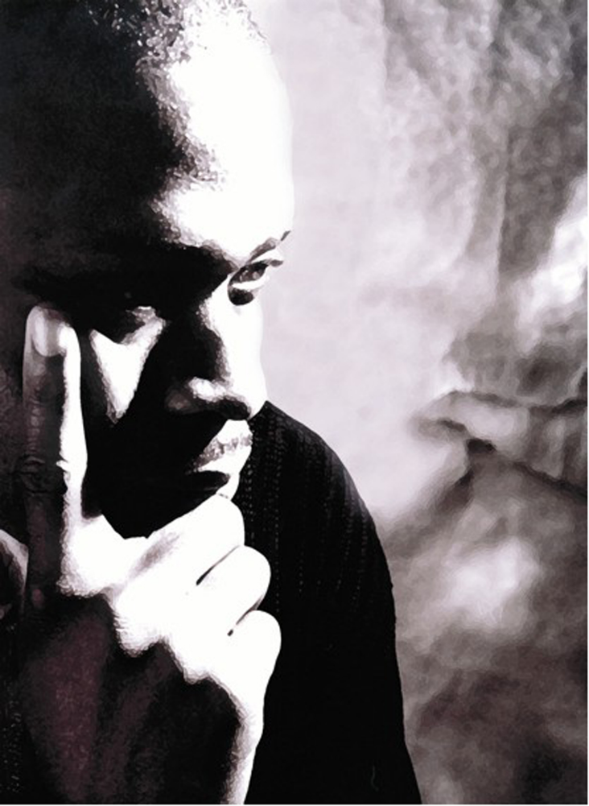
Dr Onyeka Nubia is a pioneering and internationally recognised academic, who is reinventing our perceptions of methodology and pedagogy in regards to diversity and global histories. Onyeka works to decolonise history curriculums at the Universities of Nottingham, Edge Hill and Huddersfield. He is the writer of Blackamoores Africans in Tudor England (2013/2014) and England’s Other Countrymen (2019). Onyeka is an internationally renowned keynote presenter at: the National Gallery, the National Portrait Gallery of Scotland, and universities including: Oxford University, Vanderbilt, Georgia State, and Clark Atlanta. Onyeka has been a consultant for documentaries including: “Secrets of the Mary Rose” and Channel 4’s “Crossrail Discovery: London’s Lost Graveyard.”
3 Image credit: "Contemplation" by George West
Why should we pay attention to what Black people have historically done in Britain?
[Historical] … methodology is characterized, above all else, by the critical spirit: namely, the commitment to the incessant testing of assertions through observations and/or experiments—the more stringent the tests, the better—and to revising or discarding those theories that fail the test …
Alan Sokal, ‘What is science and why should we care?’ (2008).
Historians are the chroniclers of our times, but also the critical interpreters. Historians are required to analyse notions and concepts. This is part of historical methodology. The philosophical-scientist Alan Sokal (above) suggests this process involves revealing inherent prescriptions and hegemony. Sokal’s corrective, creates a process where a narrative emerges through applying methodology. It is a process that concerns itself with the we. But who are the ‘we’ in this question? The powerful assume the position of ‘we,’—the powerless the position of ‘the other.’ So in this case, the ‘we’ may be an imaginary Eurocentric-American hegemony, which requires ‘Black people’ ‘in Britain’ to prove their significance. Of course, the ‘we’ by querying the importance of the ‘other,’ have instinctively stated their own privilege.
Africans in Britain are part of human history, so to understand human history, we must understand them. Africans do not need to prove their worth or existence, to be ‘paid attention to.’ They exist. And have done so for more than 2,000 years, this existence proves their significance. The possibility that the reader may not have ‘discovered them’ is a reflection, unfortunately of the exceptionalism outlined above. And moreover, if the reader has been learning about ‘British history’, but not Africans in Britain, then surely the reader has not been studying British history—but white-British hegemony.
I, the writer, am not an ‘other’; I am part of the world! I do not need to be convinced about by my own significance, so that I can ‘pay attention’ to myself? Such a notion would suggest a kind of ‘double-consciousness’ and require mental gymnastics. And of course, the problem of double-consciousness as Frantz Fanon outlines is you keep thinking like ‘the other fellow’—and you forget to think for yourself. In short, the central problems caused by the erasure of Africans from the history of Britain and the more recent efforts to recover that history, remain the work of centering the experiences of Africans, not as a tangential focus but as established, consistent, social, cultural, and political actors.
In surveys such as the one for which this volume is intended, the main presence of Black people has been in connection with the trans-Atlantic slave trade; while these connections are essential to understanding the history and culture of the period, overemphasizing them skews the history of Black people in Britain. To your mind, what are the most significant effects caused by this distorted emphasis?
The term ‘trans-Atlantic slave trade’ does not describe this tragedy adequately. The latter is a colloquial-hackneyed phrase, which masks something far more apocalyptic. A much more appropriate term is ‘Maafa,’ a Swahili word meaning ‘disaster.’ And it was a disaster that resulted in systemic desolation, colonialism, imperialism and industrial-exploitation. The effect of this apocalypse was genocidal and gave colonizers such as Cecil Rhodes both encouragement and permission to commit systemic atrocities against Africans more devastating than in any preceding century.
Historiography of the ‘British slave trade’ is often inhibiting and restrictive. It does not explain the 2,000-year history of Africans in Britain, but it is also often missing the horrors of European and African interactions in the nineteenth to early-twentieth centuries. For example, if we return to Cecil Rhodes, he was the British-born economic-opportunist and imperialist that Rhodesia (now Zimbabwe) in southern Africa is named after. Rhodes’ economic ventures were responsible for the deaths of millions. And yet his activities are often excluded from discussions on the ‘slave trade.’ Moreover, Rhodes had a coherent set of racist beliefs that can be mapped. Many of these beliefs were polemical and based on the science of race. They were akin to those espoused by Thomas Huxley concerning the superiority of the ‘Anglo-Saxon Race.’ British colonialists in Africa adopted methods similar to those advocated against Native Americans in America. These ideas were sometimes colloquially referred to as ‘Manifest Destiny’ and were promoted by theorists, fantasists, and apologists such as Samuel George Morton, John O’Sullivan, and Jane Cazneau. The idea was that continents populated by ‘darker people’ would be ‘ethnically cleansed’ by war, disease, or famine, and the ‘white race’ would replace them. So let us re-emphasise—this philosophy designated the continents of Africa, Oceania, North and South America as the inheritance of the ‘Anglo-Saxon race.’ In that sense, these British and European-American eugenicists were taking their inspiration from Charles Darwin (the ‘father’ of evolution). Darwin confirmed his own biological determinism when he wrote to Rev. Charles Kingsley (1819-1879), on February 6, 1862:
It is very true what you say about the higher races of men, when high enough, replacing & clearing off the lower races. In 500 years how the Anglo-saxon race will have spread & exterminated whole nations; & in consequence how much the Human race, viewed as a unit, will have risen in rank.
So discussions on the ‘Transatlantic slave trade’ are often missing many of the matters included within the historiography of the Maafa. But neither subject, enslavement or the Maafa, should be introductory topics in exploring African history in Britain or anywhere else. African history does not begin with slavery. And it is very dangerous to perpetuate a lazy historiography of Africans, where their complex histories are denied. Or a philosophy is promulgated that the ‘negro has no history.’ This latter idea was opposed by African-British scholars such as John Archer and African-American educators including Carter G. Woodson. This myopic practice causes a diminution of the African personality and it is manifestly malignant—as well as being historically inaccurate.
A significant element of the recovery of Black history has been the identification of the Black people who have been overlooked; is there a specific individual you find particularly indicative of a lost aspect of that history?
We should avoid the perpetuation of autobiographical-exceptionalism. This is an idea where we look at one or even a few people from history and avoid the wider social, political, etc. narratives. However, the investigation of an individual or individuals can provide a window into communities, peoples, and nations. But that is only if such an extrapolation is done authentically and carefully. Of course, we should still acknowledge the value of the lived-in experience of a biography as a form of social history. But we must remember that biography must never become the substitute for wider trajectories and that in the past this kind of storytelling ignored vast swathes of humanity, in favour of glorying a few: mass murderers, colonialists and imperialists, Cecil Rhodes, et al.
A good approach to use is intersectionalism. This phrase was coined by Kimberle Williams Crenshsaw and offers an opportunity for historians to critique positionality using complex metrics. And it can produce an inclusive methodology. For example, by looking at history using intersectionalism, we can see how Charles Darwin has a complex history influenced by Africans in Britain. Darwin, the ‘father of evolution,’ was taught by John Edmondstone (c. 1840s). Edmonstone was a man of African-Caribbean heritage. Darwin was his student and attended his taxidermy classes in Edinburgh, Scotland. Taxidermy was a vital aspect in Darwin’s skills that he used to decipher the ‘Origin of Species.’ Moreover, Edmonstone was born in what is now British Guyana, and the Galapagos Islands are adjacent to it. It is possible that Darwin learnt about these islands through Edmonstone.
For African American students (the majority of our student body), the initial impression of British literature, especially British literature prior to the nineteenth century, is its alienness, as a literature by and for people of another time, country, and race. How far would you say this impression could stand to be corrected?
British literature is ‘British.’ But that does not mean it is mono-ethnic, or ethnically-static. Just as American literature is ‘American,’ but can include: Maya Angelou, James Baldwin, Zora Neale Hurston, Eugene O'Neill and John Steinbeck. So, British literature can be as diverse as: Malorie Blackman, Ottobah Cugoano, Charles Dickens, Mary Prince, Dylan Thomas and William Shakespeare. The terms ‘British’ and ‘American’ are generic labels, used to describe peoples who inhabit geographical spaces. These terms do not ring-fence the multiplicity of the lived in experiences of those that live within those spaces.
One register that particularly impedes American understandings of the history of Black people in Britain is class. Would you discuss the importance in your work of distinguishing the often-overlapping categories of race and class?
There is often an overriding difficulty that Americans have in understanding any country outside of America. This is because the history of other countries is not taught in American schools. A school system that ignores world history creates the environment where people are mis-educated. In that mis-education they may assign totems and idioms to mask the ignorance of what they do not know. The totems attached to England are that the people there are all ‘white-gentlemen,’ the kind found in Downton Abbey or The Crown—who have tea with the queen and pontificate in affected received-pronunciation. This is not England. Just as: Friends, Cheers, Seinfeld, and the Sopranos are not America. What they engender are ‘sacred white spaces,’ devoid of colour. To understand any nation one needs to engage in rigorous-multidisciplinary historical research.
How would you compare the legacy of the Black experiences in Britain to the weight of the enslavement of African Americans in the context of 21st century America?
It is not a competition, although this idea is implied in the question. One context in which this representation of competition is offered is in the casting of actors. For example, Samuel Jackson criticised the casting of actors from Britain of African descent in American films. And yet African-American actors have been doing the reverse for decades. We may acknowledge pioneers such as: Ira Aldridge in Othello, Paul Robeson in the same, and films that include Song of Freedom, Big Fella, and The Proud Valley. Later on, of course, the hugely influential American-born Bahamian actor Sidney Poitier starred rather incongruously as Mark Thackeray in the film of To Sir With Love despite the film being based on the life of ER Braithwaite, an African-Caribbean man living in east London during the 1950s. Other African-Americans have seized the opportunity to play ‘Black British’ characters, and they have done this with varying degrees of efficiency.
An entire chapter of your book, England’s Other Countrymen, elucidates and historicizes the fabrication of theological justifications for the denigration and enslavement of Africans, particularly in England. Can you speak to how these kinds of fabrications were an English creation, one that they would later export to America?
These fabrications were created in many different parts of the world, in: Spain, Portugal, France, the Ottoman Empire, England, Scotland, the Netherlands, Morocco, the Holy Roman Empire, the Venetian state, one can see odes to certain negative ideas about Africans during the early modern period. There are also, by contrast, positive notions concerning Africans and Africa in all the countries that I just mentioned. It is just that the USA is a new country and when it was being formed it inherited its prognosis from England. What was created was often rewritten in American-English and created legacies of inequalities. But America’s racism is ultimately the child of a wider European malaise.
Throughout your work, there are multiple gestures to the future and invitations for readers to continue their own explorations of the presence, lives and contributions of Africans in Early Modern England. What would you say to a student discovering this work for perhaps the first time and where do you see this field of history, cultural, and literary studies in say 20 years?
It is an exciting time for early modern history. This is because this field of research is rich and the cornerstone of modern history, hence its name. But this does not mean that one can see a linear progression from the early modern period to now. History does not conform to the notions of modernity, where everything is getting better, because it was bad in the past. For example, in North America, at the beginning of the early modern period, Africans had fewer legislative limitations on their status than they did at the beginning of the twentieth century. This is a feature not only of American history but unfortunately of histories in other parts of the world. Therefore, to understand this complexity we must commit to studying early modern history.

Selected Bibliography and further reading to Onyeka Nubia Interview
Author Various. ‘Black British Film,’ https://mubi.com/lists/black-british-cinema.
Author Various. ‘Black Past org.’ https://www.blackpast.org/african-american-history/1922-marcus-garvey-principles-universal-negro-improvement-association/
Braithwaite, ER. To Sir With Love. London: Bodley Head, 1959.
Crenshaw, Kimberle Williams.’Demarginalizing the Intersection of Race and Sex: A Black Feminist Critique of Antidiscrimination Doctrine, Feminist Theory and Antiracist Politics.’ University of Chicago Legal Forum, 8: 1, 1989, https://chicagounbound.uchicago.edu/cgi/viewcontent.cgi?article=1052&context=uclf.
Dabydeen, David Dabydeen (eds.). Paul Edwards (eds.). The Black Presence in English Literature. Manchester: Manchester University Press, 1985.
Fanon, Frantz. Black Skin White Masks. Paris/New York: Grove Press, Éditions du Seuil, 1952/1967.
Fryer, Peter. Staying Power: The History of Black People in Britain Since 1504. 1984. Reprint, London: Pluto Press, 1989.
Garvey, Marcus Mosiah. ‘The Principles of the Negro Improvement Association.’ New York: Universal Press, 1922.
Harewood, David. ‘Samuel L Jackson is My Hero. But He’s Wrong About Us British Actors.’ The Guardian. 13/3/2017. https://www.theguardian.com/commentisfree/2017/mar/13/samuel-l-jackson-british-actors-racial-history
Hietala, Thomas. Manifest Design: Anxious Aggrandizement in Late Jacksonian America. New York: Cornell University Press. 1985.
Kaufmann, Miranda. Black Tudors. London: One World, 2017.
Lowe, Kate. Thomas Earle (eds.). Black Africans in Renaissance Europe. Cambridge: Cambridge University Press, 2005.
Northrup, David. Africa’s Discovery of Europe: 1450-1850. New York/Oxford: Oxford University Press, 2002.
Moore, Timothy Owens. ‘A Fanonian Perspective on Double Consciousness.’ Journal of Black Studies. 35:6, 2005, pp. 751-762. https://www.jstor.org/stable/40034879?seq=1.
Mumford, Gwilym. ‘Samuel L Jackson Criticises Casting of Black British Actors in American films.’ The Guardian, 8/3/2017, https://www.theguardian.com/film/2017/mar/08/samuel-l-jackson-criticises-casting-of-black-british-actors-in-american-films;
Olsen, Elder. The Poetry of Dylan Thomas. Chicago: The University of Chicago Press, 1954.
Onyeka. England’s Other Countrymen: Black Tudor Society. London: ZED books, 2019.
-----. Blackamoores: Africans in Tudor England Their Presence Status and Origins. London: Narrative Eye, 2013, 2014.
-----. ‘Artisans, Servants, Musicians and Kings: Africans in Tudor England.’ in, Kate Bystrova (ed.). The Commonwealth Year Book 2015. Cambridge: Nexus Strategic Partnerships, Commonwealth Secretariat, Commonwealth of Nations, 2015, pp. 75-76.
-----. ‘What’s in a Name?’ History Today, 62: 10, Oct. 2012, pp. 34-39.
-----. ‘The Missing Tudors, Black People in Sixteenth-Century England,’ BBC History Magazine, 13: 7, July 2012, pp. 32-33.
Painter, Nell Irvin. The History of White People. New York/London: Norton and Company, 2004.
Rhodes, Cecil. William Thomas Stead (ed.). The Last Will and Testament of Cecil John Rhodes … London: Review of Reviews Office, 1902. https://archive.org/details/lastwilltestamen00rhodiala
Scobie, Edward. Black Britannia: A History of Blacks in Britain. Chicago: Johnson Publishing Company, 1972.
Sokal, Alan. ‘What is science and why should we care?’ UCL Cruciform Lecture. London: 2008. https://physics.nyu.edu/sokal/sense_about_science_PUBL.pdf
Stepan, Nancy. The Idea of Race in Science: Great Britain 1800-1960. London: Macmillan, 1982.
Unger, Leonard (eds.). American Writers: a Collection of Literary Biographies. New York: Scribner, 1974.
Ungerer, Gustav. The Mediterranean Apprenticeship of British Slavery. Madrid: Verbum Editorial, 2008.
Wright. William. Black History and Black Identity: A Call for a New Historiography. Westport: Greenwood Publishing Group 2002.
Vernon, Patrick (ed.). ‘100 Great Black Britons.’ Every Generation, https://100greatblackbritons.com/bios/john_edmonstone.html
Woodson, Carter G. ‘The Celebration of Negro History Week.’ The Journal of Negro History. XII:2, pp. 103-109, (1927).
Zitzer, Leon. A Short but Full Book on Darwin’s Racism. Bloomington: iUniverse, 2017.

Links to other sections of this Introduction to African and Afro-Diasporic Peoples and Influences in British Literature and Culture before the Industrial Revolution
Preface for Instructors
Reclamations Following a History of Exclusion
Imagining Africa: Entrenching Stereotypes
Race and Religion
Constructions of Race in Britain
An Interview with Josie Gill
An Interview with Angela F. Jacobs
An Interview with Miranda Kaufmann
An Interview with Onyeka Nubia
Brief Biographies of Black People in Britain

Brief Biographies of Black People in Britain
Cheddar Man is the name of a skeleton from a person who lived in Britain approximately 8000 years BCE. His skeleton was found in a cave in Cheddar Gorge (in South West England), from which he has been named. Genetic analysis shows that he would have had “dark skin and blue eyes” (Lotzof).
The Roman emperor Claudius (r. 41-54 CE) ordered the invasion of the island of Britain, establishing an occupation of much of the territory of modern England for three and a half centuries. Roman Britain was part of a significant empire across which people and goods traveled widely. One of these travelers is the Ivory Bangle Lady, a young adult whose grave was discovered in York in 1901 (York Museums). Buried as a rich woman, she wore bracelets made of ivory and of jet that have not only given her her nickname but also provide evidence that she lived in the late-300s. Osteoarchaeological studies show that she has African ancestry and that before she was buried in York she had lived in another climate (possibly as far away as northern Africa). Further analysis of skeletons from other burials of the period shows African ancestry for more than one in ten (York Museums).
4 Bronze bowl: a shallow bowl made of copper and showing weathering from age.
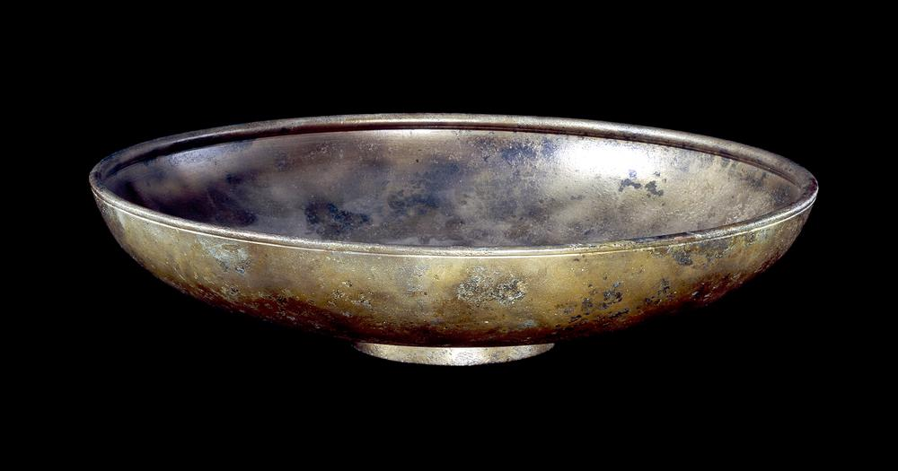
A copper alloy bowl, stamped “AFRICANUS” on the base, indicating the name of the maker, was found in Luton (in the county of Kent) in 1869. It is 32 centimeters in diameter and estimated to have been made in the first century (CE). The maker’s name should not be taken as proof that he was actually African. (Trustees of the British Museum) (Asset Number 36610001)
Image © The Trustees of the British Museum https://www.britishmuseum.org/collection/image/36610001
Hadrian’s Wall, a barrier between Roman-occupied Britain and the unconquered north-west of the island (approximately present-day Scotland), was the site of the earliest documented Africans in Britain: soldiers, likely originally from what is now Morocco (“Reading’s Early Black History”).
Geoffrey of Monmouth records that an African king called Gormund had led a navy to Ireland to conquer it and used Ireland then as a base from which to attack England. (See chapter VIII of book XI of The History of the Kings of Britain, which is a work as much of mythology as of history.)
Ipswich Man is the nickname of a man whose skeleton remains were discovered in Suffolk, having been buried sometime in the thirteenth century (Nubia). The man of clear African descent had been buried in the cemetery of a Franciscan monastery. Analysis of his remains found that he was born and grew up in a Mediterranean climate, likely North Africa or Southern Spain, but that he had spent much of his adult life in a cold, wet climate, most likely England itself. (Ridgway).
5 An oil flask, apparently missing its lid, decorated with an African face on each of the four sides of the round jar.
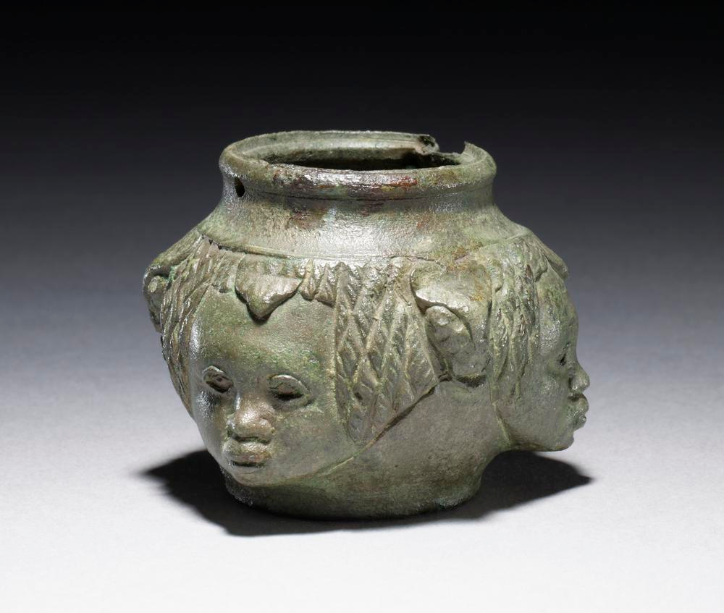
A small container for oil, approximately a quarter of an inch high, cast of a copper alloy in the second century. It was found in 1877, in Kent, as part of a burial accompaniment, together with other elements of a bathing kit. It reflects a fascination with African peoples, though it may not correlate with any Africans in the region at the time. (Trustees of the British Museum) (Asset Number 599310001)
Image © The Trustees of the British Museum https://www.britishmuseum.org/collection/image/599310001
John Blanke is represented twice on the Westminster Tournament Roll; one of these images can be found online at the British National Archives, showing Blanke, a trumpeter, playing at the tournament King Henry VIII hosted in 1511 to celebrate his wife Katherine of Aragon giving birth to a son (though the infant would die not long after the tournament concluded) (Kaufmann 7). Blanke had been hired to the court of King Henry VII and continued to be paid as a court trumpeter into the reign of Henry VIII (Kaufmann 9). He was married, in 1512, in a Catholic ceremony (suggesting he was Catholic) and in a suit paid for by the king (Kaufmann 29). Blanke may be the best documented Black person employed in an early modern European court, but he is far from the only one; records show musicians, kitchen workers, and stable-hands across the continent (Kaufmann 30).
The Mary Rose, reputed to be King Henry the VIII’s “favorite warship,” sank in battle during a war between England and France in 1545 (Morris). According to researchers from the University of Portsmouth, at least two members of the crew of the Mary Rose were likely of African descent. The first, known as “Henry,” seems to have been “a teenager of muscular build who was thought to have been involved in keeping the ship watertight, and was found in the hold” (Davis). By conducting multiple tests on his bones, teeth, and DNA, researchers have found that he has genetic “similarities to Moroccan, Mozabite and near-eastern populations” (Davis). Whether “Henry” was born in North Africa or not is unclear, but it is likely that he lived most, if not all, of his short life in England. An analysis of “oxygen isotopes in his teeth” suggests that he lived in “the rainy west or south of the country” (Davis). Another person from the ship, called the “archer royal,” “appears to have been a well-to-do individual: he was found with a sword, carrying a comb and wearing a leather wrist-guard bearing the arms of Catherine of Aragon and royal arms of England” (Davis).
Jacques Francis worked as a diver, salvaging ships and their cargoes. He was born in Africa but by 1546 was working in England (Kaufmann 34, 38). A significant source of historical evidence for details of his life is the court records where he testified on behalf of his employer; the fact that his testimony was accepted by the court suggests that he was a Christian and confirms records that he was employed, not enslaved, in working as a diver, as the courts would not have accepted testimony from an enslaved person or from somebody who could not swear on a Bible (Kaufmann 48, 51).
6 A view of the top of a lamp; the main portion is circular, with decorations around the central circle; two filling holes are in the central circle, and to each side of them extend nozzles, each about an inch and a half in extension beyond the circle.
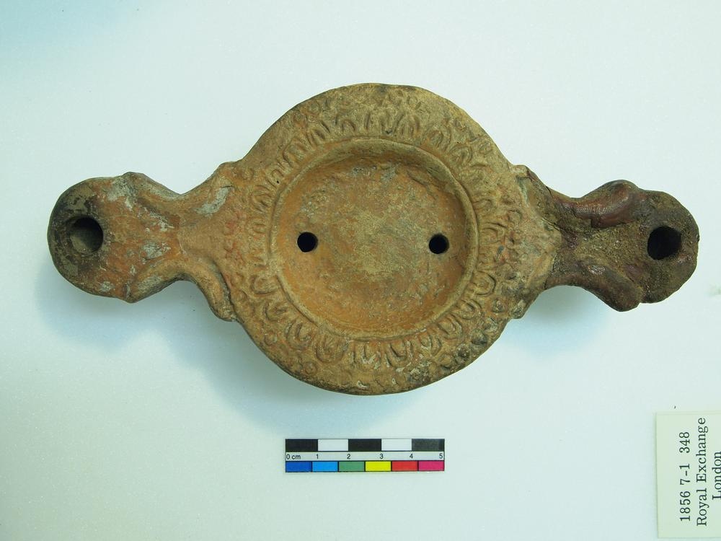
A lamp, approximately one and a quarter inches high, three and an eighth inches wide, and six and three-quarters inches long. Each of the nozzles would have contained a wick that extended down into the body of the lamp. The holes in the central portion of the lamp are for filling it with oil. It was made of orange clay approximately 150-200 AD, presumably somewhere in Africa. The Museum acquired it in Liverpool. (Trustees of the British Museum) (Asset Number 1612958803)
Image © The Trustees of the British Museum https://www.britishmuseum.org/collection/image/1612958803
Diego, enslaved in Panama in the mid-sixteenth century, escaped in June 1572 by warning Sir Francis Drake of potential dangers he might face in raiding the town where Diego lived (Kaufmann 59). Though the Spanish colonies of the time made extensive use of enslaved Africans, the English had not yet begun to colonize and were not yet significantly involved in the slave trade; it was said that merely setting foot in England would free a man, “because in that Reign nobody is a slave” (quoted in Kaufmann 60). Diego assisted Drake and his men in their ongoing raids against the Spanish and in forging working relationships between Drake and the Cimarrons (communities of Blacks escaped from the colonies) (Kaufmann 62). Having seized considerable wealth, Drake sailed home, taking Diego with him; Diego was later employed for the voyage in which Drake first circumnavigated the earth (beginning in 1577), though Diego died before the journey was completed (Kaufmann 71, 77).
Edward Swarthye, whose surname is almost certainly a nod to the color of his skin, was employed as a porter in the manor of Sir Edward Wynter from the mid-1580s onward (Kaufmann 100). In this role he was, in many ways, the face of the household, being the first person a prospective visitor would encounter at the door and having the responsibility of determining which guests might be admitted; porters were among the more highly-regarded servants in a large household (Kaufmann 101). In December 1596 his employer tasked him with whipping another servant (the white manager of Wynter’s iron works) for “neglecting [his] business” and causing significant financial losses (Kaufmann 107). When Wynter was brought to trial for his part in the beating, Swarthye was a witness, along with his fellow servants (Kaufmann 108-9).
On 25 September 1586 a girl called Elizabeth was baptized at St. Botolph Bishopgate; the baptismal record lists her as “a negro child, born white, the mother a negro” (“Elizabeth [No Surname]”). Bishopsgate was one of the major gates in the wall that used to stand around the city of London, and St. Botolph’s church is located near its former site.
Cattelena of Almondsbury (d. 1625) is known only through the probate listing of her property at the time of her death in a village near Bristol (Kaufmann 244). Because she did not own furniture, it is believed she lived in a rented home or rented a room in someone else’s home (250). Presumably she made her living from her cow, which was not only the most valuable thing she owned but also a means of ongoing income (250, 253).
Henry Mainwaring, a pirate, likely captured John Anthony around 1614, taking Portuguese ships and their cargo for his own (Kaufmann 199). By 1619 Anthony was sailing as part of Mainwaring’s crew, intending to travel to the Virginia colony to establish trade; as Miranda Kaufmann notes, “Had the voyage been completed as intended, [... he] would have been the first African to arrive in an English colony in mainland North America” (208, 209). Instead, the ship appears to have turned to piracy, acquiring a load of tobacco at sea, and Anthony had to go to court to receive his pay following the journey’s conclusion (209, 214).
Prince Dederi Jaquoah (born ca. 1591) was born in coastal Africa, in what is now Liberia, and came to England as a passenger on a merchant ship (Kaufmann 170, 176). Two years later he returned home, drawing upon his experiences in England to facilitate trade in his father’s kingdom (188, 190).
Job ben Solomon (1701-1773), born Ayyub Ben Suleiman Diallo, was sold from Senegal into slavery in Maryland colony. He wrote a letter to his father asking for his freedom to be purchased, but the letter was not delivered. Instead, a translation reached James Oglethorpe, who arranged for Suleiman Diallo to be brought to England and had agreed to buy his freedom. Ultimately Oglethorpe was already in North America by the time Suleiman Diallo arrived in England, and it was the Royal African Company that purchased his freedom. After Suleiman Diallo arranged to pay back the Royal African Company, he returned to Africa. (See Suleiman Diallo’s biography, written by Thomas Bluett—Some Memoirs of the Life of Job the Son of Solomon—and also see Al-Badaai.)
7 "An Open Letter about 'Negroes' Brought Home" in manuscript, 11 July 1596. The original is held at the National Archives and a transcript can be found on their website.
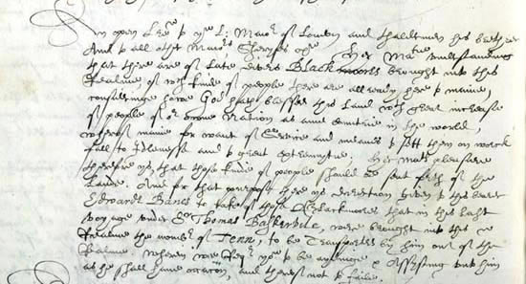
In this letter, dated 11 July 1596, Queen Elizabeth I tells mayors and sheriffs around England that the nation does not need any more people than are being born there. In effect, she cites a lack of available jobs for English-born people as the reason she is commissioning Edwarde Banes to take back out of England ten Black people who had recently been brought into the country.
Contains public sector information licensed under the Open Government Licence v3.0.
Ukawsaw Gronniosaw (1705-1775) was, like many persons enslaved in the eighteenth century, sold as a child and transported to overseas colonies—in his case to Barbados (“A narrative”). After being set free, he moved to London, married, and dictated his autobiography, which was published as A Narrative of the Most Remarkable Particulars in the Life of James Albert Ukawsaw Gronniosaw, An African Prince, Written by Himself and regularly reprinted (“A narrative”).
Queen Charlotte von Meckklenburg-Strelitz (1744-1818), the wife of King George III, has been rumored to have African ancestry, based on interpretations of portraits made of her. Mario De Valdez y Cocom, a historian, describes her family tree stemming from King Alfonso III of Portugal (1210-1279) and a mistress from a Moorish town. One of their great-great-great-great-grandchildren was Margarita de Castro e Souza (born in 1440). And Margarita de Castro e Souza was Queen Charlotte’s great-great-great-great-great-great-great-grandmother. Few historians agree with Valdes’ assumption that Alfonso III’s mistress was necessarily Black, as the Moors of Spain, Portugal, Morocco, and the surrounding region were racially diverse. It is also a stretch to call a woman with one Black ancestor five hundred years in her past “Black.”
Olaudah Equiano (ca. 1745-1797) is best known as the author of The Interesting Narrative of the Life of Olaudah Equiano, or Gustavus Vassa, the African, published in London in 1789. Images from the second edition can be found at the British Library’s website. Although the book would be extremely profitable for him, he had already achieved financial success before writing it, having worked as a merchant both as a free man and under the person who allowed him to purchase his freedom (“Life of Olaudah Equiano”).
Pero Jones (ca. 1753-1798) was transported in the 1780s from Nevis to Bristol by John Pinney, who used him as an enslaved personal servant (Gerzina). He was purchased in Nevis in 1765, along with his sisters, while still a child, and after his death his belongings were sent back to his family in Nevis (Gerzina). The city of Bristol named a bridge for him in 1999 as a commemoration of the people from Africa who were trafficked through the city and its ports (“Pero’s Bridge”). When, in 2020, Black Lives Matter protestors in Bristol took down a statue of a wealthy slave trader and threw it into the harbor, they did so in sight of this bridge (Associated Press).
Quobna Ottobah Cugoano (ca. 1757-?) became a campaigner for the abolition of slavery following his own emancipation. Born free in what is now Ghana, Cugoano was enslaved first in Grenada and later in England (“Black Presence”). His emancipation may have been connected to the Somerset ruling, which made it unlawful to sell a person living in England into slavery abroad (it did not quite make it unlawful to continue to own an enslaved person living in England, but it did change the economic considerations of owning a person in England, in that the owner could not plan on profitably selling the person onwards) (English Heritage). He learned to read and became a major figure in the abolition movement, including publishing his book, Thoughts and Sentiments on the Evil and Wicked Traffic of the Slavery and Commerce of the Human Species, Humbly Submitted to the Inhabitants of Great-Britain, which is credited as the earliest of the English-language abolitionist publications by a person of African ancestry and the earliest Black-authored call for a complete end to slavery (Gunn 620).
Sake Dean Mahomed (1759-1851) was born in India and served as a teen in the East India Company Army on a British ship under the command of Captain Godfrey Baker. Baker and Mahomed formed a close bond and Mahomed returned in Ireland with the captain where he was educated and ultimately married an Irish woman, Jane Daly (Foulkes). Throughout his long life, Mahomed proved himself a pioneer: he would become an author, a restaurateur, a medical practitioner, and a bath house proprietor. In many cases he was the first individual of Indian birth to do such things in Ireland or England.
Boston King (ca. 1760-1802) was enslaved from birth in South Carolina (Hanley 1). Like many other enslaved persons at the time of the American Revolution, he joined the British military on the promise of freedom in exchange for military service; these people are known as “black Loyalists” (Hanley 1). Approximately 3000 Black Loyalists were settled in Canada following the British defeat (Hanley 1). An ordained minister, King would go on to work as a missionary in the then-new colony of Sierra Leone; he took a break from this work from 1794 to 1796 to study in England and write his autobiography, following which he went back to his missions work in West Africa for the last four years of his life (Hanley 2).
8 The seal of the Royal African Company
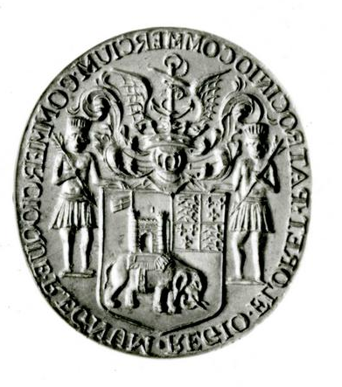 The seal of the Royal African Company, produced in England in 1662. The inscription reads “REGIO. FLORET. PATROCINO. COMMERCIUM. COMMERCIOQUE. REGNUM,” which was the official motto of the company from 1672 onwards and indicates that royal patronage causes business to flourish which then causes the kingdom to flourish. (Trustees of the British Museum) (Asset Number 1186488001)
Image © The Trustees of the British Museum https://www.britishmuseum.org/collection/image/1186488001
Dido Elizabeth Belle (1761-1804) was the daughter of John Lindsey, an officer in the British Navy, and Maria Bell, a woman of African descent enslaved in the West Indies (Braimah 2). When Dido Elizabeth Belle’s mother died, Lindsey relocated her the estate of his uncle, Lord Mansfield, the Lord Chief Justice (Braimah). Dido Elizabeth Belle’s great-uncle would later be the justice ruling on the Somersett Case, which held that a person enslaved in Britain could not be sold into enslavement elsewhere (“Black Presence”). When Dido Elizabeth Belle moved to England, Lord Mansfield was already the guardian of another of his great-nieces, near the same age as Dido Elizabeth Belle; in fact Dido Elizabeth Belle is perhaps best known due to her image painted alongside Elizabeth Murray.
The two grew up together in the Earl’s home where Dido Elizabeth Belle was educated. As an adult, Dido Elizabeth Belle stayed on in the home and “managed the estate’s dairy and poultry yards and helped Lord Mansfield with his correspondence, a task normally assigned a male secretary or clerk” (Braimah). She would later marry John Davinier and the pair had three children (Braimah).
Fanny Coker (1767-1820) was born into slavery in John Pinney’s plantation in Nevis, freed as a child, and transported from Nevis to Bristol by John Pinney in the 1780s to continue her employment, first as a seamstress and then also as a nursemaid to the Pinneys’ children (Gerzina). Records of her shipments of keepsakes, gifts, and financial support for her family in Nevis exist (Gerzina).

Bibliography to the Brief Biographies of Black People in Britain
“A narrative of the most remarkable particulars in the life of James Albert Ukawsaw Gronniosaw, an African prince / written by himself.” Slavery and Portraiture in 18th-Century Atlantic Britain. Yale Center for British Art. MS held in the Beinecke Rare Book and Manuscript Library, Yale University, JWJ Zan G898 770Nb https://interactive.britishart.yale.edu/slavery-and-portraiture/302/a-narrative-of-the-most-remarkable-particulars-in-the-life-of-james-albert-ukawsaw-gronniosaw-an-african-prince---written-by-himself Accessed 14 May 2021.
Al-Badaai, Muna Sulaiman. “Positioning the Testimony of Job Ben Solomon, An Enslaved African American Muslim.” International Journal of Applied Linguistics and English Literature, vol. 4, no. 6 (Nov. 2015): pp. 204-211. https://doi.org/10.7575/aiac.ijalel.v.4n.6p.204 Accessed 6 May 2021.
Associated Press, The. “Watery End for Statue of Slave Trader in UK City of Bristol.” Pennsylvania Real-Time News, 7 June 2020. Accessed 12 May 2021.
Black Presence: Asian and Black History in Britain, 1500-1850. The National Archives of the UK government, England, and Wales / Black and Asian Studies Association, www.nationalarchives.gov.uk/pathways/blackhistory. Accessed 4 June 2021
Braimah, Avondale. “Dido Elizabeth Belle.” BlackPast. 3 June 2014 https://www.blackpast.org/global-african-history/belle-dido-elizabeth-1761-1804/ Accessed 24 May 2021.
Davis, Nicola. “Mary Rose Crew Might Have Included Sailors of African Heritage.” The Guardian, 14 Mar. 2019. https://www.theguardian.com/science/2019/mar/14/mary-rose-crew-might-have-included-sailors-african-heritage
“Elizabeth [No Surname].” Baptismal record. 25 Sept. 1586. Reference code: Z/PROJECT/BAL/C/P69/BOT2/A/015/MS09222/001/02. London Metropolitan Archives Data Collections. Lma.gov.uk Accessed 4 May 2021.
English Heritage. “Cugoano, Ottobah (Born 1757).” English Heritage. https://www.english-heritage.org.uk/visit/blue-plaques/ottobah-cugoano/ Accessed 11 May 2021.
Foulkes, Debbie. “Sake Dean Mahomed: First Indian to Publish a Book, Own a Restaurant and Do ‘Shampooing’ in England.” Entrepreneurs, Inventions, People from England. 29 Dec. 2013 https://forgottennewsmakers.com/2013/12/29/sake-dean-mahomed-1759-1851-first-indian-to-publish-a-book-own-a-restaurant-and-do-shampooing-in-england/. Accessed 24 May 2021.
Gerzina, Gretchen. “Pero Jones and Fanny Coker.” Britain’s Black Past. BBC Radio 4. 5 Oct. 2016.
Gunn, Jeffrey. “Creating a Paradox: Quobna Ottobah Cugoano and the Slave Trade’s Violation of the Principles of Christianity, Reason, and Property Ownership.” Journal of World History, vol. 21, no. 4, 2010, pp. 629-656. JSTOR, www.jstor.org/stable/41060853. Accessed 11 May 2021.
Hanley, Ryan. “Boston King and the Black Loyalists of the American Revolution.” Faculty of History, University of Oxford, 2017. https://www.history.ox.ac.uk
Kaufmann, Miranda. Black Tudors, The Untold Story. One World Publications, 2019.
“Life of Olaudah Equiano, The, second edition.” The British Library. https://www.bl.uk/collection-items/the-life-of-olaudah-equinao# Accessed 13 May 2021
Lotzof, Kerry. “Cheddar Man: Mesolithic Britain’s Blue-Eyed Boy.” Natural History Museum, London. Accessed 20 Apr. 2021. https://www.nhm.ac.uk/discover/cheddar-man-mesolithic-britain-blue-eyed-boy.html
Morris, Steven. “Newly Decked out Mary Rose reopens after £5m Makeover.” The Guardian, 19 July 2016. https://www.theguardian.com/culture/2016/jul/19/mary-rose-newly-decked-out-reopens-5m-makeover
Nubia, Onyeka. “Who Was the Ipswich Man?” Early & Medieval Migrations, Our Migration Story. https://www.ourmigrationstory.org.uk/oms/the-ipswich-man Accessed 24 May 2021
“Pero’s Bridge.” Bristol’s Free Museums and Historic Houses. museums.bristol.gov.uk Accessed 12 May 2021.
“Reading’s Early Black History.” Blog, Reading Museum, 31 Mar. 2021. Accessed 6 Apr. 2021. https://www.readingmuseum.org.uk/blog/readings-early-black-history
Ridgeway, Claire. “Black Africans in Medieval England by Toni Mount.” The Anne Boleyn Files. 3 May 2019. Accessed 14 May 2021. https://www.theanneboleynfiles.com/black-africans-in-medieval-england-by-toni-mount/?v=7516fd43adaa
Trustees of the British Museum, The. The British Museum, www.britishmuseum.org. Accessed 2 June 2020.
York Museums and Gallery Trust. “Celebrating Ivory Bangle Lady.” York Museums Trust, https://www.yorkmuseumstrust.org.uk/blog/celebrating-ivory-bangle-lady/, 2020, accessed 27 Oct. 2020.

Suggested further reading beyond Black People in Britain
“A Long Way from Home: Diaspora Communities in Roman Britain.” University of Reading, University of Reading. https://www.reading.ac.uk/archaeology/research/Projects/arch-HE-Diaspora.aspx Accessed 27 Oct. 2020.
Beier, A. L. Masterless Men: The Vagrancy Problem in England, 1560-1640. Methuen, 1986.
Brundage, Anthony. The English Poor Laws, 1700-1930, Red Globe P, 2002
Eickelmann, Christine and David Small. Pero: The Life of a Slave in Eighteenth-Century Bristol. Redcliffe P, 2004.
File, Nigel, and Chris Power. Black Settlers in Britain 1555-1958. Heinemann Educational Books, 1981.
Eckardt, Hella. “A Long Way from Home: Diaspora Communities in Roman Britain.” In Roman Diasporas: Archaeological Approaches to Mobility and Diversity in the Roman Empire, edited by Hella Eckardt. Journal of Roman Archaeology, 2010. pp. 99-130.
Leach, S., et al. “A Lady of York: Migration, Ethnicity and Identity in Roman Britain.” Antiquity, vol. 84, no. 323, 2010, pp. 131–145. https://doi.org/10.1017/S0003598X00099816.
Leach, S., et al. “Migration and Diversity in Roman Britain: A Multidisciplinary Approach to Immigrants in Roman York, England.” American Journal of Physical Anthropology, vol. 140, no. 3, 2009, pp. 546-561. https://doi.org/10.1002/ajpa.21104.
Slack, Paul. Poverty & Policy in Tudor & Stuart England. Longman, 1988.
Walvin, James. Black and White: The Negro and English Society, 1555-1945. Penguin P, 1973.

Links to other sections of this Introduction to African and Afro-Diasporic Peoples and Influences in British Literature and Culture before the Industrial Revolution
Preface for Instructors
Reclamations Following a History of Exclusion
Imagining Africa: Entrenching Stereotypes
Race and Religion
Constructions of Race in Britain
An Interview with Josie Gill
An Interview with Angela F. Jacobs
An Interview with Miranda Kaufmann
An Interview with Onyeka Nubia
Brief Biographies of Black People in Britain

Travellers are an ethnic group believed to originate in Ireland; like the Roma, Travellers have historically lived an itinerant lifestyle.
Alan Sokal, ‘What is science and why should we care?’ UCL Cruciform Lecture, (London: 2008), https://physics.nyu.edu/sokal/sense_about_science_PUBL.pdf
Frantz Fanon, Black Skin White Masks (Paris/New York: Grove Press, Éditions du Seuil, 1952/1967); also, see Timothy Owens Moore, ‘A Fanonian Perspective on Double Consciousness,’ Journal of Black Studies, 35:6, 2005, pp. 751-762, https://www.jstor.org/stable/40034879?seq=1.
Marcus Mosiah Garvey, ‘The Principles of the Negro Improvement Association,’ (New York: 1922), https://www.blackpast.org/african-american-history/1922-marcus-garvey-principles-universal-negro-improvement-association/
William D. Wright, Black History and Black Identity: A Call for a New Historiography (Westport: Greenwood Publishing 2002), p.117.
Cecil Rhodes, William Thomas Stead (ed.), The Last Will and Testament of Cecil John Rhodes … (London: Review of Reviews Office, 1902), https://archive.org/details/lastwilltestamen00rhodiala
On Thomas Henry Huxley and the rest see, Nancy Stepan, The Idea of Race in Science: Great Britain 1800-1960 (London: Macmillan, 1982), passim.
On manifest destiny see, Thomas Hietala, Manifest Design: Anxious Aggrandizement in Late Jacksonian America (New York: Cornell University Press. 1985), passim.
Leon Zitzer, A Short but Full Book on Darwin’s Racism (Bloomington: iUniverse, 2017), n.p.
John Archer was a man of African descent, who was Mayor of Battersea (London) and founder of the African Progress Union, please see Peter Fryer, Staying Power … (London: Pluto Press, 1984), pp. 410–411; Carter G Woodson was the ‘father’ of Black History Month, see, Carter G Woodson, ‘The Celebration of Negro History Week,’ The Journal of Negro History, XII:2, pp. 103-109, (1927).
Kimberle Williams Crenshaw, ’Demarginalizing the Intersection of Race and Sex: A Black Feminist Critique of Antidiscrimination Doctrine, Feminist Theory and Antiracist Politics,’ University of Chicago Legal Forum, 8: 1, 1989, https://chicagounbound.uchicago.edu/cgi/viewcontent.cgi?article=1052&context=uclf.
For more on John Edmonstone see, Patrick Vernon (ed.), ‘100 Great Black Britons’, Every Generation, https://100greatblackbritons.com/bios/john_edmonstone.html
Dylan Thomas was a great Welsh poet, see Elder Olsen, The Poetry of Dylan Thomas (Chicago: The University of Chicago Press, 1954), passim. Wales is a separate country from England and has its own ethnic identity and history. It also has a long history of conflict against English hegemony.
To find out more about the American authors, see Leonard Unger, American Writers: a Collection of Literary Biographies (New York Scribner, 1974), passim. On the African British writers see, David Dabydeen (eds.), Paul Edwards (eds.), The Black Presence in English Literature (Manchester: Manchester University Press, 1985), passim; Charles Dickens and William Shakespeare can be discovered in any text on ‘great British novelists, or playwrights.
Gwilym Mumford, ‘Samuel L Jackson Criticises Casting of Black British Actors in American films,’ The Guardian, 8/3/2017, https://www.theguardian.com/film/2017/mar/08/samuel-l-jackson-criticises-casting-of-black-british-actors-in-american-films; for another view see David Harewood, ‘Samuel L Jackson is My Hero. But He’s Wrong About Us British Actors,’ The Guardian, 13/3/2017, https://www.theguardian.com/commentisfree/2017/mar/13/samuel-l-jackson-british-actors-racial-history
ER Braithwaite, To Sir With Love (London: Bodley Head, 1959).
For more on these films, please do see the individual actors’ biography. Or Black British Film, https://mubi.com/lists/black-british-cinema
See, Onyeka, England’s Other Countrymen: Black Tudor Society (London: ZED books, 2019); Onyeka, Blackamoores: Africans in Tudor England Their Presence Status and Origins (London: Narrative Eye, 2013, 2014); Onyeka, ‘The Missing Tudors, Black People in Sixteenth-Century England,’ BBC History Magazine, 13, No. 7, July 2012, pp. 32-33; Onyeka, ‘What’s in a Name,’ http://www.historytoday.com/onyeka/tudor-africans-whats-name#sthash.G2xe8vO4.dpuf
See, Nell Irvin Painter, The History of White People (New York/London: Norton and Company, 2004), passim.

